# Financial Ratio Analysis: Amazon.com, Inc. (2020-2022)

# Liquidity Ratios

Here, we analyzed the Current Ratio, Quick Ratio, Cash Ratio, and Defensive Interval. Liquidity ratios provide insights into Amazon's ability to meet its short-term obligations. The drop in the Current Ratio and Quick Ratio in 2022, as noted by the BBC (BBC, 2020), is consistent with broader industry challenges in maintaining liquidity during periods of rising operational costs (Forrester, 2023).

**Current Ratio and Quick Ratio:** These ratios indicate Amazon's ability to meet its short-term liabilities. Both ratios have been declining, showing weakening liquidity in 2022.

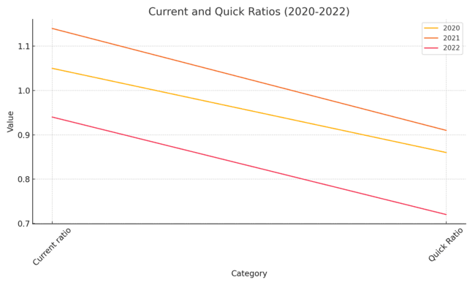

**Cash Ratio and Defensive Interval:** The Cash Ratio represents the ability to meet liabilities using only cash. Amazon's Defensive Interval shows a decreasing ability to cover daily operational expenses, which dropped significantly in 2022.

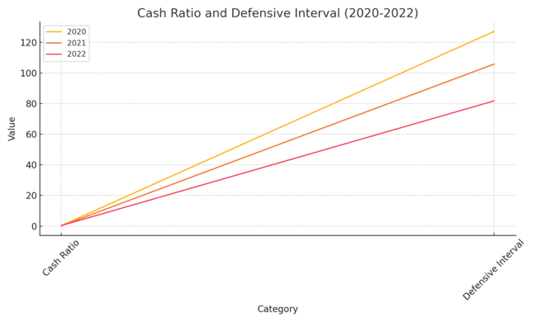

# Profitability Ratios

Profitability ratios measure how efficiently Amazon generates profits relative to sales and expenses. The analysis includes Gross Margin, EBITDA Margin, EBIT Margin, and Net Margin. Amazon's profitability saw a significant decline in 2022, largely due to increased shipping and labor costs (CNN, 2022; Forrester, 2023). The halving of operating income during this period is reflective of broader market challenges faced by global retailers like Walmart (Forrester, 2023).

**Gross Margin and EBITDA Margin:** Amazon's margins were relatively high in 2020 and 2021, but they dropped sharply in 2022, indicating a decrease in profitability.

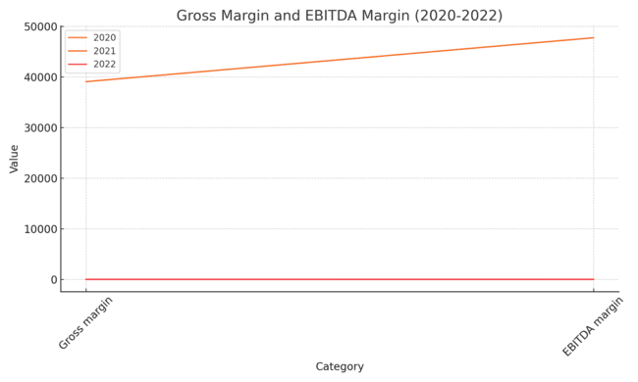

**EBIT Margin and Net Margin:** EBIT and Net Margins show significant deterioration in 2022, with the Net Margin turning negative, implying a loss for the year.

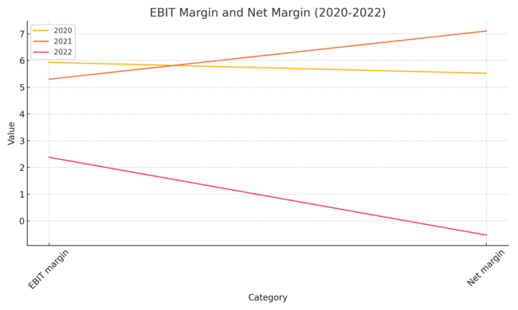

# Solvency Ratios

Solvency ratios help assess Amazon's long-term financial health and its ability to meet long-term obligations. The analysis includes Debt to Equity, Debt to Total Assets, Times Interest Earned, and Debt Coverage. The rising Debt to Equity ratio reflects Amazon’s increased reliance on debt to fund expansion, a common trend seen across major retailers globally (PwC, 2022; CNN, 2022). Amazon’s decline in interest coverage ratios further emphasizes the pressures of servicing debt in a high-interest environment (Forrester, 2023).

**Debt to Equity and Debt to Total Assets:** Amazon's reliance on debt has increased over time, as shown by rising Debt to Equity and Debt to Total Assets ratios.

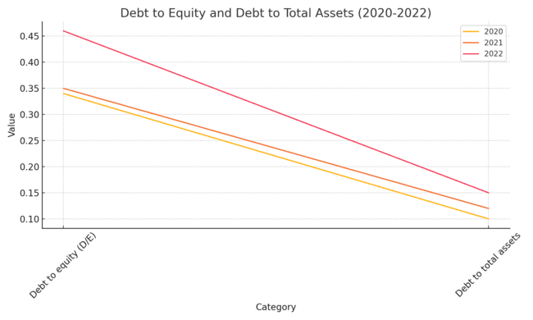

**Times Interest Earned and Debt Coverage:** Both ratios dropped significantly in 2022, indicating a reduced ability to cover interest payments and meet debt obligations.

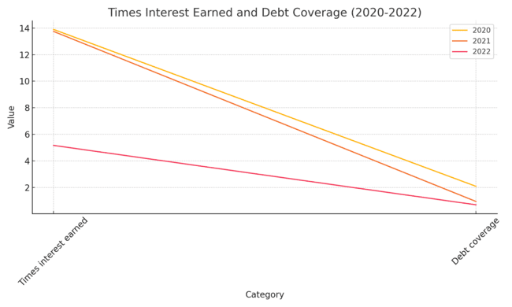

# Asset Utilization Ratios

These ratios show how effectively Amazon uses its assets to generate revenue. The analysis includes Total Asset Turnover, Fixed Asset Turnover, Inventory Turnover, and Return on Assets (ROA). Amazon's asset utilization ratios, although remaining efficient in 2022, show a slight decline in total asset turnover (PwC, 2022). The improvement in inventory turnover is a positive sign, reflecting better management of resources (BBC, 2020; Forrester, 2023).

**Total Asset Turnover and Fixed Asset Turnover:** Amazon's efficiency in using its assets has slightly declined, but it still demonstrates significant revenue generation from assets.

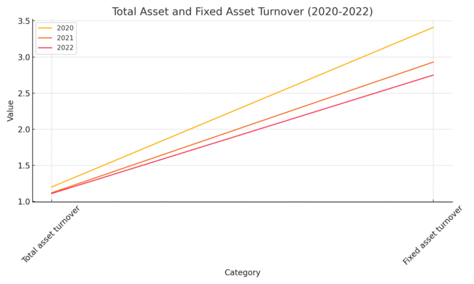

**Inventory Turnover and ROA**: Inventory management improved in 2022, but the negative ROA highlights overall losses for the year.

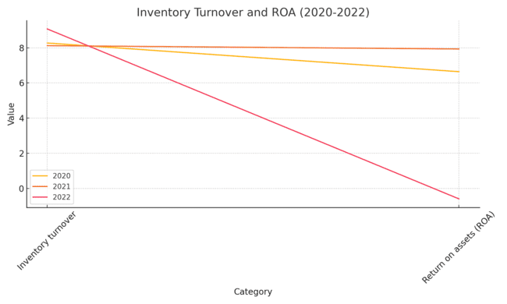

# Investor/Market Ratios

Investor ratios help assess Amazon's performance from the perspective of shareholders. The analysis includes P/E Ratio, Earnings per Share (EPS), Return on Equity (ROE), and Return on Capital Employed (ROCE). The negative EPS and sharp decline in Amazon's P/E ratio in 2022 have raised concerns among investors (BBC, 2022; CNN, 2022). This is consistent with the broader market sentiment during this period, as tech companies globally experienced reduced stock valuations (PwC, 2022).

**P/E Ratio and EPS:** A sharp decline in the P/E Ratio and negative EPS in 2022 reflects weakened investor confidence and poor earnings performance.

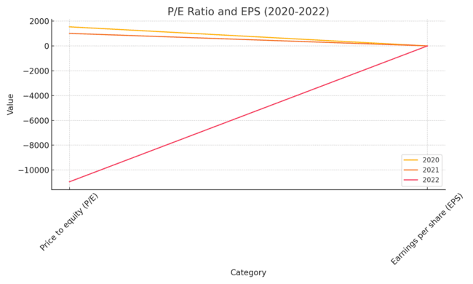

**ROE and ROCE:** Both Return on Equity and Return on Capital Employed turned negative in 2022, indicating losses for shareholders and inefficiencies in capital usage.

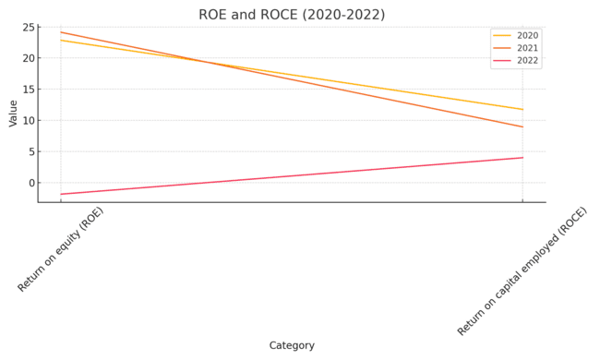

# References

BBC. (2020). Global inflation and liquidity challenges. Retrieved from https://www.bbc.com/news/business.

CNN. (2022). Amazon’s profitability decline and market challenges. Retrieved from https://www.cnn.com/business.

Forrester. (2023). Amazon Sales And Profit Analysis For 2022: Top 10 Insights. Retrieved from https://www.forrester.com.

PwC. (2022). Financial Trends in Global Retail. Retrieved from https://www.pwc.com.