**Instructions:**

1. After deriving the intrinsic share price based on our model, the next step is to focus on putting together a report with an investment recommendation.
2. You are required to fill in the report template below using the sample report attached and your readings on the company’s guidance in terms of key segments and products.
   1. Identify two to three key products that are vital for the company’s growth and you can discuss about the trends and expectations. But remember to keep them all short cause and effect sentences.
3. You can take up to two days for this task and feel free to reach out to me if you have any questions.

**Investment Recommendation Report: Nike Inc.**

Company Name: NIKE INC

Ticker: NKE

Current Share Price: $125.31Upside/Downside to Current Share Price: +139.41% (Forecasted Price: $300.00)

**Executive Summary**

Nike Inc. is poised for significant growth, with a projected intrinsic value of $300.00 per share, representing an upside of 139.41%. This performance is driven by robust revenue growth, improved profitability, strategic investments in innovation, and strong market positioning, particularly in North America. Despite potential risks such as fluctuating Capex and external market pressures, Nike’s strategic focus on key segments like footwear and apparel positions it as a solid investment opportunity.

**Company Overview**

Nike Inc., headquartered in Beaverton, Oregon, is a global leader in athletic footwear, apparel, and equipment. With a strong brand identity and innovative product offerings, Nike has established itself as a dominant player in the sports and lifestyle markets. Its key segments include footwear, apparel, and equipment, with footwear contributing the largest revenue share.

**Revenue Growth and Key Segment Performance**

Nike’s revenue is projected to grow from $44.5 billion in 2021 to $62.4 billion in 2026, with a stable annual growth rate of 7-8%. North America remains the largest market, contributing significantly to growth, with revenue expected to increase from $13.7 billion in 2015 to $25.9 billion by 2027. Footwear is the primary revenue driver, growing from $8.5 billion in 2015 to $15.6 billion by 2027, fueled by innovation and strong demand for running shoes and lifestyle sneakers. Apparel, while smaller, contributes steadily, with projected growth from $4.4 billion in 2015 to $8.4 billion in 2027.

**Valuation Summary**

The intrinsic share price of $300.00 was derived using a Discounted Cash Flow (DCF) model, incorporating assumptions of a stable revenue growth rate, improving EBITDA margins, and steady Free Cash Flow to Firm (FCFF) generation. Key valuation metrics include a P/E ratio of 38.86 in 2022 and a forecasted EV/EBITDA multiple of 31.18. These figures highlight Nike’s strong market valuation and investor confidence.

**EBITDA Margins and Segment Contributions**

Nike’s EBITDA margin improved steadily from 27.4% in 2015 to a projected 28.5% in 2027, peaking at 30.4% in 2021. The equipment segment, consistently contributing at a 28.5% margin, grew from $3.8 billion to $7.4 billion. Depreciation and Amortization costs, stable at 0.9% of revenue, increased from $121 million to $175.6 million. These trends emphasize Nike's strong financial management and operational efficiency, ensuring sustained profitability.

**EPS, FCFF, and Capex Trends**

EPS rose steadily from $1.90 in 2015 to $3.83 in 2022, reflecting profitability and recovery. FCFF growth, while volatile, rebounded significantly in 2019 (+33.2%) after a decline in 2018. Capex trends mirrored market conditions, with a sharp dip in 2020 (-38.6%) followed by a robust recovery in 2021 (+132.6%), signaling a strategic focus on innovation and expansion.

**Risks and Mitigation**

While Nike exhibits strong financial performance, potential risks include fluctuating Capex, market pressures, and supply chain challenges. Investment cycles may impact short-term cash flows, but prioritizing high-return projects mitigates this risk. External economic factors and competition could affect growth; however, Nike’s diversified product portfolio and global presence provide a buffer. Delays or cost increases in the supply chain could impact profitability, but strategic partnerships and effective inventory management help reduce this risk.

**Peer Comparison**

Nike outperforms its peers in key financial metrics such as revenue growth, EBITDA margins, and market valuation. For example, its P/E ratio of 38.86 in 2022 exceeds industry averages, reflecting investor confidence in its growth potential. Compared to competitors like Adidas and Under Armour, Nike’s focus on innovation and market leadership strengthens its competitive advantage.

**Market Outlook**

The global sportswear market is projected to grow at a CAGR of 8-10% over the next five years. Nike’s strong brand equity, innovative product pipeline, and expanding digital sales channels position it to capitalize on this trend. Key growth opportunities include emerging markets and sustainable product lines.

**Conclusion and Recommendation**

Based on robust financial performance, strong market positioning, and growth potential, we recommend a BUY rating for Nike Inc. The stock’s forecasted intrinsic value of $300.00 represents a significant upside of 139.41% from its current share price of $125.31. Nike’s strategic investments in innovation and sustainability further reinforce its long-term growth trajectory.

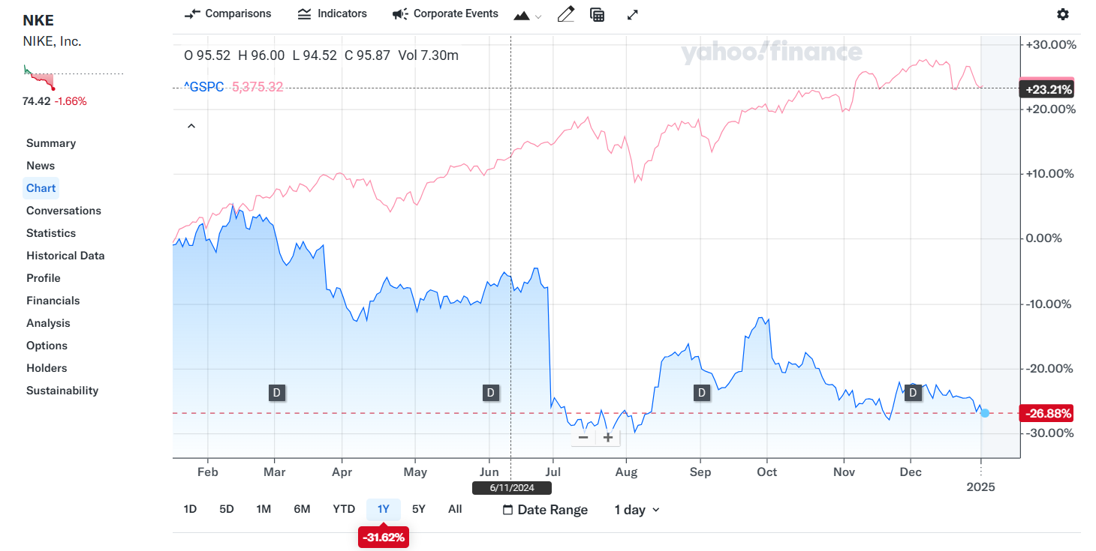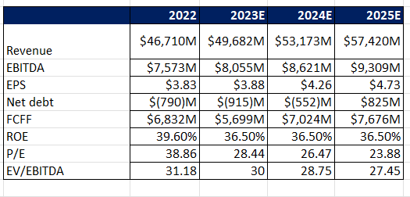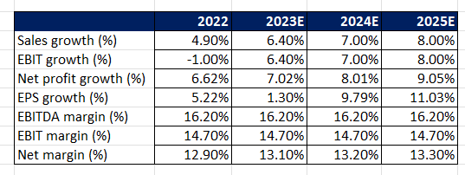

**Point 1: Comment on revenue growth expectation, key segment, and product performance (not required to talk about all, which is the main segment and the main product that can impact the revenue growth the most)**. Nike’s revenue is projected to grow from $44.5 billion in 2021 to $62.4 billion in 2026, with a stable annual growth rate of 7-8%. North America remains its largest market, contributing significantly to overall growth, with revenue expected to rise from $13.7 billion in 2015 to $25.9 billion by 2027. Footwear is the key revenue driver, growing from $8.5 billion in 2015 to $15.6 billion by 2027, fueled by innovation and strong demand for running shoes and lifestyle sneakers. Apparel, while smaller, also contributes steadily with projected growth from $4.4 billion in 2015 to $8.4 billion in 2027.

**Point 2: Margin of the group EBITDA, each segment’s contribution to earnings. The expectation of the margin growth. Key cost trends according to historical numbers (R&D).** Nike's EBITDA margin has steadily improved, rising from 27.4% in 2015 to a projected 28.5% in 2027, peaking at 30.4% in 2021. The equipment segment, contributing consistently at a 28.5% margin, grew from $3.8 billion to $7.4 billion. Depreciation and Amortization costs, stable at 0.9% of revenue, increased from $121 million to $175.6 million. These trends highlight Nike's strong financial management and efficient operations, ensuring sustainable profitability and growth.

**Point 3: EPS, FCFF, and Capex forecasts. Any future developments, company’s key drug pipeline/development.** Nike's financial performance has shown steady improvement, with EPS rising from $1.90 in 2015 to $3.83 in 2022, reflecting strong profitability and operational recovery. FCFF growth was volatile, rebounding significantly in 2019 (+33.2%) after a decline in 2018. Capex trends mirrored market conditions, with a sharp dip in 2020 (-38.6%) followed by a robust recovery in 2021 (+132.6%). These trends highlight Nike’s strategic focus on investment, efficiency, and sustained growth opportunities.

**Investment thesis:**

**Short 2-line summary of the stock’s expected performance, based on your model.** Nike Inc.’s stock is positioned for consistent growth, supported by rising EPS, strong FCFF recovery, and strategic investments in innovation. Potential risks include fluctuating Capex and external market pressures.

Company Name **NIKE INC**

Ticker: **NKE**

Current Share Price **$125.31**

Upside/Downside to current share price: ((Forecasted Price – Current Price)/Current Price) **+139.41%** (Forecasted Price: $300.00) ​​

4o