Instructions:
- After deriving the intrinsic share price based on our model, the next step is to focus on putting together a report with an investment recommendation.
- You are required to fill in the report template below using the sample report attached and your readings on the company’s guidance in terms of key segments and products.
  - Identify two to three key products that are vital for the company’s growth and you can discuss about the trends and expectations. But remember to keep them all short cause and effect sentences.
- You can take up to two days for this task and feel free to reach out to me if you have any questions.

Point 1
According to the analysis, revenues are expected to be increasing regularly in the short and long term. A rate of around 3% is logical. Based on long term inflation expectation, this should leave the company with a very small real growth rate. Non-traditional categories, such as the “Equipment” should be the main driver of growth, compared to apparel and footwear.
Point 2:
The margin levels of EBITDA are satisfactory at around 20%. They have remained almost constant over the last 5 years and are projected to continue doing so. The R&D is expected to increase in the future, which is also reflected on the company’s last earning report-announcement that they are plan major investments in research and development of new products.
Point 3: The EPS is projected to remain stable-healthy in the long term, although it does not take under consideration the CAPEX which are set to increase-partly due to the company’s commitment of investing in infrastructure and technological capabilities. Finally, the FCFF projection analysis, partly due to increased CAPEX, is set to remain in negative territory. As many of the company’s fundamentals are healthy, the negative FCFFs do not demonstrate any danger or raise concern about the company meeting its financial obligations.
Investment thesis:
According to the model and the general analysis conducted, the stock in expected to underperform in the very short-term and outperform in the long term.

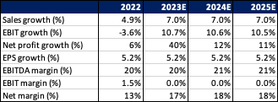
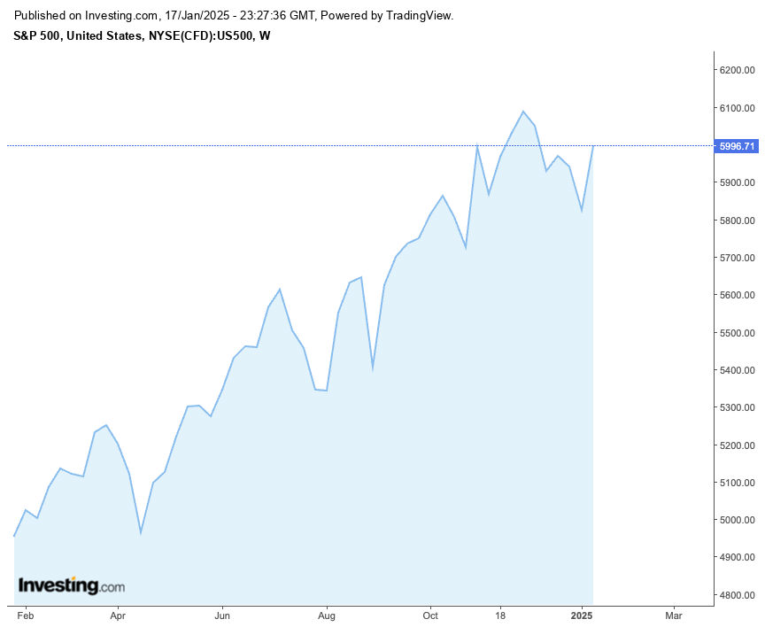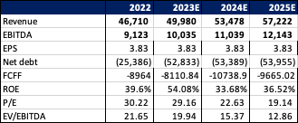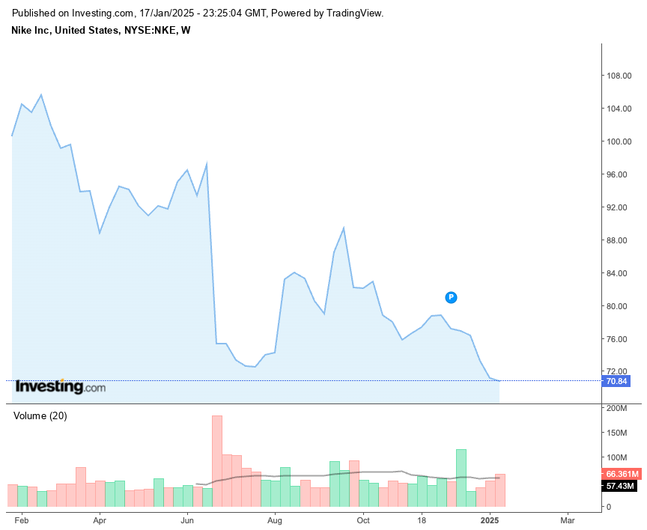
Company Name: Nike
Ticker: NKE
Current Share Price: $72.08
Upside/Downside to current share price: ((Forecasted Price – Current Price)/Current Price): - 3%

