Task 4 - Revenue and Cost Drivers
J&J
US revenue increased by 10.6% between ‘22 and ’23, being the main revenue growth driver, which has seen overall customer revenue increase by 6.5% during this period.
Largest products Sterlara 12.4 % and Darzalex 11.8% accounting for a combined 24% of revenue.
R&D expenditure return: Med tech R&D at 10.3% of sales and innovation R&D at 21.8% of sales. Overall, 6.7% increase year-on-year in R&D expenditure. Accounting for 17.7% of sales.
Litigation costs 8% of revenue, making it material.
Profitability from J&J’s R&D – 46% return $15 billion spent and income from Innovative and Medtech segment at a combined $22 billion.

An 8% increase in COS can be attributed to commodity inflation and restructuring costs associated with excessive inventory. This is supported by a slowdown in the growth in sales volume by 1.5 percentage points since 2022. However, inflation has been partially offset by both a minor price increase by 0.6% with sales volume increasing by 6.8% from 2022. This shows that J&J has somewhat been able to pass on costs to its customers.
Merck & Co Comparison
In contrast, Merck & Co’s R&D costs have adversely impacted its net margins and net income. With a 2.3 times increase in R&D expenditure accounting for 50% of its revenue, Merck has seen its net income fall by 97% and its net margin has been reduced by almost 24 percentage points. Merck only managed to deliver just over a 1% return of net income on its $30 billion expenditure on R&D. J&J increased its R&D expenditure with only a 6.7% rise in expenditure from 2022, suggesting a steadier increase was more appropriate and their use of this expenditure was far more judicious than Merck’s, with a far superior 46% return on R&D alone.

J&J has utilised further investment in its acquisition of PPE in 2023, more efficiently than Merck. This is supported by J&J’s superior asset turnover ratio of 4.29 in comparison to Merck’s at 2.7.

Marriott
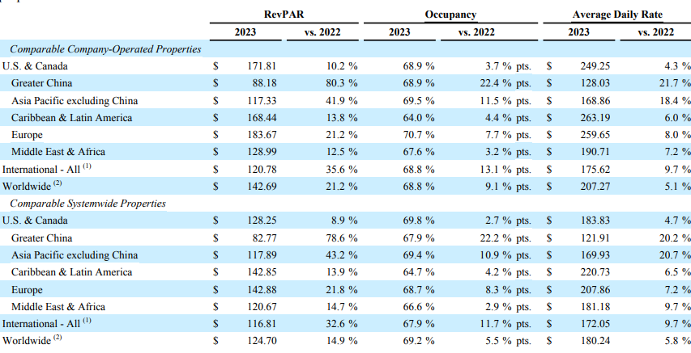
A growth in rate revenue per available room REVPAR has largely driven the 19% rise in base management fees.
A growth of nearly 500 more properties since 2022 and 75,000 (circa) more rooms.

Company operated properties (worldwide) – average daily rate risen by 5.1%, occupancy risen by 9 percentage points to 68%, REVPAR up by 21.2% at $143.
Systemwide properties (worldwide) – ADR up by 5.8%, occupancy risen by 5 percentage points to nearly 70% and REVPAR risen by 15%.
This in turn has led to a rise to fee revenues.
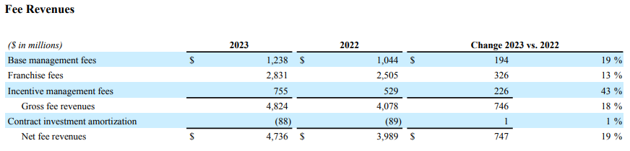
Higher management fees, notably a 43% rise in incentive management fees can be reflected by higher profits at their hotels.

Incentive management fees earned worldwide increased from 61% of their managed properties to 68%.
These changes can be reflected in the easing of covid restrictions globally as well as the recovery of the travel and hospitality industries, with tourists resuming their pre-covid travel habits. This is supported by almost a 50% surge in year over year revenue growth in 2022, which slowed down to 14.15% in 2023. In 2023 Marriott surpassed its pre-pandemic revenue by 15% and despite inflation challenges, this partially demonstrates the ability of Marriott to pass on rising costs to its customers, suggesting Marriott appropriately estimated the spending power of customers. This can be reflected in rising ADR.

Hilton Comparison
Both Hilton and Marriott have similar year-over-year revenue growth rates with no more than 3 percentage points margins for their respective revenues between 2021 and 2023. Both recovered rapidly as covid and travel restrictions began to ease. Whilst growth slowed when customers’ travel habits began to normalise, both Hilton and Marriott surpassed annual pre-pandemic revenues at the end of 2023. This indicates they are close competitors who made a full and similar recovery to each other. Comparing their net income figures is appropriate and proportionate. Marriott’s revenue is 2.3 times higher than Hilton’s with and Marriott’s net income is 2.7 times higher than Hilton’s. Marriott’s margin is just under 2 percentage points higher. Therefore, whilst on a different scale, their performances, pound-for-pound are very similar.

