# Task 3

**1. Peer Analysis for Marriott International**

This document provides a peer analysis for Marriott International, identifying key competitors within the hospitality industry. The analysis focuses on Airbnb, Inc., Royal Caribbean Cruises Ltd., Hilton Worldwide Holdings Inc., Trip.com Group Limited, and Amadeus IT Group, detailing comparative insights and highlighting stock price return trends.

**Airbnb, Inc.**

* Alternative Accommodations Leader: Airbnb disrupts traditional hotel chains by providing unique short-term rentals, competing with Marriott's hotel offerings.
* Global Reach with Technology: Airbnb leverages technology to connect travelers with hosts globally, offering a broad range of accommodations, similar to Marriott's global presence.
* Millennial and Gen Z Appeal: Airbnb attracts a younger demographic interested in unique stays, presenting a distinct challenge to traditional hotel brands.

**Royal Caribbean Cruises Ltd.**

* Luxury and Leisure Market: Royal Caribbean competes with Marriott in the luxury travel and leisure sector, targeting similar customer demographics for vacations and experiences.
* Brand Strength in Tourism: With a strong brand presence in the cruise industry, Royal Caribbean appeals to travelers seeking premium experiences, aligning with Marriott’s upscale offerings.
* Recovery Post-Pandemic: Both companies are recovering from the pandemic's impact on travel, competing for customers resuming leisure travel.

**Hilton Worldwide Holdings Inc.**

* Direct Competitor in Hotels: Hilton operates a vast portfolio of hotels globally, competing directly with Marriott for market share in the hotel industry.
* Loyalty Programs: Hilton’s Honors program competes with Marriott Bonvoy, attracting repeat customers through rewards and exclusive benefits.
* Asset-Light Expansion: Both Marriott and Hilton use an asset-light model to expand globally, relying on franchising and management contracts.

**Trip.com Group Limited**

* Travel Booking Services: Trip.com offers booking services for hotels, flights, and more, competing indirectly with Marriott by providing hospitality options and travel services.
* Strong Presence in Asia: As a leading travel service provider in Asia, Trip.com is a significant competitor for Marriott in attracting international travelers.
* Diversification of Offerings: Trip.com’s range of travel-related services positions it to cater to a wide array of traveler needs, creating competition for hospitality brands.

**Amadeus IT Group, S.A.**

* Technology Solutions for Hospitality: Amadeus provides tech solutions to hospitality companies, competing in the technology space essential to Marriott’s operations.
* Global Presence in Travel IT: With solutions for airlines, hotels, and travel agencies, Amadeus plays a significant role in the travel ecosystem, affecting customer booking experiences.
* Focus on Efficiency and Customer Experience: Amadeus’s solutions improve operational efficiency and customer experience, aligning with Marriott’s goals to enhance guest satisfaction.

**Price Return Comparison (2020-2024)**

The chart below shows the price return of Marriott and its identified peers from 2020 to 2024. Marriott and Hilton have shown considerable growth, while Airbnb has also gained traction as a prominent alternative accommodation provider.

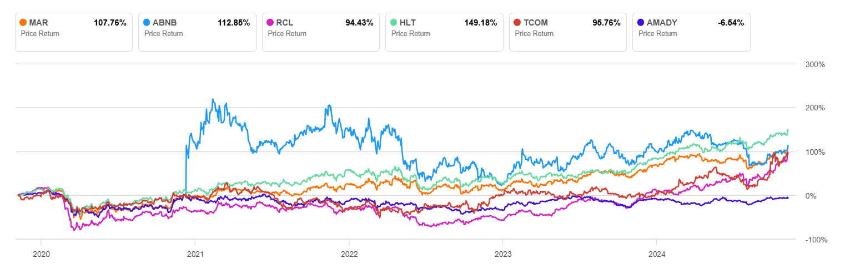

Figure 1: Price return comparison for Marriott and its peers (2020-2024).

Source: [Seeking Alpha](https://seekingalpha.com/symbol/TSLA/peers/comparison?interval=5Y)

**Key Insights**

- Marriott’s Market Leadership: Marriott’s strong price return reflects its robust position in the hotel and resort industry and recovery post-pandemic.

- Airbnb’s Disruptive Impact: Airbnb’s success in the alternative accommodation sector highlights changing consumer preferences, creating competition for traditional hotel brands.

- Diversification of Travel Services: Companies like Trip.com and Amadeus IT Group showcase the broadening scope of the travel industry, indicating Marriott’s need to innovate in service and technology.

- Luxury and Experience Market: Royal Caribbean and Hilton appeal to consumers seeking premium experiences, competing for high-spending travelers that Marriott also targets

# 2. Peer Analysis for Tesla Inc.

This document provides a peer analysis for Tesla Inc., identifying key competitors within the automobile manufacturing industry. The analysis focuses on Toyota Motor Corporation, BYD Company Limited, Ferrari N.V., Porsche AG, and General Motors, detailing comparative insights and highlighting stock price return trends.

## Toyota Motor Corporation

* Market Leader: Toyota is one of the largest automobile manufacturers globally, providing stiff competition to Tesla with its expansive production capabilities.
* Hybrid and Electric Vehicles: Toyota's focus on hybrid technology and its recent initiatives in the EV space positions it as a key competitor in sustainable transportation.
* Global Presence: Toyota has a broad global presence, helping it reach diverse markets that Tesla is also targeting.

## BYD Company Limited

* Leading Chinese EV Manufacturer: BYD is a prominent player in China's electric vehicle market, competing directly with Tesla in this high-growth region.
* Battery Technology: BYD also manufactures batteries, providing it with a cost advantage and control over a key component of EVs.
* Expanding Internationally: BYD's expansion into international markets increases competitive pressure on Tesla.

## Ferrari N.V.

* Luxury Performance Vehicles: Ferrari targets the high-performance luxury car segment, sharing a niche with Tesla's high-end Model S Plaid.
* Strong Brand Loyalty: Ferrari has a loyal customer base and a strong brand reputation, making it a formidable player in the luxury car market.
* Gradual Shift to Electric: Ferrari’s future plans include entering the EV market, potentially appealing to performance-oriented EV customers.

## Porsche AG

* High-Performance EVs: Porsche has successfully entered the EV market with models like the Taycan, which directly compete with Tesla's high-end EVs.
* Brand Prestige: Porsche's strong brand presence in luxury sports cars attracts customers similar to Tesla’s Model S and Model X markets.
* Focus on Sustainability: Porsche is actively investing in sustainable practices and technologies, aligning with Tesla’s environmental appeal.

## General Motors

* Expanding EV Lineup: GM is aggressively expanding its EV offerings, with plans to transition most of its lineup to electric by 2035.
* Investment in Autonomous Driving: GM’s Cruise division focuses on autonomous driving, which directly competes with Tesla’s autopilot technology.
* Large Market Share in North America: GM’s established presence in the U.S. market places it as a significant competitor in Tesla's home market.

**Price Return Comparison (2020-2024)**

The chart below shows the price return of Tesla and its identified peers from 2020 to 2024. Tesla has shown exceptional growth, significantly outperforming its peers. However, companies like BYD have also shown strong price returns due to the growing demand for electric vehicles.

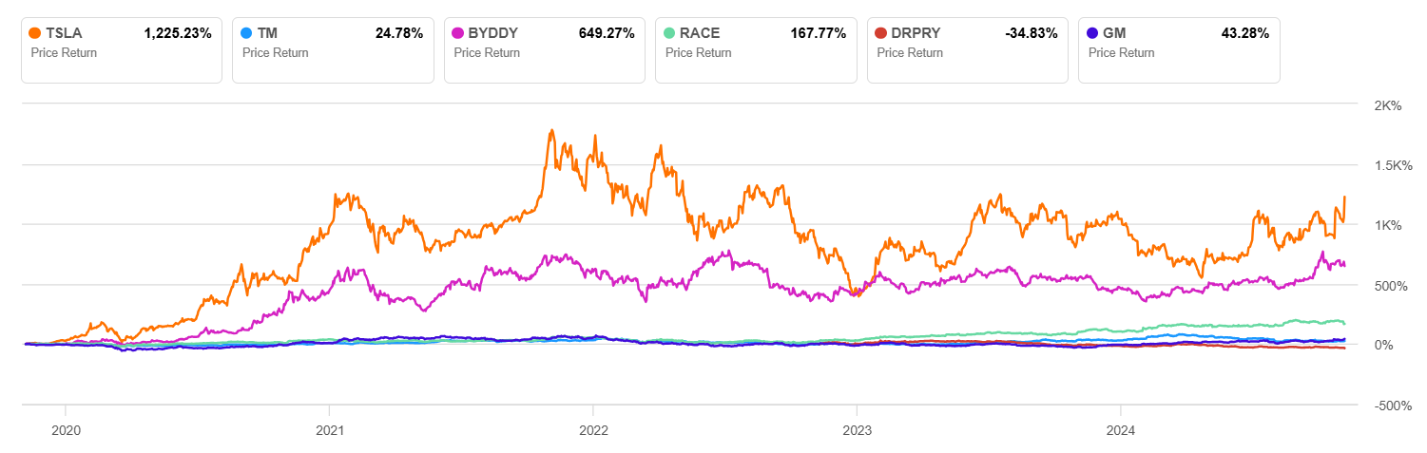

Figure 1: Price return comparison for Tesla and its peers (2020-2024).

Source: [Seeking Alpha](https://seekingalpha.com/symbol/TSLA/peers/comparison?interval=5Y)

## Key Insights

* Tesla's Market Leadership: Tesla’s significant lead in price return reflects its market dominance and first-mover advantage in the electric vehicle industry.
* BYD’s Competitive Position: BYD’s substantial price return demonstrates its strong presence in China’s EV market, positioning it as a key competitor to Tesla in Asia.
* Traditional Auto Giants’ Transition: Companies like Toyota and GM are actively expanding their EV offerings, indicating the broader industry's shift toward electric vehicles.
* Luxury and Performance Market: Ferrari and Porsche compete with Tesla in the high-performance, luxury EV segment, targeting affluent consumers with unique brand appeals.

# 3. Peer Analysis for Netflix Inc.

This document provides a peer analysis for Netflix Inc., identifying key competitors within the streaming and entertainment industry. The analysis focuses on The Walt Disney Company, Spotify Technology S.A., Live Nation Entertainment, Inc., TKO Group Holdings, Inc., and Warner Bros. Discovery, Inc., detailing comparative insights and highlighting stock price return trends.

## The Walt Disney Company

* Extensive Content Library: Disney owns a vast catalog of popular franchises and content assets, competing directly with Netflix’s content offerings.
* Streaming Services: Disney+ and Hulu are strong competitors in the streaming space, aiming for a similar audience and subscription model as Netflix.
* Global Reach: Disney has a strong international presence and established brand recognition, challenging Netflix’s global market share.

## Spotify Technology S.A.

* Subscription-Based Model: Spotify’s focus on subscription-based streaming aligns with Netflix’s business model, though Spotify specializes in audio content.
* Digital Content Leader: As a leader in digital music streaming, Spotify competes for consumer attention and monthly subscription revenue, similar to Netflix’s strategy.
* Focus on Content Curation: Spotify's curated playlists and personalized recommendations create engagement similar to Netflix's personalized content suggestions.

## Live Nation Entertainment, Inc.

* Focus on Entertainment Experiences: Live Nation’s emphasis on live events and entertainment experiences makes it a competitor for leisure time and entertainment budgets.
* Digital Engagement: Live Nation leverages digital platforms to engage audiences, appealing to the same demographics that Netflix targets for entertainment.
* Expansion into Digital: Live Nation’s initiatives in streaming concerts and events create overlap with Netflix’s digital entertainment focus.

## TKO Group Holdings, Inc.

* Unique Sports and Entertainment Offering: TKO specializes in sports entertainment (e.g., WWE and UFC), providing a different but overlapping form of content with Netflix.
* Strong Brand in Live Content: TKO’s strength in live events and sports draws audiences who may also consume Netflix's streaming content.
* Appeal to a Global Audience: TKO’s brand appeals to a worldwide audience, similar to Netflix’s international strategy.

## Warner Bros. Discovery, Inc.

* Comprehensive Content Portfolio: Warner Bros. Discovery has a diverse content library, including popular franchises and original productions, directly competing with Netflix.
* Streaming Services: HBO Max (now Max) positions Warner Bros. Discovery as a strong competitor in the streaming industry.
* Focus on High-Quality Content: Warner Bros. emphasizes high-quality, cinematic content, appealing to Netflix's target audience.

**Price Return Comparison (2020-2024)**

The chart below shows the price return of Netflix and its identified peers from 2020 to 2024. Netflix’s high price return reflects its strong position in the streaming industry, while competitors like Spotify and Live Nation have also shown substantial growth.

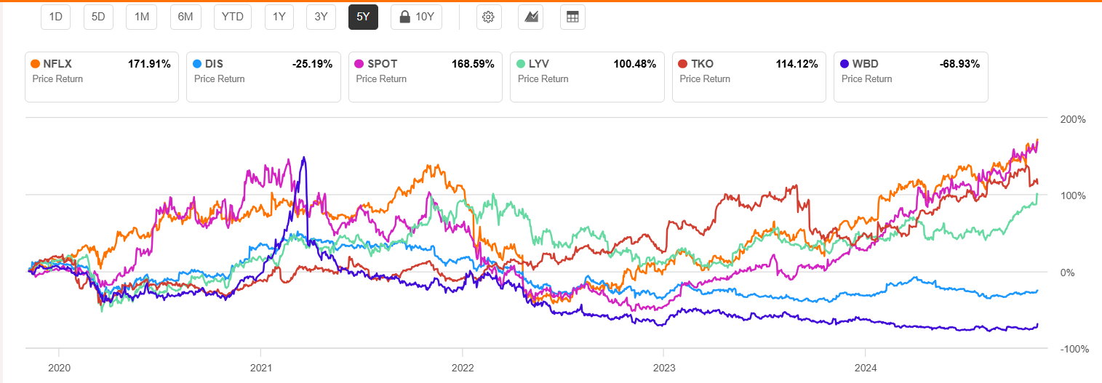

Figure 1: Price return comparison for Netflix and its peers (2020-2024).

Source: [Seeking Alpha](https://seekingalpha.com/symbol/TSLA/peers/comparison?interval=5Y)

## Key Insights

* Netflix’s Market Leadership: Netflix’s high price return underscores its strong position and continued expansion in the global streaming industry.
* Disney’s Competitive Edge: Disney’s extensive content library and multiple streaming services position it as a formidable competitor in the streaming market.
* Diversified Entertainment Landscape: The presence of companies like Live Nation and TKO in entertainment highlights the growing competition for consumer engagement.
* Streaming as a Dominant Force: Warner Bros. Discovery and Spotify show the diversification within streaming, with each platform capturing different types of content consumption.

# 4. Peer Analysis for Nvidia Corporation

This document provides a peer analysis for Nvidia Corporation, identifying key competitors within the semiconductor industry. The analysis focuses on Taiwan Semiconductor Manufacturing Company Limited (TSMC), Broadcom Inc., Advanced Micro Devices, Inc. (AMD), QUALCOMM Incorporated, and Texas Instruments Incorporated, detailing comparative insights and highlighting stock price return trends.

## Taiwan Semiconductor Manufacturing Company Limited (TSMC)

* Key Chip Supplier: TSMC is a major semiconductor manufacturing company and a critical supplier to Nvidia, producing Nvidia's advanced chips.
* Advanced Manufacturing Capabilities: TSMC’s capabilities in advanced node manufacturing (e.g., 5nm, 3nm) allow it to produce cutting-edge chips used by Nvidia.
* Strategic Dependence: Nvidia relies heavily on TSMC’s manufacturing, making TSMC a vital partner and indirect competitor in the semiconductor value chain.

## Broadcom Inc.

* Diverse Semiconductor Solutions: Broadcom provides semiconductor and infrastructure solutions that compete with Nvidia’s offerings in data centers and networking.
* Focus on Data Centers and Connectivity: Broadcom’s strength in networking and connectivity solutions aligns with Nvidia’s interest in high-performance computing and AI.
* Large Market Cap and Influence: Broadcom’s size and diversified portfolio make it a significant competitor in the semiconductor space.

## Advanced Micro Devices, Inc. (AMD)

* Direct Competitor in GPUs: AMD directly competes with Nvidia in the GPU market, challenging Nvidia’s dominance in gaming and data center graphics.
* Expansion into AI and HPC: AMD is making strides in high-performance computing and AI, posing a challenge to Nvidia in these growing sectors.
* Strong Growth Trajectory: AMD’s growth and product innovations make it a formidable competitor for Nvidia across various computing segments.

## QUALCOMM Incorporated

* Leader in Mobile and Edge Computing: Qualcomm’s expertise in mobile and edge computing allows it to compete with Nvidia in AI and embedded systems.
* AI and 5G Focus: Qualcomm’s investments in AI, IoT, and 5G align with Nvidia’s strategy to expand into connected devices and smart technologies.
* Broad IP Portfolio: Qualcomm’s extensive patent portfolio in wireless and processing technologies provides a competitive edge in semiconductor solutions.

## Texas Instruments Incorporated (TXN)

* Strength in Analog and Embedded Processors: Texas Instruments leads in analog semiconductors and embedded processors, complementing Nvidia’s digital focus.
* Diversified Applications: TI’s products are used in industrial, automotive, and personal electronics, overlapping with Nvidia’s ambitions in autonomous vehicles.
* Focus on Efficient Manufacturing: Texas Instruments’ cost-effective manufacturing strategy provides it with a competitive advantage in semiconductor production.

**Price Return Comparison (2020-2024)**

The chart below shows the price return of Nvidia and its identified peers from 2020 to 2024. Nvidia’s significant price return reflects its leadership in GPUs and its pioneering work in AI technologies, which have driven strong investor confidence and growth.

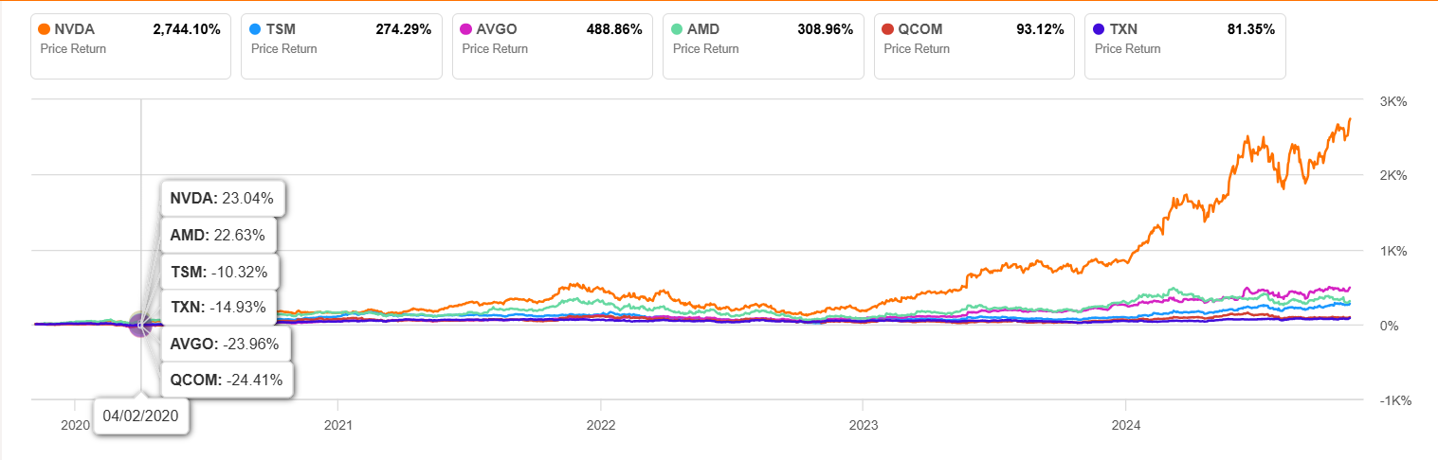

Figure 1: Price return comparison for Nvidia and its peers (2020-2024).

Source: [Seeking Alpha](https://seekingalpha.com/symbol/TSLA/peers/comparison?interval=5Y)

## Key Insights

* Nvidia’s Market Leadership: Nvidia’s exceptional price return reflects its strong position in GPUs and AI, making it a top player in the semiconductor industry.
* TSMC’s Critical Role: As a major chip manufacturer, TSMC is integral to Nvidia’s supply chain, demonstrating the interdependence in the semiconductor industry.
* Diverse Applications of Semiconductors: Competitors like Broadcom, AMD, and Qualcomm highlight the diverse applications of semiconductors across data centers, AI, and connected devices.
* Growth in AI and HPC: Nvidia and AMD are at the forefront of high-performance computing (HPC) and AI, shaping the future of data centers and advanced computing.

# 5. Peer Analysis for Pfizer Inc. (PFE)

## Introduction

This document provides a peer analysis for Pfizer Inc., identifying key competitors within the pharmaceutical industry. The analysis focuses on Sanofi (SNY), Bristol-Myers Squibb (BMY), and AstraZeneca (AZN), providing comparative insights and   
highlighting stock price return trends. Pfizer, a leading player in health care and pharmaceuticals, operates in a competitive landscape where other pharmaceutical giants impact and drive innovation in similar fields, including vaccines, oncology, and   
therapeutics.

### Sanofi (SNY)

* Global Pharmaceutical Leader - Sanofi is a major player in the pharmaceutical industry, competing with Pfizer in multiple therapeutic areas, including vaccines and specialty care.
* Similar Market Cap and Revenue Streams - With a comparable market capitalization, Sanofi’s size and global reach mirror Pfizer’s scale in the pharmaceutical industry.
* Diverse Product Portfolio - Sanofi has a well-diversified portfolio across multiple therapeutic areas, enhancing its competitiveness in the same segments Pfizer operates in.
* Shared Focus on R&D in Vaccines - Sanofi and Pfizer both focus on vaccine development, leading in global vaccine distribution and R&D investments.

### Bristol-Myers Squibb (BMY)

* Strong Oncology Pipeline - Bristol-Myers has a strong presence in oncology, a key area for Pfizer’s business, making it a direct competitor in this high-growth segment.
* Immunology and Cardiovascular Innovations -Bristol-Myers Squibb's advancements in immunology and cardiovascular treatments add to its competitive edge in markets where Pfizer is active.
* R&D Investment in Biologics - With significant R&D investments in biologics, Bristol-Myers competes closely with Pfizer in biotechnology and innovative therapeutics.
* Global Reach and Similar Analyst Coverage - Bristol-Myers has similar analyst coverage, indicating comparable investor interest and expectations in the market.

### AstraZeneca (AZN)

* Leading in Respiratory and Oncology Treatments - AstraZeneca is a strong competitor in respiratory and oncology drugs, areas where Pfizer is also focused.
* High Return Performance - AstraZeneca’s impressive return performance demonstrates its resilience and growth in critical therapeutic areas.
* Vaccine Development and Biologics - With a strong focus on vaccine development, especially during the COVID-19 pandemic, AstraZeneca directly competes with Pfizer in vaccine innovation.
* Similar Market Cap - AstraZeneca’s market cap places it in the same tier as Pfizer, indicating comparable operational scale and market valuation.

## Price Return Comparison (2020-2024)

The chart below shows the price return of Pfizer and its identified peers from 2020 to 2024. Pfizer has seen variable returns   
as the pharmaceutical industry faced challenges like patent expirations, generic competition, and market saturation in key drug segments.  
  
Figure 1: Price return comparison for Pfizer and its peers (2020-2024).

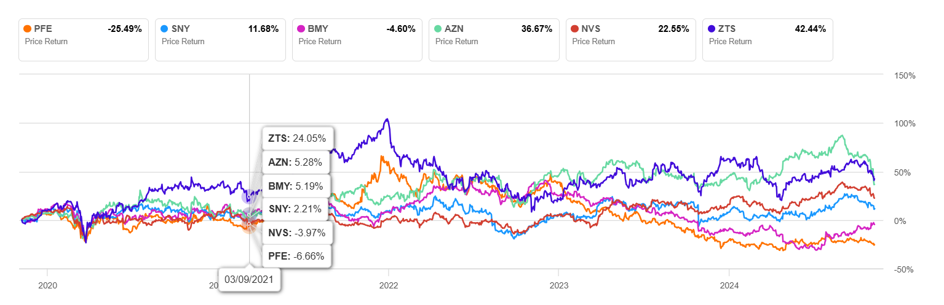

Figure 1: Price return comparison for Pfizer and its peers (2020-2024).

Source: [Seeking Alpha](https://seekingalpha.com/symbol/TSLA/peers/comparison?interval=5Y)

## Key Insights

* Competitive Landscape in Pharmaceuticals - Pfizer’s returns highlight its standing in a highly competitive market, where peers like AstraZeneca and Bristol-Myers offer strong competition in oncology and vaccines.
* Growth in Vaccines and Biologics - Pfizer, Sanofi, and AstraZeneca are heavily invested in vaccine and biologics development, showcasing their leadership in preventive health.
* R&D Focus and Innovation - R&D investment by these companies is key to future growth, with Pfizer and its peers advancing in high-demand fields such as oncology, immunology, and respiratory health.
* Impact of Market Capitalization - Similar market caps among Pfizer, Sanofi, and AstraZeneca illustrate their comparable influence and ability to drive industry trends.