# 

# **Visa Inc. Overview**

Visa Inc. was founded in 1958 and has its headquarters in San Francisco, California. The company provides its services to merchants, financial institutions, and government entities. Visa Inc. operates as a **payment technology company** and its core business for is listed below:

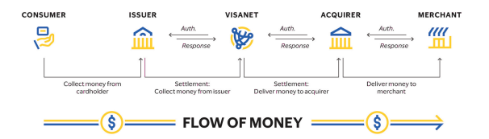

[Source: Visa 2023 Annual Report](https://annualreport.visa.com/financials/default.aspx)

Visa earns its revenue by facilitating money movement across more than 200 countries and territories among an international pool of customer which includes merchants, financial institution, and government entities through their progressive technologies.

# **Visa Inc. Two closest Peer**

The two closest peers for Visa Inc. have been considered according to the Market Capitalisation of the companies:

|  |  |  |  |
| --- | --- | --- | --- |
| **Company Name** | **Visa Inc.** | **Mastercard Inc** | **Fiserv Inc** |
| **Sector** | Financials | Financials | Financials |
| **Industry** | Transaction & Payment Processing Services | Transaction & Payment Processing Services | Transaction & Payment Processing Services |
| **Market Capitalisation** | 588.10B | 485.52B | 121.78B |
| **Enterprise Value** | 594.79B | 492.52B | 146.60B |
|  |  |  |  |

# **Visa Inc. Substitutes and New Market**

## **Substitutes**

Visa operates in the dynamic payments industry and faces substitutes from emerging technologies and alternative payment solutions. These substitutes include:

1. **Peer-to-Peer (P2P) Payment Systems:** Companies like PayPal, Venmo, Zelle, etc. use these systems which enable direct money transfers without intermediaries, often at lower transaction costs.
2. **Real-Time Payment (RTP) Networks:** FedNow in the U.S., PIX in Brazil, UPI in India use RTP networks which offer instantaneous domestic payments and are gaining traction globally.
3. **Cryptocurrencies and Blockchain Technology:** Digital currencies like Bitcoin, Ethereum, and stablecoins provide decentralized and borderless payment alternatives. Blockchain technology also supports cross-border remittances, challenging Visa’s traditional revenue streams.
4. **Buy Now, Pay Later (BNPL):** Providers such as Affirm, Klarna, and Afterpay are reshaping consumer financing by allowing instalment-based purchases without credit cards.
5. **Digital Wallets:** Notable companies include Apple Pay, Google Wallet, and Samsung Pay. These companies’ wallets integrate non-card payment options and are increasingly popular for both online and in-person transactions.

## **New Markets**

Visa is actively exploring and penetrating new markets to drive growth and innovation:

1. **Underbanked and Emerging Economies:** Visa focuses on financial inclusion by introducing prepaid and debit cards in regions with limited banking infrastructure, such as parts of Africa, Latin America, and Southeast Asia.
2. **Real-Time Payments:** Expansion into real-time payment systems through partnerships and the development of Visa Direct, which processed over 7.5 billion transactions in FY2023​.
3. Blockchain and Cryptocurrency Integration: Initiatives such as Visa B2B Connect aim to facilitate blockchain-based cross-border transactions while reducing friction and enhancing security.
4. **Value-Added Services**: Visa is developing data-driven services, fraud prevention tools, and consulting services, diversifying its revenue streams, and strengthening its client relationships.
5. **Business-to-Business (B2B) Payments**: Visa's investments in solutions like Visa Commercial Solutions and Visa B2B Connect aim to digitize accounts payable and receivable processes globally.

# **Visa Inc. Revenue and Cost Drivers**

Below is the revenue structure as of three months ended and nine months ended 30 June (i.e Quarter 3 results) for Visa Inc. This along with quarters 1 and 2 and the Annual Report for 2023 would act as our basis for revenue driver.

|  |  |
| --- | --- |
| **Revenue Drivers** | **Description** |
| Transaction Fees (Volume) | Revenue generated from the total number of transactions processed across Visa's payment network. |
| Cross-Border Fees | Higher fees associated with international transactions due to additional complexity and risk. |
| Value-Added Services | Income from fraud prevention, data analytics, consulting, and advisory services. |
| Licensing Fees | Revenue from financial institutions for using Visa's brand and technology. |
| Partnership Revenues | Generated through strategic partnerships with fintech and digital wallet providers. |
| Card Issuance Growth | Increased issuance of debit, credit, and prepaid cards driving consumer and commercial usage. |

**Performance Analysis of Revenue Drivers**

* Transaction Fees: Transaction volumes reached 276 billion in FY2023, driving a significant portion of Visa's $32.65 billion revenue.
* Cross-Border Transactions: This segment grew by over 15% in FY2023 due to recovering international travel post-pandemic.
* Value-Added Services: Represent a smaller but fast-growing segment, bolstered by consulting engagements that generated over $3 billion for clients in FY2023.

**Cost Drivers**

The table below details Visa Inc.'s primary cost components and their variability:

|  |  |
| --- | --- |
| **Cost Drivers** | **Description** |
| Network Maintenance (Fixed) | Regular costs to operate and secure Visa's global payment infrastructure. |
| Client Incentives (Variable) | Payments to financial institutions, vary by transaction volume and strategic agreements. |
| Marketing and Branding | High fixed and variable costs for global campaigns to maintain Visa’s brand visibility. |
| Regulatory Compliance | Costs associated with data privacy, fraud prevention, and adherence to global regulations. |
| Technology Investments | Expenses for upgrading platforms, including investments in blockchain and real-time payments. |
| Personnel Costs | Salaries and benefits for employees, with fixed costs for corporate staff and variable incentives. |

**Performance Analysis of Cost Drivers**

* Client Incentives: Increased to align with higher transaction volumes and competitive pressures, representing a significant variable cost.
* Regulatory Compliance: Visa maintained high investment in cybersecurity and fraud prevention, ensuring operational integrity.

# **Visa Inc. current industry and market trends in relation Revenue and Cost Drivers**

## **For Revenue:**

|  |  |  |
| --- | --- | --- |
| **Revenue Drivers** | **Trend** | **Impact** |
| **Growth in Digital Payment** | Increasing adoption of cashless transactions, fuelled by e-commerce, contactless payments, and mobile wallets. | Higher transaction volumes, especially in emerging markets, are driving revenue from transaction and cross-border fees. |
| **Expansion of Cross -Border Payments** | Recovery in international travel post-pandemic has significantly increased cross-border payment volumes. | Cross-border fees, which carry higher margins, are a growing revenue source for Visa. |
| **Growth in Real-Time Payments (RTP)** | Rising demand for instant payment solutions, such as Visa Direct. | Visa processed over 7.5 billion RTP transactions in FY2023, representing an expanding revenue segment |
| **Partnership with Fintechs** | Collaboration with digital wallets, neobanks, and startups to expand the payment ecosystem. | Generates licensing and partnership revenues while enhancing network volumes. |
| **Increasing Tokenisation** | Enhanced security measures like network tokenization, reducing fraud and ensuring customer trust. | Drives growth in digital commerce by providing secure transaction environments. |
|  |  |  |

## **For Cost:**

|  |  |  |
| --- | --- | --- |
| **Cost Drivers** | **Trends** | **Impact** |
| **Rising Compliance and Regulatory Costs** | Stricter global regulations on data privacy (e.g., GDPR) and cross-border transactions. | Increased investments in compliance systems and legal costs, impacting operational expenses. |
| **Higher Technology Investments** | Growing demand for blockchain, AI, and cybersecurity to maintain network security and scalability. | Significant capital expenditures for platform upgrades and fraud prevention systems. |
| **Marketing and Branding** | Sustained investment in global marketing campaigns to maintain brand leadership. | Fixed marketing costs are rising due to competitive pressures and the need for consistent consumer engagement. |
| **Client Incentives as a Variable Cost** | Increasing competition in the payments ecosystem leading to higher client incentives. | Incentives vary with transaction volumes and strategic partnerships, directly affecting profit margins. |
| **Cost Efficiency through Automation** | Adoption of AI and machine learning for fraud detection and operational optimization. | Mitigates rising costs in other areas by improving efficiency and reducing fraud-related losses. |
|  |  |  |

# **Visa Inc. S.W.O.T Analysis**

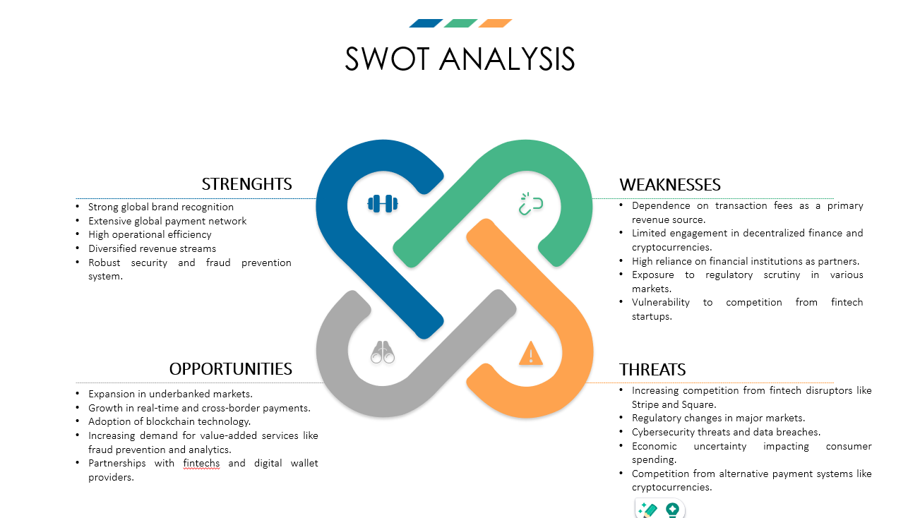

# **Visa Inc. PESTEL Analysis**

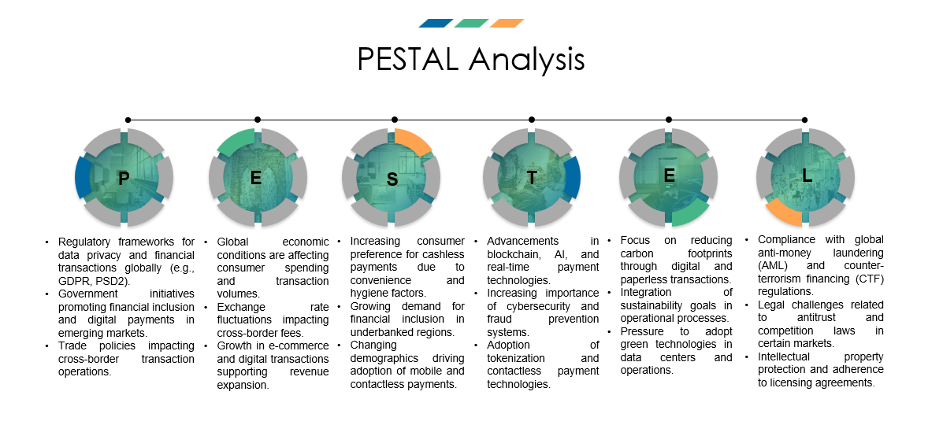

# **Visa Inc. analysis of the competitive environment**

**Competitive Landscape**

Visa Inc. operates in the highly competitive payments and fintech industry. Its major competitors include:

* **Mastercard Inc.**: A global payment network and Visa's closest competitor.
* **Fiserv Inc.**: A leading provider of financial technology and payment solutions.
* **American Express Co.**: Focused on premium customer segments.
* **PayPal Holdings, Inc.**: A leader in digital wallet and online payments.
* **Emerging Fintechs**: Disruptors like Stripe and Square offering innovative payment solutions.

**Key Competitors and their strategies**

|  |  |  |
| --- | --- | --- |
| **Company** | **Performance Metrics** | **Key Strategies** |
| **Visa Inc.** | FY2023 Revenue: $32.65 billion | - Focus on real-time payments (Visa Direct). |
|  | Transactions: 276 billion | - Strategic partnerships with fintech’s and neobanks. |
|  | Market Share: Leading globally | - Expansion into underbanked regions. |
| **Mastercard Inc.** | FY2023 Revenue: $24 billion | - Investment in cross-border and real-time payment systems. |
|  | Transactions: 120 billion | - Focus on open banking and AI-driven solutions. |
|  | Market Share: Second globally |  |
| **Fiserv Inc.** | FY2023 Revenue: $19.3 billion | - Leader in merchant acquiring services. |
|  | Market Share: Significant presence in North America and Europe | - Focus on integrated payment systems and digital transformation. |
|  | Key Offerings: Clover POS systems | - Partnerships with banks and retailers to expand its footprint. |
| **American Express** | FY2023 Revenue: $15 billion | - Targeting high-net-worth individuals through premium services. |
|  | Transactions: 40 billion | - Loyalty programs and co-branded partnerships. |
| **PayPal Holdings** | FY2023 Revenue: $27 billion | - Leader in digital wallets and P2P payment systems. |
|  | Market Share: Dominant in e-commerce | - Expansion into BNPL (Buy Now, Pay Later) and crypto payments. |

**Performance Insights**

* Visa Inc. continues to lead the industry in transaction volumes, processing 276 billion transactions in FY2023.
* Mastercard competes closely, emphasizing innovation in real-time and cross-border payments.
* Fiserv Inc. focuses on integrated payment solutions, particularly through its Clover POS systems, targeting merchants and retailers.
* American Express thrives in the premium segment but lacks Visa’s geographic and demographic reach.
* PayPal leads in digital wallet solutions and peer-to-peer payments, presenting a unique competitive challenge.

**Conclusion**

Visa Inc. remains a leader in the global payments industry due to its extensive network, continuous innovation, and strategic partnerships. However, competitors like Fiserv Inc., with their focus on merchant services and integrated payment solutions, and Mastercard, with strong cross-border payment capabilities, continue to challenge Visa's dominance. Visa’s focus on real-time payments, emerging markets, and fintech collaborations ensures it stays ahead in this dynamic and evolving industry.