|  |  |  |  |  |  |  |  |  |  |
| --- | --- | --- | --- | --- | --- | --- | --- | --- | --- |
|  | **Apple Inc.**  **Financial Performance Analysis Report**  **Fiscal Years 2020 - 2022** |  |  |  |  |  |  |  |  |

**Apple Inc. is an American multinational corporation and technology company headquartered and incorporated in Cupertino, California, in Silicon Valley. It is best known for its consumer electronics, software, and services. Founded in 1976 as Apple Computer Company by Steve Jobs, Steve Wozniak and Ronald Wayne, the company was incorporated by Jobs and Wozniak as Apple Computer, Inc. the following year. Apple is the largest technology company by revenue, with US$383.29 billion in 2023.**

**OWNERSHIP**

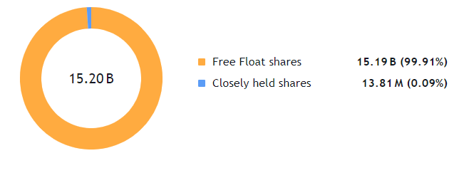

**Apple Inc. VS Nasdaq 100 Index**

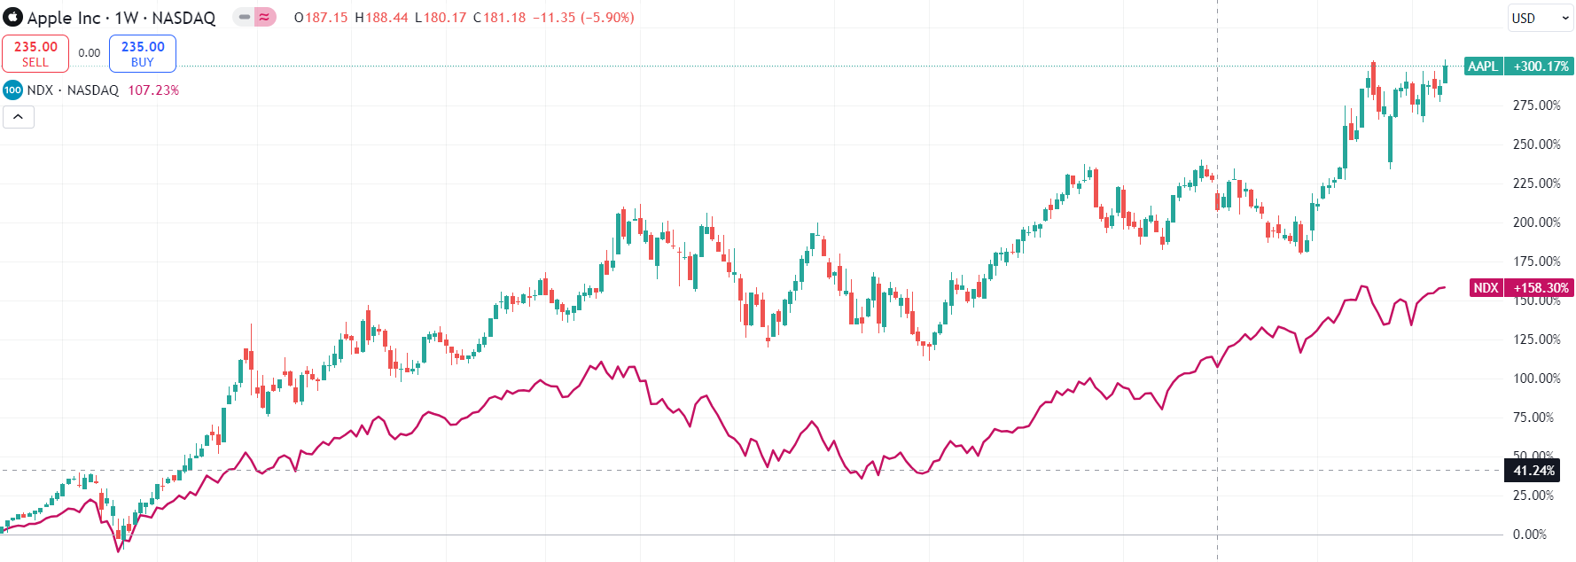

**Fig 1. Outperformance of Apple Inc. as compared to Nasdaq 100 Index**

|  |  |  |  |  |  |  |  |  |  |
| --- | --- | --- | --- | --- | --- | --- | --- | --- | --- |
|  | **Executive Summary** |  |  |  |  |  |  |  |  |

**This analysis examines Apple Inc.'s financial performance from 2020 to 2022, revealing strong revenue growth, improved profitability, and some emerging challenges in working capital management. The company has maintained its market leadership while expanding its services segment and managing operational efficiency.**

**Years ended September, 2022 : Revenue reported $394.3 billion , up 8% from $366 billion in 2021.**

**Years ended September, 2021 : Revenue reported $365.8 billion, up 33% from $274 billion in 2020.**

**Revenue Composition:**

* **Products: Represents 80% of revenue 2020: $220 billion 2021: $297 billion 2022: $316.2 billion**
* **Services:** **Shows consistent growth 2020: $54 billion 2021: $68 billion 2022: $78 billion**

**Key Observations:**

* **Revenue growth rate slowed in 2022**
* **Services segment maintained steady growth**
* **Product revenue shows maturity signs**

**PROFITABILITY ANALYSIS:**

* **Gross Margin: Improved from 38% in FY2020 to 43% in FY2022**
* **EBITDA Margin: Increased from 29% in FY2020 to 33% in FY2022**
* **Net Margin: Rose from 21% in FY2020 to 25% in FY202**

|  |  |  |  |  |  |  |  |  |  |
| --- | --- | --- | --- | --- | --- | --- | --- | --- | --- |
|  | **Earnings Highlights** |  |  |  |  |  |  |  |  |

* **EBITDA grew to $130 billion in 2022**
* **EPS increased from $3.3 to $6 in FY2022**
* **Operating expenses well-controlled at 17% of revenue**

|  |  |  |  |  |  |  |  |  |  |
| --- | --- | --- | --- | --- | --- | --- | --- | --- | --- |
|  | **Cost Structure Analysis** |  |  |  |  |  |  |  |  |

**Operating Costs:**

* **Cost of Goods Sold (COGS): 2020: 62% of revenue 2021: 58% of revenue 2022: 57% of revenue Trend: Improving efficiency in production costs**
* **Research & Development: Consistent at 6-7% of revenue Shows sustained investment in innovation**
* **SG&A: Maintained at 6% of revenue Demonstrates strong cost control**

**Capex Trends:**

* **As % of Sales: 2020: 13% 2021: 11% 2022: 11% Trend: Stabilized at lower level**
* **As % of Fixed Assets: 2020: 20% 2021: 18% 2022: 19% Trend: Consistent investment level**

|  |  |  |  |  |  |  |  |  |  |
| --- | --- | --- | --- | --- | --- | --- | --- | --- | --- |
|  | **Working Capital Management** |  |  |  |  |  |  |  |  |

**Components:**

* **Inventory Days: Decreased to 8**
* **Receivable Days: Stable at 26**
* **Payable Days: Increased to 105**
* **Net Trading Cycle: -70.5 days**

**Concerns:**

* **Negative working capital** **of $18.6 billion in 2022**
* **Declining current ratio**
* **Extended supplier payment terms**

|  |  |  |  |  |  |  |  |  |  |
| --- | --- | --- | --- | --- | --- | --- | --- | --- | --- |
|  | **Operational Efficiency** |  |  |  |  |  |  |  |  |

**Asset Growth:**

* **Total Assets grew by 9% from 2020 to 2022**
* **Current Assets declined by 6% from 2020 to 2022**
* **Non-Current Assets increased by 20.6% from 2020 to 2022**

**Key Observations:**

* **Minimal growth in total assets (0.5%) from 2021 to 2022**
* **Shift towards long-term assets over the period**
* **Stable current asset position with 0.4% growth in 2022**

**Asset Utilization:**

* **Total Asset Turnover: 1.1 (improved)**
* **Fixed Asset Turnover: 1.8 (improved)**
* **Inventory Turnover: 45.2 (efficient)**

**Improvements Noted:**

* **Better asset utilization ratios**
* **Optimized inventory management**
* **Increased operational efficiency**

**Financial Structure**

**Debt Position:**

* **Debt-to-Equity: Increased to 6**
* **Interest Coverage: 355.60x**
* **Debt Coverage: 5.3x**

**Risk Assessment:**

* **Higher leverage but manageable**
* **Strong interest coverage**
* **Adequate cash flow coverage**

|  |  |  |  |  |  |  |  |  |  |
| --- | --- | --- | --- | --- | --- | --- | --- | --- | --- |
|  | **Market Performance** |  |  |  |  |  |  |  |  |

**Investment Metrics:**

* + **ROE: Improved to 197%**
  + **ROCE: Increased to 60%**
  + **P/E Ratio: Decreased to 24.3**

**Shareholder Returns:**

* + **Yield around 0.6%**
  + **Improved valuation metrics**
  + **Consistent dividend growth**

|  |  |  |  |  |  |  |  |  |  |
| --- | --- | --- | --- | --- | --- | --- | --- | --- | --- |
|  | **Future Outlook** |  |  |  |  |  |  |  |  |

**Based on the financial trends, Apple shows consistently strong fundamentals with several key positive indicators. The company has maintained impressive revenue growth, reaching $394.3 billion in 2022, while demonstrating improved operational efficiency through expanding gross margins from 38% to 43%. Their cash flow generation remains robust, with free cash flow per share increasing to $7,460.9, and they continue to deliver healthy returns on capital, evidenced by ROE of 197% and ROCE of 60%.**

**However, certain areas require careful attention as the company moves forward. The working capital position has shifted into negative territory at -$18.6 billion, with the current ratio declining to 0.88, indicating potential liquidity pressures. The increasing leverage, shown by a debt-to-equity ratio of 5.96, while manageable given strong interest coverage of 355.60x, suggests a need for careful debt management. The declining liquidity ratios, particularly the quick ratio at 0.85 and cash ratio at 0.15, warrant monitoring.**

**Looking ahead, Apple's strong market position and growing services segment provide a solid foundation for continued success. The company's consistent investment in R&D at 6-7% of revenue, combined with stable operating expenses at 17% of revenue, positions them well for future innovation and growth.**

**While the immediate focus should be on working capital optimization and leverage management, the underlying business fundamentals and operational efficiency suggest positive long-term prospects, particularly in the expanding services ecosystem and potential new product categories.**