|  |  |  |  |  |  |  |  |  |  |
| --- | --- | --- | --- | --- | --- | --- | --- | --- | --- |
|  | **Amazon.com,Inc.**  **Financial Performance Analysis Report**  **Fiscal Years 2017-2019** |  |  |  |  |  |  |  |  |

**Amazon.com, Inc. doing business as Amazon is an American multinational technology company engaged in e-commerce, cloud computing, online advertising, digital streaming, and artificial intelligence. It is considered one of the Big Five American technology companies, the other four being Alphabet (parent company of Google), Apple, Meta (parent company of Facebook), and Microsoft.**

**Amazon was founded on July 5, 1994 by Jeff Bezos in Bellevue, Washington. The company originally started as an online marketplace for books but gradually expanded its offerings to include a wide range of product categories. This diversification led to it being referred to as "The Everything Store".**

**The company has multiple subsidiaries, including Amazon Web Services, providing cloud computing, a self-driving car division, Kuiper Systems, a satellite Internet provider, and Amazon Lab126, a computer hardware R&D provider. Other subsidiaries include Ring, Twitch, IMDb, and Whole Foods Market. Its acquisition of Whole Foods in August 2017 for US$13.4 billion substantially increased its market share and presence as a physical retailer. Amazon also distributes a variety of downloadable and streaming content through its Amazon Prime Video, MGM+, Amazon Music, Twitch, Audible units. It publishes books through its publishing arm, Amazon Publishing, film and television content through Amazon MGM Studios, including the Metro-Goldwyn-Mayer studio, which was acquired in March 2022, and owns Brilliance Audio and Audible, which produce and distribute audiobooks, respectively. Amazon also produces consumer electronics—most notably, Kindle e-readers, Echo devices, Fire tablets, and Fire TVs.**

**OWNERSHIP**

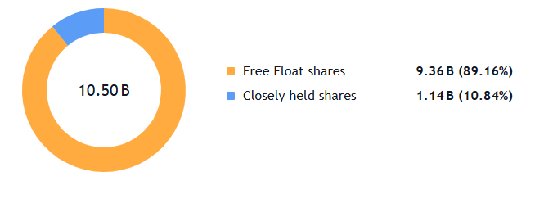

**Amazon Inc. VS Nasdaq 100 Index**

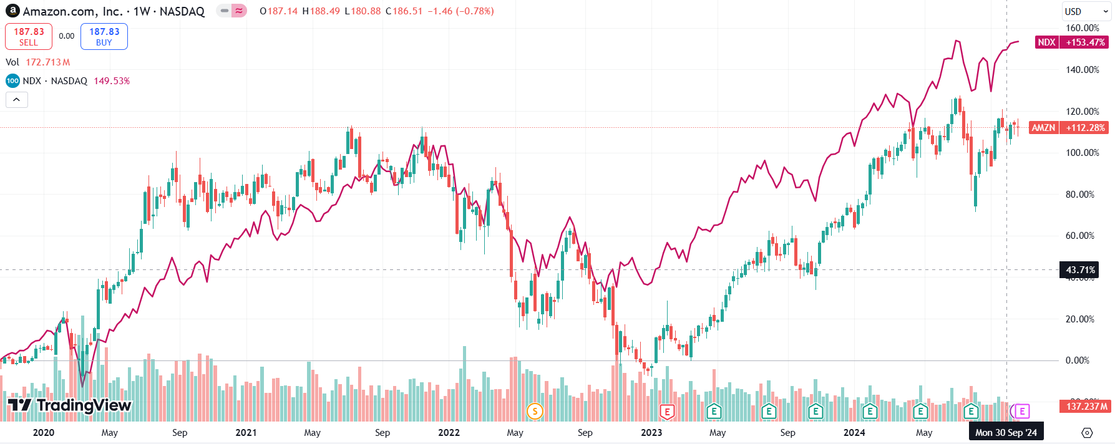

|  |  |  |  |  |  |  |  |  |  |
| --- | --- | --- | --- | --- | --- | --- | --- | --- | --- |
|  | **Executive Summary** |  |  |  |  |  |  |  |  |

**This analysis examines Amazon Inc.'s financial performance from 2017 to 2019, revealing strong revenue growth, improved profitability, and some emerging challenges in working capital management. The company has maintained its market leadership while expanding its services segment and managing operational efficiency.**

**Years ended September 2019: Revenue reported $280522 million, up 20% from $232 billion in 2018.**

**Years ended September 2018: Revenue reported $** **232,887 million, up 31% from $177 billion in 2017.**

**The company's EBITDA showed strong growth, increasing from $16,128 million in 2017 to $28,028 million in 2018, representing a 73.8% increase. In 2019, EBITDA continued to grow, reaching $37,351 million, a 33.3% increase from 2018.**

**As for EBIT performance, the company saw remarkable growth from $4,106 million in 2017 to $12,421 million in 2018, marking a substantial 202.5% increase. In 2019, EBIT continued to grow, reaching $14,541 million, though at a more moderate pace of 17.1% compared to 2018.**

**Key Financial Outcomes**

1. **Margin Expansion:**
   * **Gross Margin**: 37% → 41% (↑4 points)
   * **EBITDA Margin**: 9% → 13% (↑4 points)
   * **Net Margin**: 1.7% → 4.1% (↑2.4 points)
2. **Return Metrics:**
   * **ROE**: 11% → 27% (↑16 points)
   * **ROCE**: 4% → 15% (↑11 points)
   * **ROA**: 2% → 7% (↑5 points)

**Revenue Composition:**

* **Products: Represents 67% of revenue in 2017: to 57% in 2019**
* **Services:** **Shows consistent growth in 2019 with 43% of revenue, increasing from 30% in 2017**

**EPS Performance:**

**Amazon's earnings per share showed remarkable growth, starting at $6.32 in 2017, jumping significantly to $20.68 in 2018 (a 227.2% increase), and further improving to $23.46 in 2019 (a 13.4% increase).**

|  |  |  |  |  |  |  |  |  |  |
| --- | --- | --- | --- | --- | --- | --- | --- | --- | --- |
|  | **Earnings Highlights** |  |  |  |  |  |  |  |  |

|  |  |  |  |  |  |  |  |  |  |
| --- | --- | --- | --- | --- | --- | --- | --- | --- | --- |
|  | **Cost Structure Analysis** |  |  |  |  |  |  |  |  |

**Operating Costs:**

* **Cost of Goods Sold (COGS): 2017: 63% of revenue to 2022: 59% of revenue Trend: Improving efficiency in production costs**
* **Research & Development: Consistent at 12% of revenue Shows sustained investment in innovation and technology.**
* **SG&A: Maintained at 2% of revenue Demonstrates strong cost control**

**Capex Trends:**

* **As % of Sales: 2017: 7% 2018: 6% 2019: 6% Trend: Stabilized at lower level**
* **As % of Fixed Assets: 2017: 24% 2018: 18% 2019: 27% Trend: Consistent investment level**

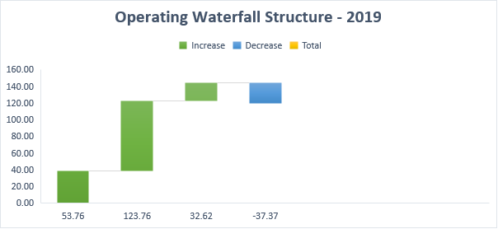

|  |  |  |  |  |  |  |  |  |  |
| --- | --- | --- | --- | --- | --- | --- | --- | --- | --- |
|  | **Working Capital Management** |  |  |  |  |  |  |  |  |

**Components:**

* **Inventory Days: Decreased to 38**
* **Receivable Days: Stable at 22**
* **Payable Days: Decreased to 84**
* **Net Trading Cycle: improved to -24.5 days**

**Key Takeaways:**

* **Improved working capital** **cycle**
* **Improved current ratio. Stable short-term financing**
* **Effectively uses supplier financing to fund operations**

|  |  |  |  |  |  |  |  |  |  |
| --- | --- | --- | --- | --- | --- | --- | --- | --- | --- |
|  | **Operational Efficiency** |  |  |  |  |  |  |  |  |

**Asset Growth:**

* **Total Assets grew from 321,195M (2017) to 225,248M (2019), a 29.8% increase**
* **Working Capital increased from 2,314M (2017) to 6,710M (2019), a 190% growth**
* **Fixed Asset Turnover improved from 3.64x to 4.54x, showing 24.7% better efficiency**

**Key Observations:**

* **Significant jump in assets utilization from 2018 to 2019**
* **Strong working capital management through negative trading cycle**
* **Improved efficiency in current asset management from 2018 to 2019**

**Asset Utilization:**

* **Total Asset Turnover: 1.72 (improved from 1.35)**
* **Fixed Asset Turnover: 4.54 (improved from 3.64)**
* **Inventory Turnover: 9.64 (improved from 6.98)**

**Improvements Noted:**

* **Enhanced inventory management with days reducing from 52.33 to 37.87**
* **Better working capital efficiency shown by 2.39% of sales in 2019**
* **Stronger asset turnover ratios across all categories**
* **More efficient use of fixed assets as shown by higher turnover ratios**
* **Superior supplier payment management with reduced payable days from 112.88 to 84.21**

**Financial Structure**

**Debt Position:**

* **Debt-to-Equity: Decreased from 4.496 to 2.735**
* **Interest Coverage: Improved from 4.84x to 9.09x**
* **Debt Coverage: Improved from 4.84x to 9.09x**

**Risk Assessment:**

* **Improving leverage metrics**
* **Strong interest coverage growth**
* **Robust free cash flow coverage**
* **Times Interest Earned doubled**

|  |  |  |  |  |  |  |  |  |  |
| --- | --- | --- | --- | --- | --- | --- | --- | --- | --- |
|  | **Market Performance** |  |  |  |  |  |  |  |  |

**Investment Metrics:**

* **ROE: Improved from 11% to 27%**
* **ROCE: Increased from 4% to 15%**
* **EPS: Grew from $6.32 to $23.46**

**Shareholder Returns:**

* **P/E ratio remained stable around 0.002**
* **Book value per share increased to 88.16**
* **Strong EPS growth trajectory**

|  |  |  |  |  |  |  |  |  |  |
| --- | --- | --- | --- | --- | --- | --- | --- | --- | --- |
|  | **Future Outlook** |  |  |  |  |  |  |  |  |

**Based on the financial trends, Amazon shows consistently improving fundamentals with several key positive indicators. The company has maintained impressive revenue growth, reaching $280,522 million in 2019, while demonstrating improved operational efficiency through expanding gross margins from 37% to 41%.**

**Their cash flow generation remains robust, with free cash flow per share increasing to 49, and they continue to deliver improving returns on capital, evidenced by ROE growth to 27% and ROCE reaching 15%.**

**Areas for Attention:**

* **Working capital optimization**
* **Marketing expenses trending up**
* **Maintaining growth while improving margins**
* **Balance between investment and profitability**

**The company's consistent investment in technology and content (around 12.5% of revenue), combined with improving operating margins, positions them well for future growth. While maintaining focus on working capital efficiency and continued margin improvement, the strong fundamentals and operational improvements suggest positive long-term prospects, particularly in the expanding service revenue segment which has grown to 42.8% of total revenue.**

**The declining debt ratios (D/E from 4.496 to 2.735) and improved profitability metrics (EPS growth from $6.32 to $23.46) suggest a well-managed transition to a more mature, efficient business model while maintaining aggressive growth potential across e-commerce, cloud services, and emerging technology sectors.**

**This comprehensive outlook suggests Amazon is well-positioned for sustained growth, supported by strong financial fundamentals and strategic investments in key growth areas. The company's improved efficiency metrics and robust cash flow generation provide a solid foundation for future expansion while maintaining financial flexibility through efficient working capital management and declining leverage ratios.**