

**MARKET RESEARCH REPORT - Visa Inc.**

*Prepared Date: January 5, 2025*

*Prepared By: Mehul Goel*

**Executive Summary**

This comprehensive market research report analyzes Visa Inc.'s position in the global digital payments and financial technology industry. The report examines the competitive landscape, market dynamics, and strategic opportunities while providing detailed SWOT and PESTEL analyses.

1. **Industry Overview**

Visa Inc. operates in the global digital payments and financial technology (fintech) industry, specifically in the payment processing and technology sector. The company provides electronic payment solutions connecting consumers, merchants, financial institutions, businesses, and governments worldwide.

**2. Competitive Landscape**

2.1 Key Competitors

**Mastercard**

- Similar global presence and market position

- Comparable business model and technology infrastructure

- Market Cap: **~$400 billion**

**American Express**

- Differentiated by closed-loop network

- Focus on premium market segments

- Direct issuer of credit cards

**2.2 Substitutes and New Markets**

**Current Substitutes**

- Cash and traditional banking methods

- Digital wallets (PayPal, Apple Pay, Google Pay)

- Buy Now, Pay Later (BNPL) services

- Cryptocurrency payment solutions

**Emerging Markets and Opportunities**

- Real-time payment systems

- Business-to-Business (B2B) payment solutions

- Cross-border payment services

- Digital banking infrastructure in developing markets

**3. Revenue and Cost Drivers**

**3.1 Key Revenue Drivers**

Transaction Processing Fees

* Volume of transactions processed
* Cross-border transaction fees
* Data processing fees

Service Fees

* Card issuance partnerships
* Value-added services
* Consulting and analytics services

**3.2 Key Cost Drivers**

**Technology Infrastructure**

* Network maintenance and upgrades
* Cybersecurity investments
* Innovation and R&D

**Operating Expenses**

* Marketing and promotion
* Personnel costs
* Regulatory compliance

**4. Current Industry Trends**

4.1 **Revenue-Related Trends**

# Digital Payment Acceleration

* Continued shift from cash to digital payments
* Growth in contactless payments
* Expansion of e-commerce globally

**Emerging Payment Technologies**

* Rise of real-time payments
* Integration of AI and blockchain
* Growth in mobile payments

**4.2 Cost-Related Trends**

# Technology Investment

* Cloud infrastructure adoption
* AI/ML implementation
* Enhanced security measures

## Regulatory Environment

* Increasing compliance requirements
* Data privacy regulations
* Open banking initiatives

**SWOT Analysis**

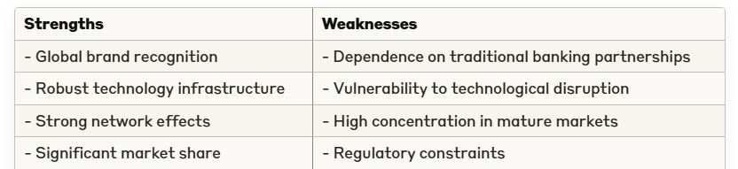

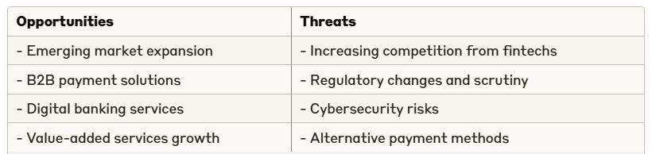

**PESTEL Analysis**

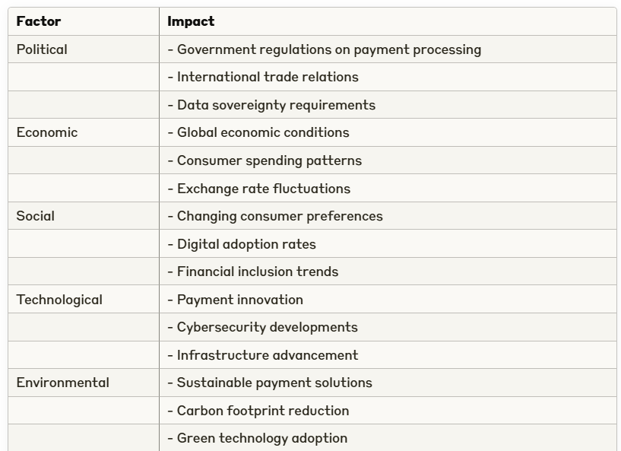



**Competitive Analysis**

7.1 Market Position

Visa maintains its position as the largest payment processor globally, with superior transaction volume and network reach compared to peers. The company's competitive advantage stems from its established infrastructure, brand trust, and technological capabilities.

7.2 Strategic Initiatives

**Visa**

- Focus on digital payment innovation

- Expansion of B2B payment solutions

- Investment in blockchain and cryptocurrency capabilities

**American Express**

* Premium customer segment focus
* Expansion of merchant network
* Enhanced rewards programs

**Performance Metrics (FY 2024)**

**Transaction Volume Growth**

- Visa: ~**10-12%**

- Mastercard: ~**8-10%**

- American Express: ~**7-9%**

*Sources*

*1. Visa Annual Reports and Financial Statements*