**The Report**

To : Paul

From : Kehinde

Date: 20/11/2024

Subject: **Analysis of financial performance and position of Apple**

**Introduction:**

These report talks about liquidity, profitability, debt management, asset utilization and market ratio of Apple from September 2020 to September 2022. It covers the area of Liquidity, profitability, debt management, asset utilization and market ratio.

**Liquidity**

**Liquidity Ratios:**

* Current Ratio improved from **0.88** to **1.36**, showing stronger short-term solvency.
* Quick Ratio rose from **0.85** to **1.33**, indicating better liquidity without relying on inventory.
* Cash Ratio increased from **0.31** to **0.86**, reflecting enhanced cash reserves.

**Working Capital**:

* Improved from −18,577-18,577−18,577 in 2020 (negative) to **38,321** in 2022 (positive).
* As a percentage of sales, it grew from −4.71-4.71%−4.71 to **13.96%**, signalling robust operational health. **Operating Efficiency**:
* Payable Days decreased from **104.7 to 91.0 days**.
* Receivable Days dropped from **26.1 to 21.4 days**, showing faster collections.

**Defensive Interval**:

* Increased from **1,228.2 days** to **1,899.7 days**, indicating strong liquidity reserves to cover expenses

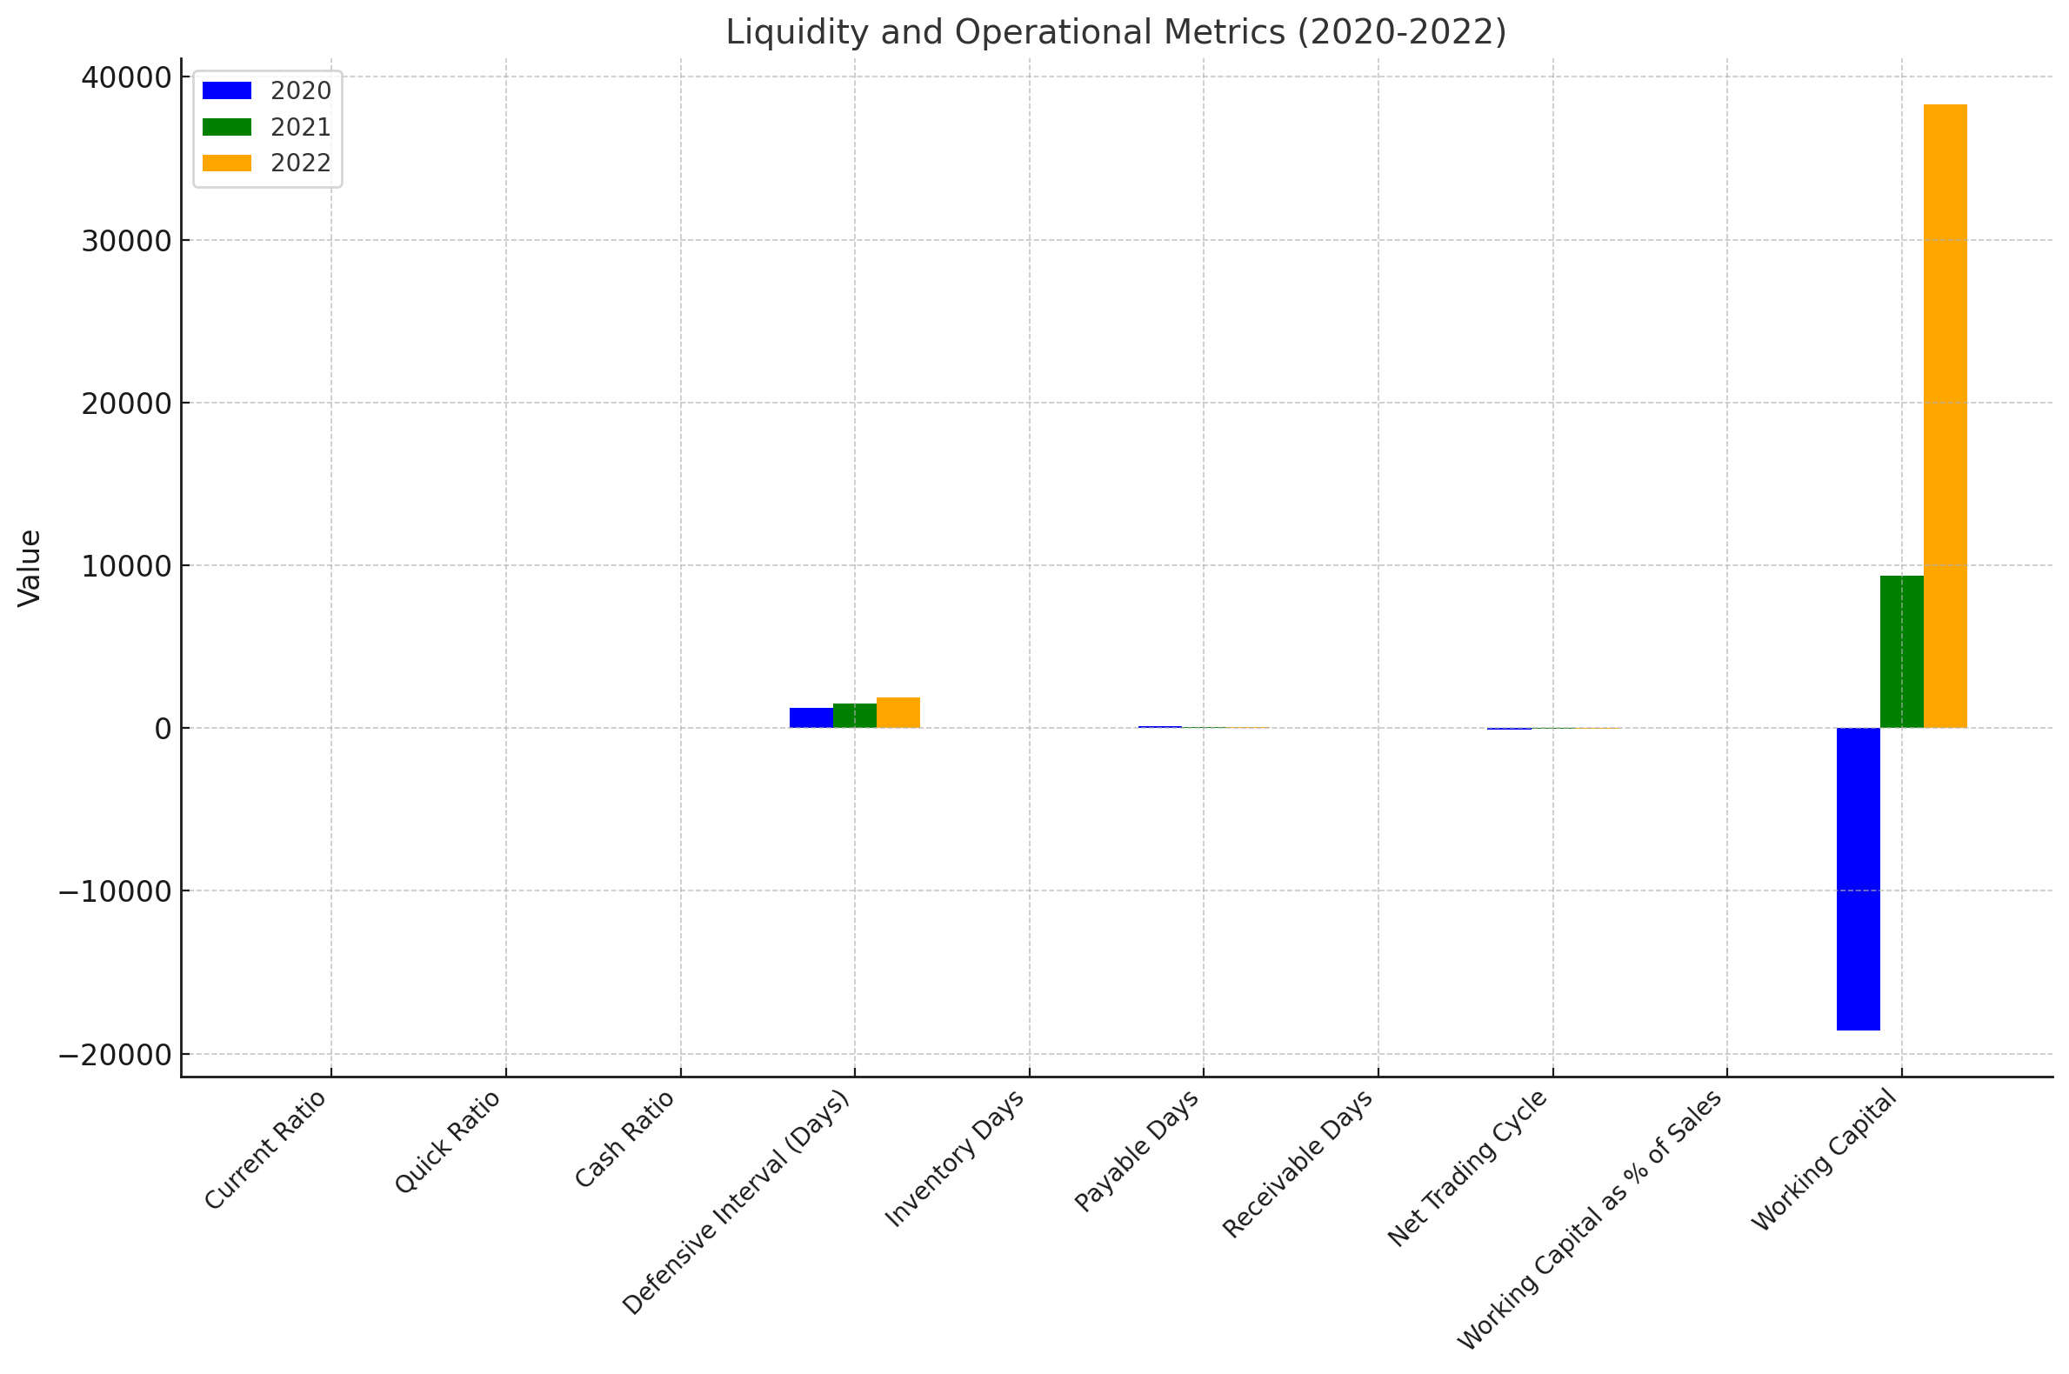

This chart shows:

• **Liquidity Ratios** (Current, Quick, Cash) are grouped on the left, showing clear improvements over the years.

• **Defensive Interval and Operational Metrics**:

* Metrics like Inventory Days, Payable Days, and Receivable Days are consistent and provide insight into operational efficiency.

• **Working Capital**:

* On the far right, the significant turnaround from negative working capital in 2020 to strongly positive in 2022 is clearly visible.

**Profitability**

* Gross Margin fell from **43.31% to 38.23%**, indicating higher COGS.
* EBITDA Margin dropped from **33.10% to 28.17%**, showing increased operational costs.
* Net Margin decreased from **25.31% to 20.91%**, impacting overall profitability.
* EBITDA declined from **130,541** to **77,344**.
* EBIT fell from **119,437** to **66,288**, reflecting reduced efficiency in core operations.

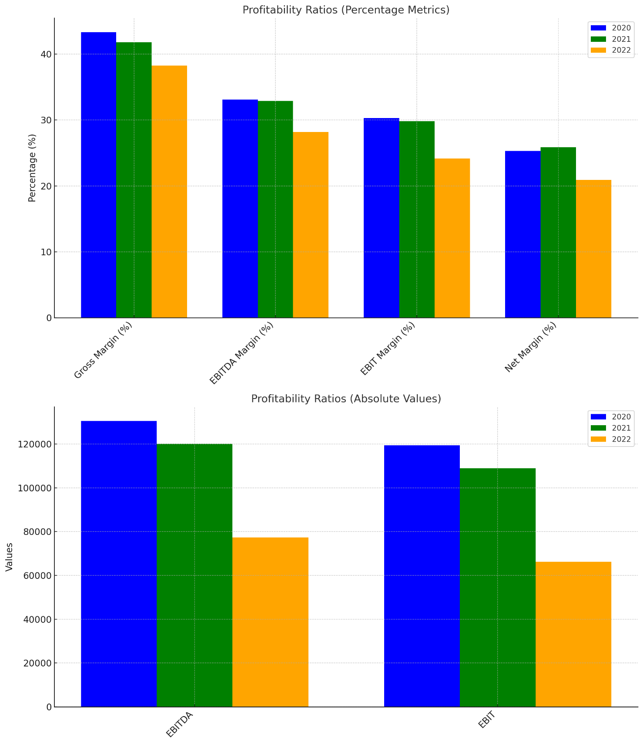This chart shows that;

* **Margins are declining:** Gross, EBITDA, EBIT, and Net margins all show a steady decrease from 2020 to 2022.
* **Absolute earnings are falling:** EBITDA and EBIT have dropped significantly, reflecting weaker operational profitability.

**Solvency/Debt Management**

• Debt dependency is decreasing: Debt-to-Equity and Long-term Debt-to-Capital ratios are declining.

• Leverage increasing slightly: Debt-to-Total Assets rose from 0.42 to 0.47.

• Interest coverage weakening: Times Interest Earned and Debt Coverage have significantly declined, signalling reduced ability to handle debt obligations.

• Cash flow under pressure: FCFE and FCFE per share have dropped steadily, indicating lower cash availability for shareholders.

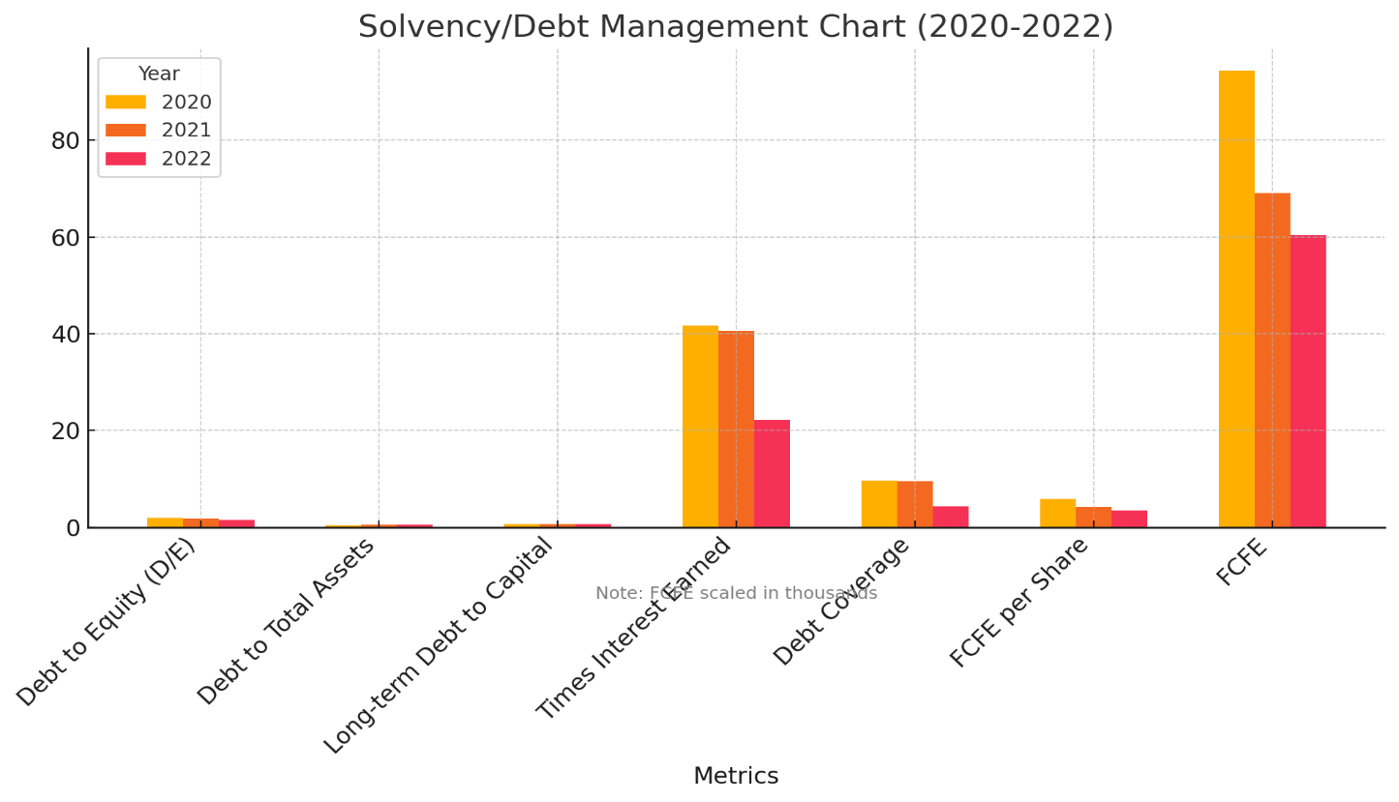

The chart shows that;

The Debt-to-Equity (D/E) and Long-term Debt-to-Capital ratios show a steady decline, indicating reduced dependence on debt financing.

The Debt-to-Total Assets ratio increased slightly, suggesting a higher proportion of debt in the asset structure.

A drop in Times Interest Earned and Debt Coverage ratios reflects reduced ability to meet interest obligations, signalling potential financial strain.

Both FCFE and FCFE per share declined consistently, showing reduced cash availability for equity holders.

**Asset Utilization**

• Total Asset Turnover decreased from 1.12 to 0.85, suggesting lower asset utilization for generating revenue.

• Fixed Asset Turnover fell from 1.81 to 1.52, showing reduced efficiency in using fixed assets to generate sales.

• Inventory Turnover dropped slightly from 40.73 to 37.25, indicating a minor slowdown in inventory movement.

• Return on Assets (ROA) decreased from 0.28 to 0.18, reflecting reduced profitability from assets.

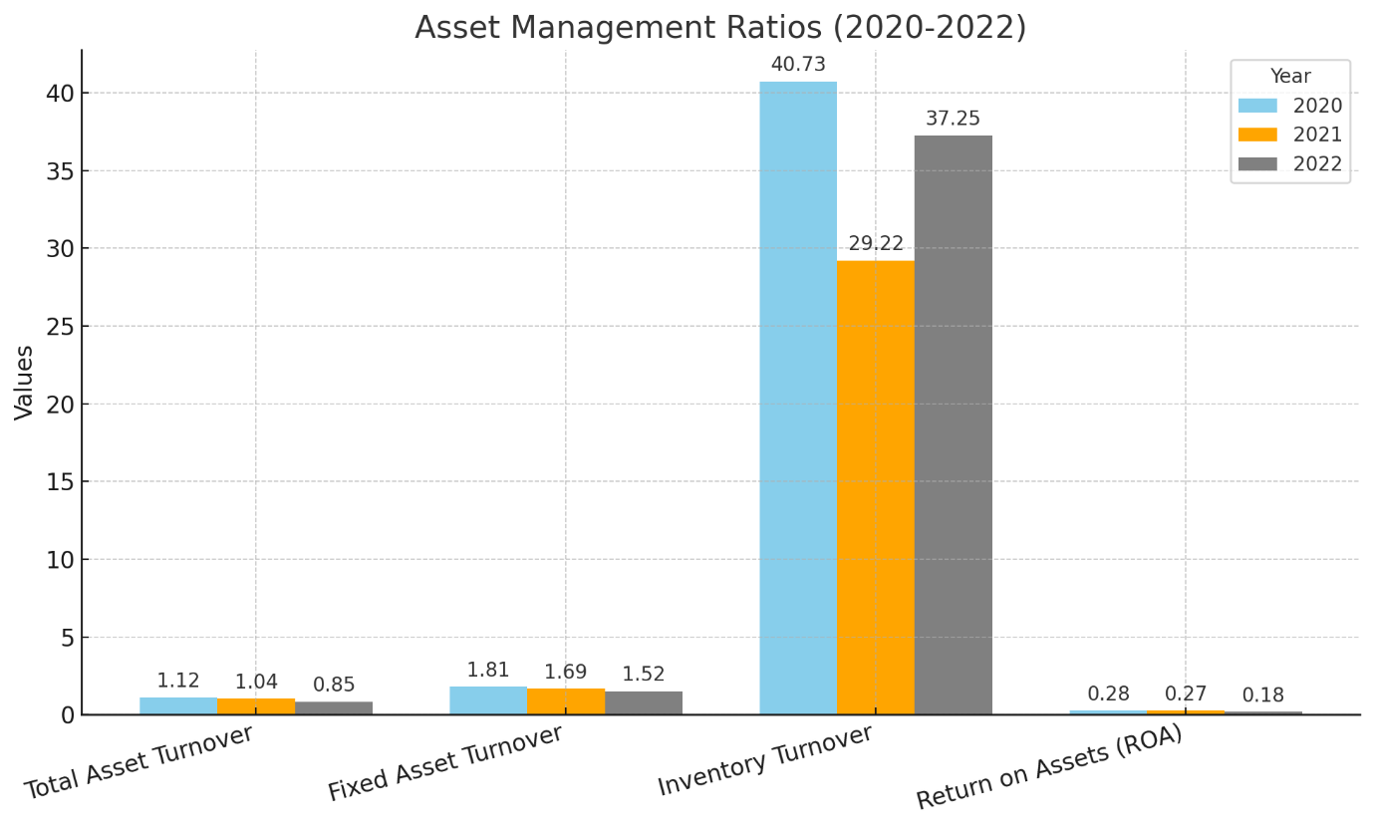

The chart shows declining efficiency in asset management:

* **Total and Fixed Asset Turnover**: Both ratios decrease, indicating reduced efficiency in using assets to generate revenue.
* **Inventory Turnover**: Fluctuates, with a recovery in the final period but not to the initial level.
* **Return on Assets (ROA)**: Declines, showing reduced profitability from assets.

**Investor/Market ratio:**

* **Valuation Ratios**:
  + **P/E Ratio**: Increased from **22.41** to **34.37**, indicating higher market valuation despite declining earnings.
  + **PBV Ratio**: Declined from **44.40** to **30.52**, reflecting reduced market valuation relative to book value.
* **Profitability Metrics**:
  + **EPS**: Dropped from **6.11** to **3.28**, indicating declining profitability.
  + **ROE**, **ROCE**, and **ROA** all showed a consistent decline, indicating lower returns on equity, capital, and assets over time.
* **Book Value and Dividends**:
  + **Book Value Per Share (BV)**: Remained stable around **3.10–3.74**.
  + **Dividend Payout Ratio**: Increased from **0.15** to **0.25**, but **Dividend Per Share** declined slightly from **0.91** to **0.80**.
* **Enterprise Value (EV)**:
  + **EV** decreased from **316,062** to **285,872**, with the **EV/EBITDA Ratio** rising from **2.63** to **3.70**, showing a higher valuation relative to earnings.

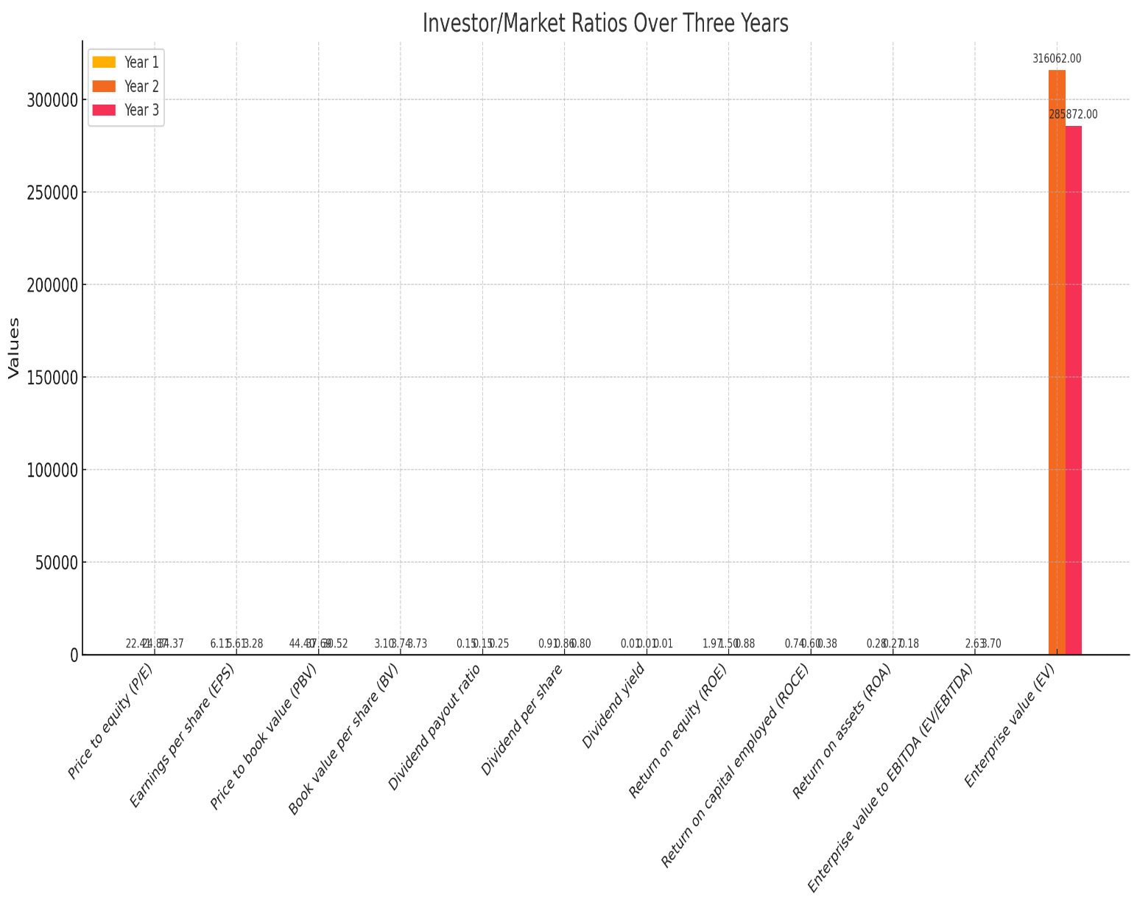

This chart shows Market ratios for 3 years .

**Conclusion:**

The company’s liquidity position has significantly improved, with better solvency, cash management, and working capital efficiency. Sustaining these trends will ensure continued financial stability.. The company’s profitability is shrinking, likely due to rising costs, falling revenues, or both. I recommend Focus on cost optimization, revenue growth, and operational efficiency to reverse the declining trends.. The company's debt structure is improving, its declining cash flow and reduced interest coverage may pose future challenges. Company’s Asset Utilization trends suggest weakening asset utilization and profitability over the years. Asset management ratios show a trend of decreasing efficiency in asset use and a decline in profitability, which may signal challenges in operational efficiency and asset management. Market ratios trends suggest weakening profitability and asset efficiency, with the company increasing dividend payouts to retain investor interest.

|  |  |  |  |
| --- | --- | --- | --- |
|  |  |  |  |
|  |  |  |  |
|  |  |  |  |
|  |  |  |  |
|  |  |  |  |
|  |  |  |  |
|  |  |  |  |
|  |  |  |  |