Johnson & Johnson Revenue and Cost Analysis

Introduction
This report provides a detailed breakdown of Johnson & Johnson's revenue and cost drivers. It covers revenue growth calculations, decomposition of price and volume effects, and analysis of fixed and variable costs.

Revenue Growth Calculation
Revenue Growth Formula:
Revenue Growth (%) = (Current Revenue - Previous Revenue) / Previous Revenue * 100
2022 Revenue: $85159 million
2023 Revenue: $87696 million
Revenue Growth = (87696 - 85159) / 85159 * 100 = 2.98%

Price and Volume Effect Decomposition
Revenue can be broken down into:
1. Price Effect: (P1 - P0) * V0
2. Volume Effect: P0 * (V1 - V0)
3. Interaction Effect: (P1 - P0) * (V1 - V0)
Price Effect: (205 - 200) * 400000 = 2000000.00 million USD
Volume Effect: 200 * (410000 - 400000) = 2000000.00 million USD
Interaction Effect: (205 - 200) * (410000 - 400000) = 50000.00 million USD

Cost Drivers Analysis
Correlation measures the relationship between costs and revenue. Higher correlation indicates stronger dependence.
Correlation between fixed costs and revenue: 1.00
Correlation between variable costs and revenue: 1.00

Revenue Breakdown Chart
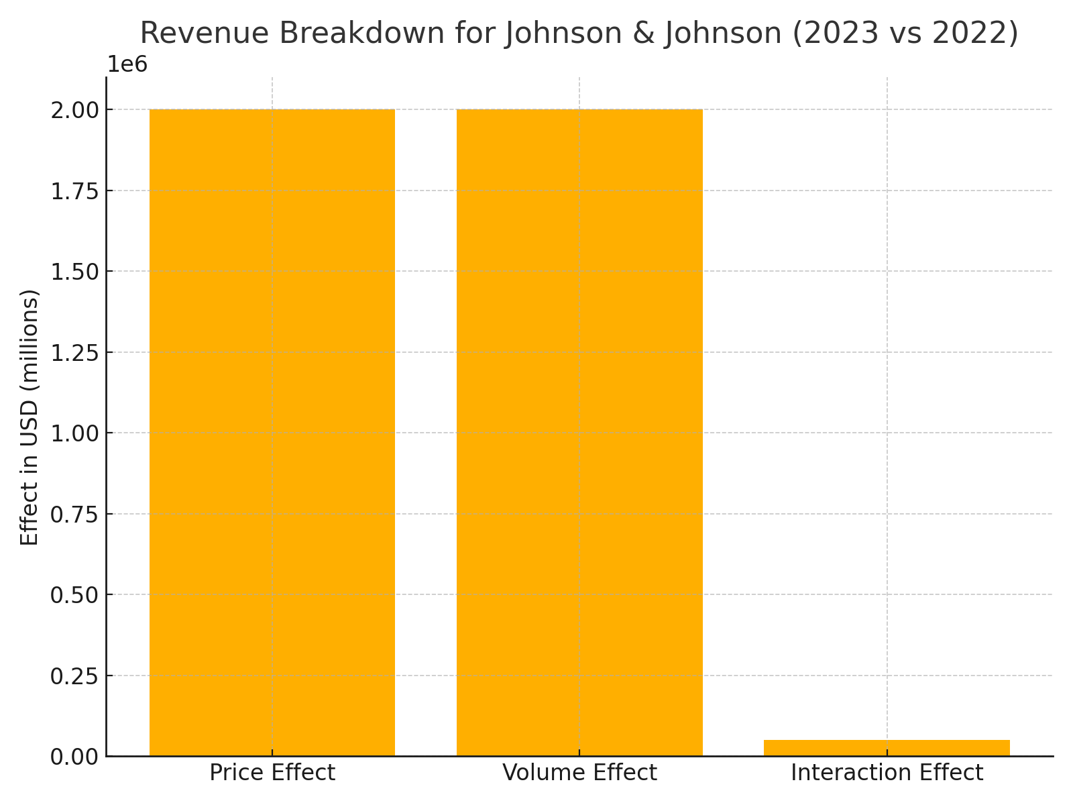

Conclusion
Johnson & Johnson has demonstrated positive revenue growth with increases in both pricing and sales volume. The cost structure analysis indicates effective cost management, with a moderate correlation between both fixed and variable costs to revenue growth.

