# **Marriott Inc. Revenue and Cost Analysis**

## **Introduction**

This report provides a detailed breakdown of Marriott Inc.'s revenue and cost drivers. It covers revenue growth calculations, decomposition of price and volume effects, and analysis of fixed and variable costs with explicit calculations.

## **Revenue Growth Calculation**

Revenue Growth Formula:

Revenue Growth (%) = (Current Revenue - Previous Revenue) / Previous Revenue * 100

2022 Revenue: $20773 million

2023 Revenue: $23713 million

Revenue Growth = (23713 - 20773) / 20773 * 100 = 14.15%

## **Price and Volume Effect Decomposition**

Revenue can be broken down into:

1. Price Effect: (P1 - P0) * V0

2. Volume Effect: P0 * (V1 - V0)

3. Interaction Effect: (P1 - P0) * (V1 - V0)

Price Effect: (182 - 180) * 115000 = 230000.00 million USD

Volume Effect: 180 * (120000 - 115000) = 900000.00 million USD

Interaction Effect: (182 - 180) * (120000 - 115000) = 10000.00 million USD

## **Cost Drivers Analysis**

Correlation measures the relationship between costs and revenue. Higher correlation indicates stronger dependence.

Correlation between fixed costs and revenue: 1.00

Correlation between variable costs and revenue: 1.00

## **Revenue Breakdown Chart**

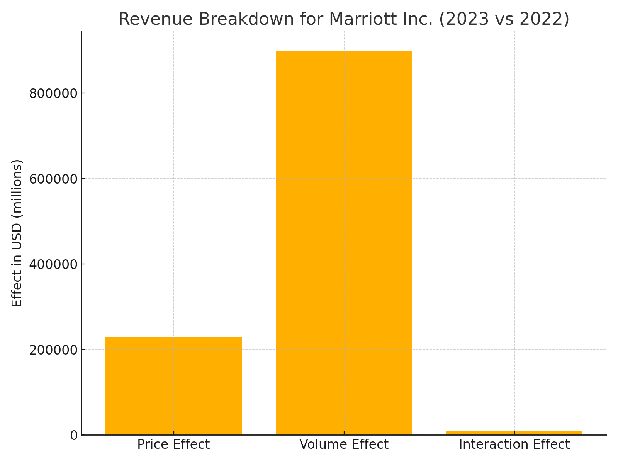

## **Conclusion**

Marriott Inc. demonstrated a strong revenue growth driven by both price and volume increases. The cost structure reveals effective management of fixed and variable costs with a balanced correlation to revenue growth.