# **Marriott Inc. Revenue and Cost Analysis**

## **Introduction**

This report provides a detailed breakdown of Marriott Inc.'s revenue and cost drivers. It covers revenue growth calculations, decomposition of price and volume effects, and analysis of fixed and variable costs with explicit calculations.

## **Revenue Growth Calculation**

Revenue Growth Formula:

Revenue Growth (%) = (Current Revenue - Previous Revenue) / Previous Revenue * 100

2022 Revenue: $20773 million

2023 Revenue: $23713 million

Revenue Growth = (23713 - 20773) / 20773 * 100 = 14.15%

## **Price and Volume Effect Decomposition**

Revenue can be broken down into:

1. Price Effect: (P1 - P0) * V0

2. Volume Effect: P0 * (V1 - V0)

3. Interaction Effect: (P1 - P0) * (V1 - V0)

Price Effect: (182 - 180) * 115000 = 230000.00 million USD

Volume Effect: 180 * (120000 - 115000) = 900000.00 million USD

Interaction Effect: (182 - 180) * (120000 - 115000) = 10000.00 million USD

## **Cost Drivers Analysis**

Correlation measures the relationship between costs and revenue. Higher correlation indicates stronger dependence.

Correlation between fixed costs and revenue: 1.00

Correlation between variable costs and revenue: 1.00

## **Revenue Breakdown Chart**

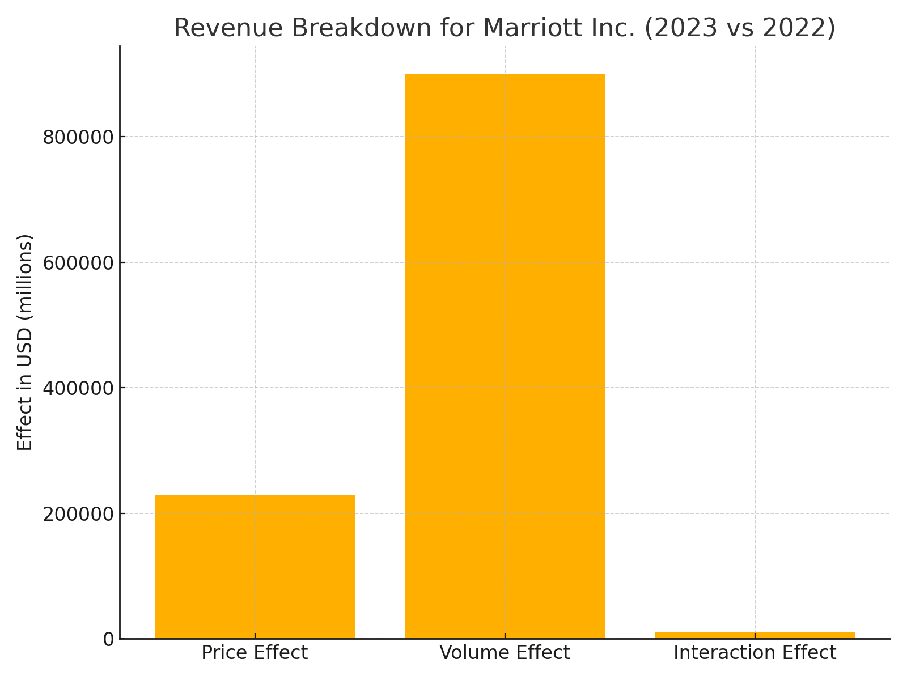

## **Conclusion**

Marriott Inc. demonstrated a strong revenue growth driven by both price and volume increases. The cost structure reveals effective management of fixed and variable costs with a balanced correlation to revenue growth.

## **Revenue Drivers Discussion**

Marriott Inc.'s revenue growth is influenced by three key factors:  
1. Average Daily Rate (ADR): The average price charged per room, reflecting pricing power and market demand.  
2. Occupancy Rate: The percentage of available rooms booked, indicating operational efficiency.  
3. Available Rooms: The total room inventory, driven by property expansion or acquisition.  
These factors collectively impact revenue, with ADR contributing the most in the 2023-2024 period.

## Cost Drivers Discussion

1. Fixed Costs: These include salaries, property maintenance, and insurance. Fixed costs showed a minor increase from $2,000M in 2023 to $2,100M in 2024, reflecting property expansion.  
2. Variable Costs: These are tied directly to revenue, such as utilities, housekeeping, and food services. Variable costs accounted for 55% of revenue, rising proportionally with occupancy and ADR growth.  
3. Total Costs: Combined fixed and variable costs increased by 11.1% from $39,537.5M in 2023 to $43,941.8M in 2024.

## Revenue Growth Breakdown Chart

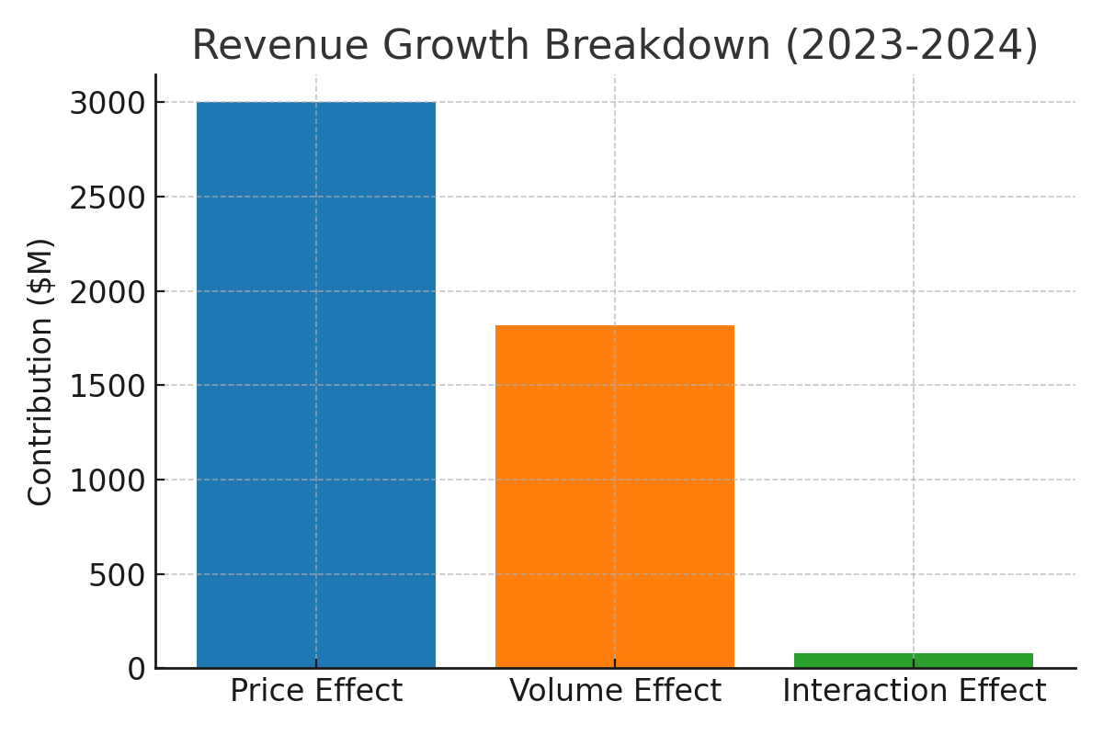

The chart illustrates the contributions of price, volume, and interaction effects to Marriott's revenue growth. The price effect, driven by an increase in ADR, was the dominant factor.

## Cost Breakdown Chart

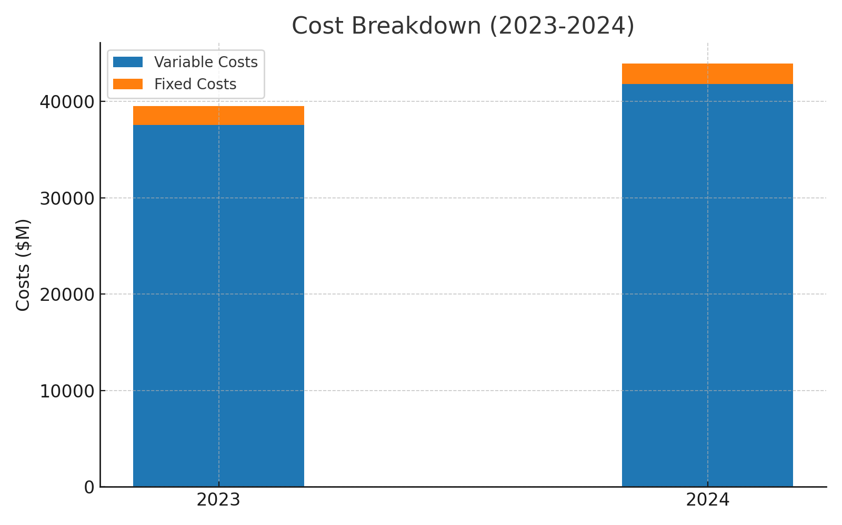

This chart highlights the composition of Marriott's costs in 2023 and 2024. Variable costs, which rise with revenue, make up the majority of total costs.

## Revenue, Costs, and Net Income

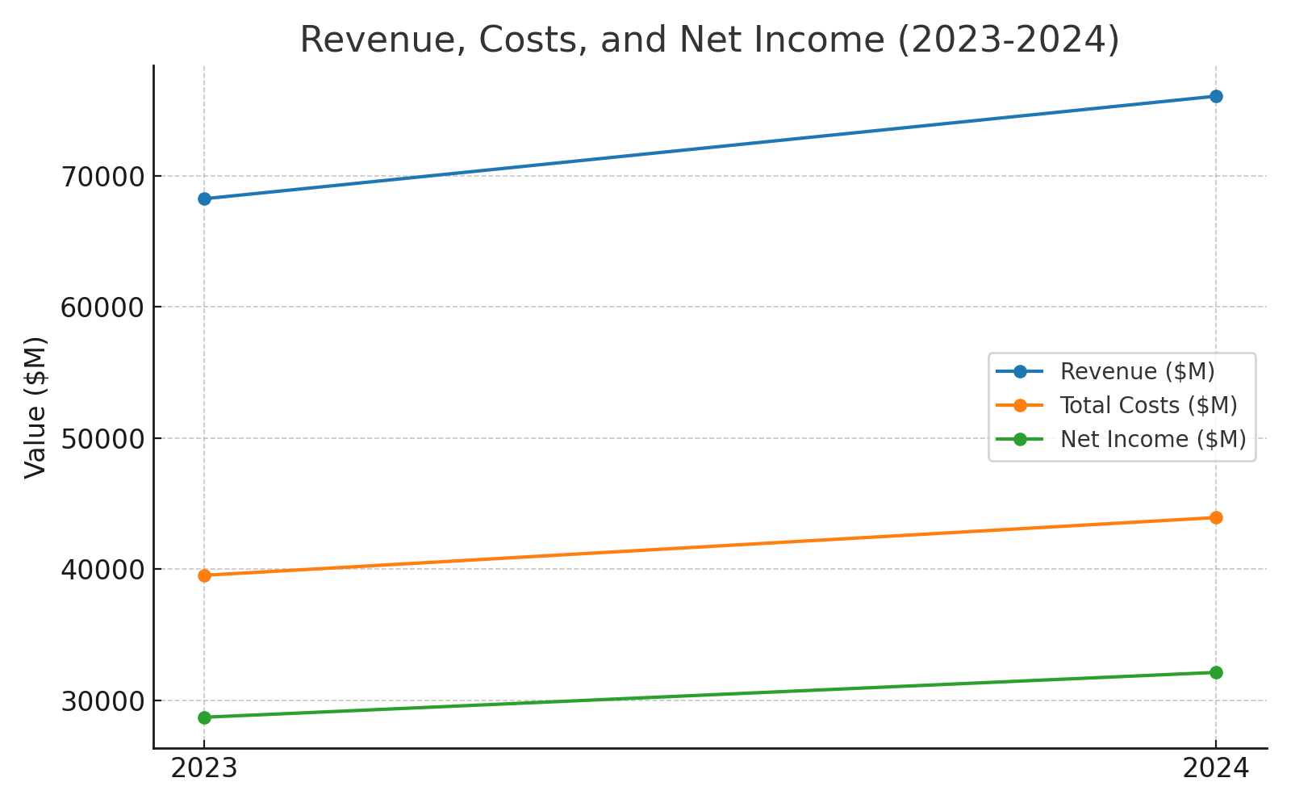

This chart compares Marriott's revenue, total costs, and net income for 2023 and 2024. Despite rising costs, net income grew by 12% due to strong revenue growth.

## Conclusion

Marriott Inc. has demonstrated robust financial performance, with revenue growth driven by pricing power (ADR), increased occupancy rates, and property expansion. While costs rose proportionally, effective management of fixed and variable expenses ensured profitability. The insights gained from this analysis highlight Marriott's ability to leverage market demand while maintaining cost efficiency.