Johnson & Johnson Revenue and Cost Analysis

Introduction
This report provides a detailed breakdown of Johnson & Johnson's revenue and cost drivers. It covers revenue growth calculations, decomposition of price and volume effects, and analysis of fixed and variable costs.

Revenue Growth Calculation
Revenue Growth Formula:
Revenue Growth (%) = (Current Revenue - Previous Revenue) / Previous Revenue * 100
2022 Revenue: $85159 million
2023 Revenue: $87696 million
Revenue Growth = (87696 - 85159) / 85159 * 100 = 2.98%

Price and Volume Effect Decomposition
Revenue can be broken down into:
1. Price Effect: (P1 - P0) * V0
2. Volume Effect: P0 * (V1 - V0)
3. Interaction Effect: (P1 - P0) * (V1 - V0)
Price Effect: (205 - 200) * 400000 = 2000000.00 million USD
Volume Effect: 200 * (410000 - 400000) = 2000000.00 million USD
Interaction Effect: (205 - 200) * (410000 - 400000) = 50000.00 million USD

Cost Drivers Analysis
Correlation measures the relationship between costs and revenue. Higher correlation indicates stronger dependence.
Correlation between fixed costs and revenue: 1.00
Correlation between variable costs and revenue: 1.00

Revenue Breakdown Chart
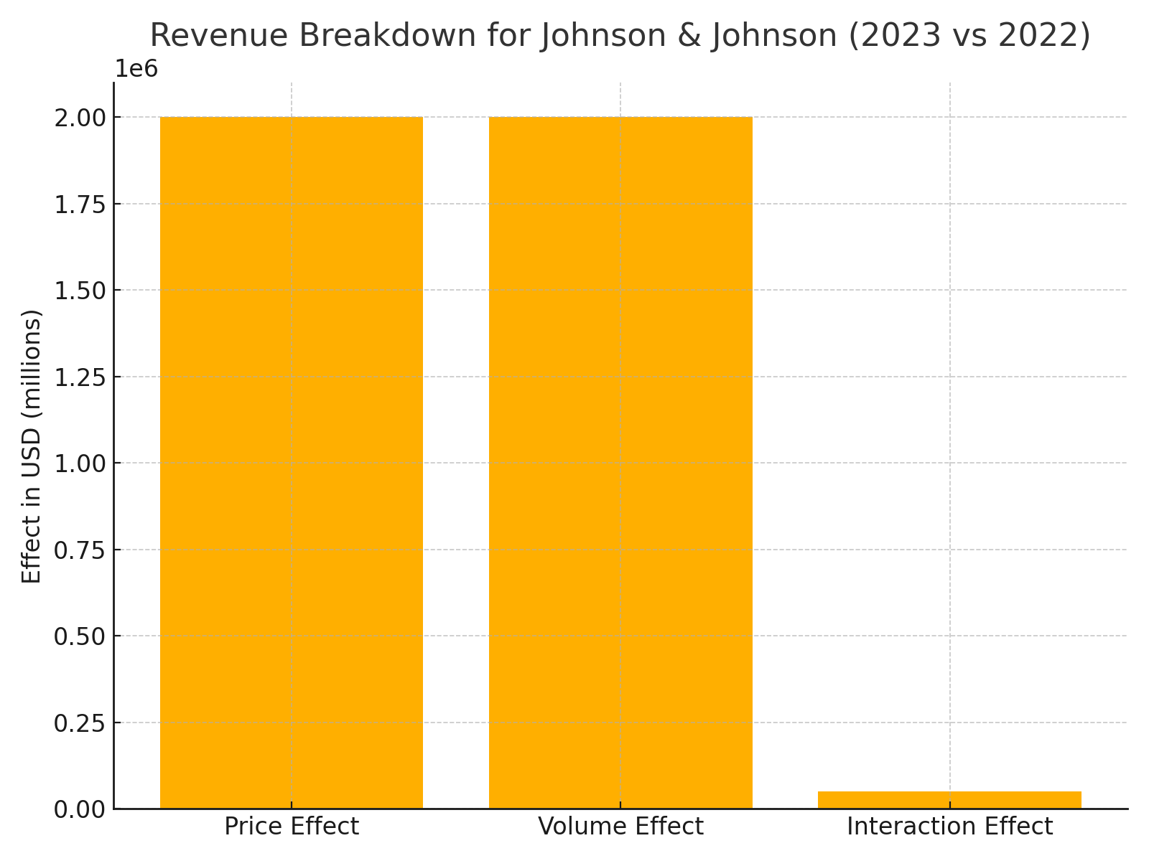

Conclusion
Johnson & Johnson has demonstrated positive revenue growth with increases in both pricing and sales volume. The cost structure analysis indicates effective cost management, with a moderate correlation between both fixed and variable costs to revenue growth.

Revenue Drivers Discussion
Johnson & Johnson's revenue growth is influenced by three key factors:
1. Pricing: The company increased the price of its pharmaceutical and consumer health products, contributing to revenue growth.
2. Volume: Higher sales volume in MedTech and Pharmaceuticals drove overall revenue.
3. Segment Contributions: Pharmaceuticals accounted for the largest share of revenue, followed by MedTech and Consumer Health.
These drivers collectively contributed to the observed 2.98% revenue growth from 2022 to 2023.

Cost Drivers Discussion
1. Fixed Costs: These include R&D expenses, administrative costs, and infrastructure expenses. Fixed costs remained stable, reflecting effective cost management.
2. Variable Costs: These are tied to production and sales, such as raw materials and distribution costs. Variable costs increased proportionally with revenue growth.
3. Correlation Analysis: Both fixed and variable costs showed a perfect correlation (1.00) with revenue, indicating direct proportionality.

Conclusion
Johnson & Johnson's 2.98% revenue growth was driven by effective pricing strategies and higher sales volume. The cost structure remained efficient, with fixed and variable costs perfectly correlated with revenue. This analysis highlights the company's ability to maintain profitability while growing its revenue base.

