Apple Inc Investment Report

Overview

This report reviews the performance of Apple Inc in the periods between 2020 to 2022 inclusive. The areas covered include liquidity, profitability, solvency/ debt management, asset utilisation, investor value and tax.

Liquidity

Looking at the quick ratio, we can see a steady decrease in the company’s ability to meet its currently liabilities, though there is a decrease (from 1.363 in 2020 to 0.879 in 2022), this is not a cause for concern as there has been a noted steady decrease in the inventory days from moving from a high of 11.27 days in 2021 to 8.08 days in 2022. If required, more sales could be generated in a short time to raise any potential shortfalls.

It should be noted that liquidity requirements should continue to be monitored as the company has been seen a growth in net sales from 2020 to 2022 of 43.6%, and resources that may have been higher in reserves have been employed to support this growth.

Please view graph 1 showing the trend between payable days and receivable days. Though there is a noted increase in both metrics, the receivable days have remained within a smaller range than receivable days indicating that there are more frequent intervals of cash inflows to meet the payments to its suppliers.

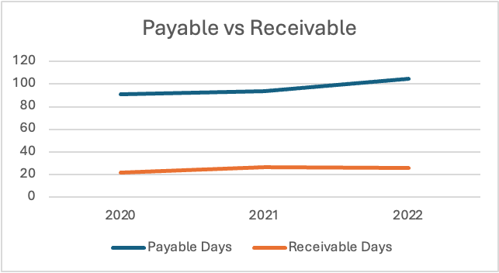

There has been a steady decline in the defensive interval ratio in the period between 2020 to 2022 (down from 1356.55 days or 3.72 years). Still, the company still displays a healthy timeframe of 963 days (2.6 3years) before needing to tap into capital sources other than its current assets

The net trading cycle has seen a decrease from 60.88 days in 2020 to 56.35 days in 2021.This may be due to the COVID-19 pandemic where inventory supplies were not replenished as usual, indicating an easier access to cash if needed. This increased notably to 70.53 days in 2022. This may be due to inertia caused from the on-going pandemic where the inventory levels were restored, but purchase decisions by consumers more measured.

Working capital has seen a drastic change from 2020 of $38.321bn to -$18.577bn in 2022, as the company’s current liabilities exceeded current assets held, as the company borrowed heavily to fund its growth. This brings us to considering ‘working capital as a percentage of sales’. In 2020, the company has a substantial working capital of 13.96%, given the growth of net sales achieved in 2021 and again in 2022, we can see funds have been utilised in this endeavour.

Profitability

Looking at the company’s gross margin we notice a substantial growth from 2020 to 2021 and slower growth from 2021 to 2022, as viewed in the graph 2 below:

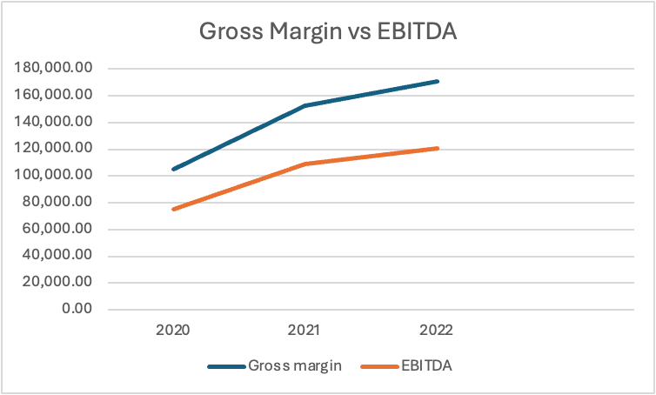

We now consider the company’s EBITDA in this period, which has mirrored the growth seen in above. There has been strong and sustained growth in revenues. To understand what this means for Apple Inc, we look to the Operating margin (EBITDA margin). Here we note that growth has been steady and stable with year-on-year increases from 27.32% in 2020, 29.78% in 2021 and 30.67% in 2022.

We now turn to looking at the company’s EBIT figures. The profits Apple makes on a dollar of sales after account for the direct costs involved in earning those revenues too have increased in a sustained and steady way, with the biggest increase witnessed between 2020 to 2021 (23.29% to 26.70%).

Finally, this brings us to net margin. Once again, we see an increase of 4.97% from 2020 (20.91%) to 2021 (25.88%), however we note a small decrease in 2022 by 0.57% to 25.31%.

Solvency/ Debt management

We now look at Apple Inc’s debt management, starting with its ‘debt-to-equity’ ratio. As we have established, the company has seen substantial growth in its revenues and net sales in the period between 2020 and 2022, in which cash and liabilities in the form of debt have been utilised to support this. This is reflected in the ‘debt-to-equity’ ratio which has grown steadily from 3.96 in 2020 to 4.56 in 2021 and 5.96 in 2022.
It should be of no surprise that there has been a steady percentage increase in the ‘debt to asset’ the company, which has grown from 79.83% in 2020, to 82.03% and 85.64%. This is a highly leveraged position that the company has utilised rather than convert capital into cash to fund its growth.
Given the above, we should now consider how much of the capital used comes from long-term debt. Here, we witness a decrease from the highs stated in the previous ratio; long-term debt accounted for 60.16% of capital used in 2020, which has seen steady increases in 2021 to 63.36% and 66.14% in 2022.

We now move to taking the company’s solvency into consideration. Looking at Apple’s time interest earned, we see a positive trend moving from 21.3 in 2020, to 36.35 in 2021 and slower growth in 2022 to 38.34. Still, this places the company in a great position to pay off its debt charges with its earnings achieved.
Continuing, we note an improved ratio in debt coverage in 2020 of 0.74 to 0.97 in 2021 and 1.19 in 2022. This denotes the company’s strengthening position to pay off its debt service costs without needing to borrow more.
Lastly, we will now consider the free cash flow per share. Again, we see an overall upward trend over the 3-year period, with a slightly lower figure being recorded in 2021 ($5,301.19 per share) and finishing with a high of $6,594.37 per share in 2022. This should give confidence to investors that Apple is in a stronger position to meet its obligations and to pay dividends.

Asset Utilisation

We now look to how the company utilises its assets to generate sales revenue, starting with ‘Total asset turnover’. Here, we see growth year-on-year (0.85 in 2020 to 1.12 in 2022), indicating the company’s ability to use their assets efficiently. Comparatively, we look to how much fixed assets accounted for this outcome. From graph 3 below, we see that fixed assets have been a consistent presence responsible for the company’s sustained growth.

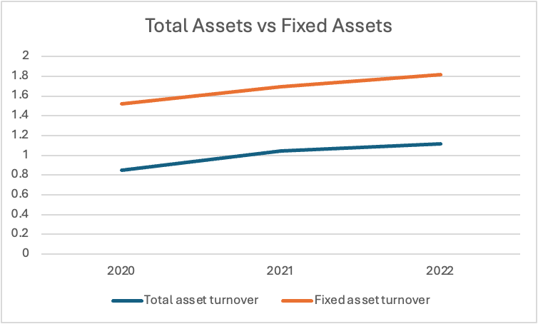

We now turn our attention to inventory turnover, here we can see a downward dip in the period between 2020 (41.75) and 2021 (32.37) before recovering in 2022 (45.20), regardless this indicates that the company is efficiently managing its inventory and generating revenue. For a company such as Apple, these ratios are usually high.

We conclude this section by looking at the return on assets (ROA). Very promisingly, we note consistent and sustained growth over the 3-year period, going from $323.888bn in 2020 to $351.879bn in 2022. This indicates that the company is well-managed and using its assets efficiently which is reflected in its profitability.

Investor/ market ratios

We will now look at value to investors, starting with price to equity (price to earnings). While still positive and returning great returns to investors, there is a noted reduction year-on-year, from a high in 2020 of 69.91, to 40.81 in 2021 and 37.63 in 2022. This may indicate that the stock was overvalued previously and is now trading closer to its fair value.

To clarify this, we will look at the company’s earnings per share. Here we note year-on-year increases from 3.31 in 2020 to 5.67 in 2021 and 6.15 in 2022. This points to the company being more profitable, which is good news for investors.

While still on the theme of investor value, we now look at the price to book value (PBV) for the company. Apple being such a unique company once again has high ratios that held consistent in 2020 and 2021 (61.46 and 61.27 respectively), before seeing significant growth in 2022 (to 74.05). While this could indicate the company’s stock being overvalued or trading at a premium, we need to consider other metrics in addition for a more complete picture. We can also consider the book value per share (BVPS). At the time this report was written, Apple Inc’s (AAPL) stock price was $231.41. The BVPS has dropped held consistent from 2020 to 2021 (3.765 to 3.777) and dropped in 2022 to 3.125, looking at this metric in isolation would indicate the stock as being overvalued, however this would be more effective when compared to other companies in the same sector.

Next, we look to the dividend payout ratio. We can see a 9.25% drop in dividend payout from 2020 to 2021 (15.28% down from 24.53%) with a further decrease in 2022 to 14.87%. Given the discovery earlier in this report, this can be explained by the company reinvesting a large portion of its earnings, which could mean it’s more likely to sustain dividends in the future. Should this dividend hold steady or grow in the coming years, this should indicate that the company is in good financial health. We can see this further illustrated in graph 4 below:

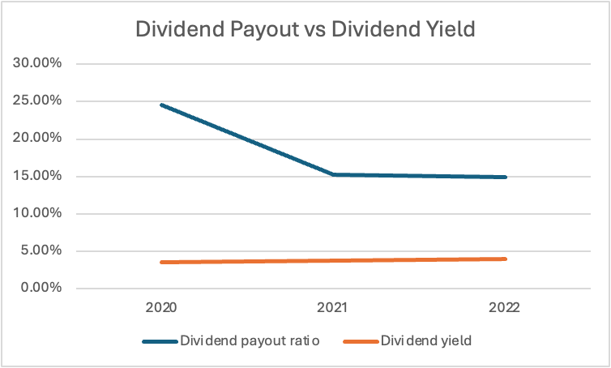

Here, we can see that the dividend yield (as well as dividend per share) has steadily grown over the 3-year period despite the dividend payout dropping in this time.

We now move on to consider Return on Equity (ROE). Looking at the performance over the 3-year period, the company has delivered phenomenal value to shareholders. Starting in 2020, the ROE has grown from 87.87% to 150.07% in 2021 and 196.90% in 2022. Here we can see the company as effectively and efficiently used its equity to generate income, for better perspective it would be advised to compare these figures with other companies within this sector.

Next, we consider Return on capital employed (ROCE). The company has returned noted increased returns progressively in the 3-year period starting with 0.98% in 2020, 1.55% in 2021 and 2.17% in 2022. This indicates that Apple is generating more profit year-over-year per dollar of capital, showing its efficiently using capital and a higher percentage of its value may be returned to shareholders as profit.

Given the profitability, asset utilisation and other performance metrics above, we now move to consider Apple’s potential for growth. Here we look to the enterprise value to EBITDA for assistance. Over the 3-year period, we see a steep decline from 2020 (54.48) to 2021 (36.24) and still further in 2022 (31.74). As stated previously, these figures should be used in tandem when making comparisons with other companies in this sector. As the company is returning more value to shareholders, there is still potential for growth albeit not as exponentially as previously seen.
We now take into consideration the enterprise value (EV) of the company. The EV in 2020 was $4.08tn and has dropped to $3.95tn in 2021 and $3.84 tn in 2022. Many different elements (internally and externally) go into arriving at this value. We need to consider the income tax rate applicable during these periods and its effects on the company’s bottom line, with this increasing sharply from 2020 to 2021 (14.16% to 23.24% respectively), while this has reduced in 2022 to 16.43%, this is still higher than that of income tax applied in 2020.

Lastly, we investigate two capital expenditure metrics: percentage of sales and percentage of fixed assets. Considering the former, we see a general decline from 17.42% in 2020, to 13.87% in 2021 and 13.50% in 2022. This indicates that there has been less of a reliance of using revenues to invest into capital expenditure, which is also reflected in earlier ratios where debt has been a large factor in supporting the growth of the company.
Finally looking at capital expenditure as a percentage of fixed assets, this has been consistent over the 3-year period with the highest figure in 2020 (26.54%), the lowest in 2021 (23.47%) and increasing in 2022 to 24.49%. This indicates that long-term assets provided a stable base for continuance in the growth of the company.

