Ratio Analysis & Interpretation, Apple inc.

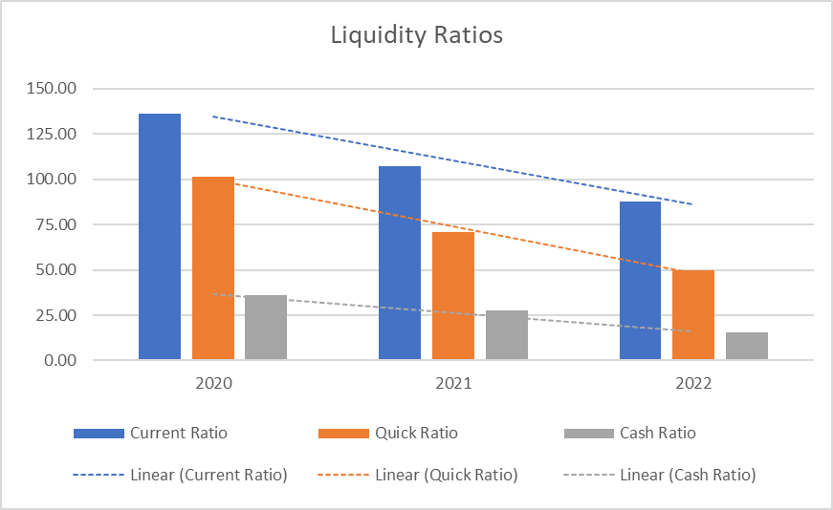Liquidity Ratios

Apple's liquidity ratios, including the current, quick, and cash ratios, have shown a consistent decline from FY 2020 to FY 2022. While still maintaining strong liquidity, the narrowing ratios suggest reduced short-term assets relative to liabilities, possibly indicating increased efficiency or strategic allocation of resources. The declining defensive interval aligns with this trend, showing fewer operational days covered by liquid assets.

Turnover Ratios

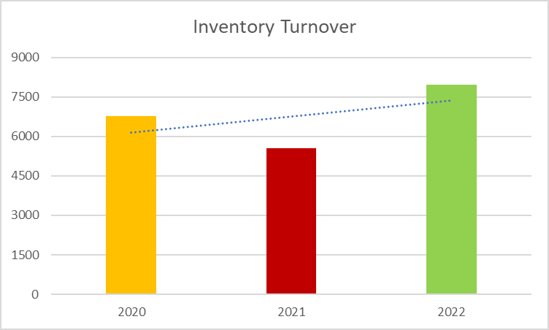In terms of asset turnover, Apple's metrics demonstrate notable improvement in efficiency. Total asset turnover and fixed asset turnover have increased, reflecting enhanced revenue generation from both total and fixed assets. Inventory turnover has also improved significantly, indicating more efficient inventory management and higher demand. The increase in return on assets (ROA) further highlights Apple's effective use of assets to generate profitability, reflecting strong operational performance and prudent asset management.

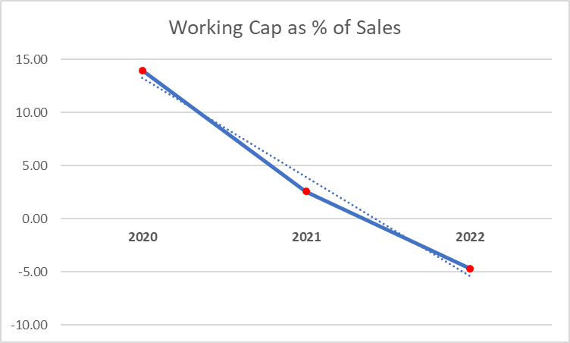Cause for Concern?

**Apple’s working capital as % of sales**, which shows the proportion of sales that is tied up in working capital, has seen a sharp decline over the years. It fell from ***13.96%*** in FY 2020 to ***2.56%*** in FY 2021, and further to ***-4.71%*** in FY 2022. The negative value in FY 2022 suggests that Apple may be operating with negative working capital, indicative of potential liquidity issues or aggressive working capital management. While this may suggest efficiency in asset use, as we have covered, it could also imply challenges in meeting short-term obligations.