# **Financial Analysis Report: Apple Inc.**

## **Executive Summary**

This report provides a comprehensive financial analysis of Apple’s performance over the fiscal years 2020, 2021, and 2022. Using key financial ratios, we assess the company’s liquidity, profitability, solvency, asset utilization, and investor attractiveness. The analysis reveals strengths in profitability, concerns in liquidity, and moderate investor confidence.

## **1. Liquidity Ratios**

Liquidity ratios indicate the company’s ability to meet its short-term obligations using current assets.

### **1.1 Current Ratio**

The current ratio has declined from 1.36 in 2020 to 0.87 in 2022. A ratio below 1 indicates that the company may struggle to meet its short-term liabilities with its current assets, signaling a potential liquidity risk.

### **1.2 Quick Ratio**

A similar declining trend in the quick ratio suggests that even after removing inventories from current assets, the company's ability to meet its short-term liabilities has weakened. This is concerning for creditors.

### **1.3 Cash Ratio**

The cash ratio has dropped sharply from 0.86 in 2020 to 0.31 in 2022, indicating that cash reserves are insufficient to cover immediate liabilities. This decline shows the company is becoming increasingly dependent on non-cash current assets or external financing to meet obligations.

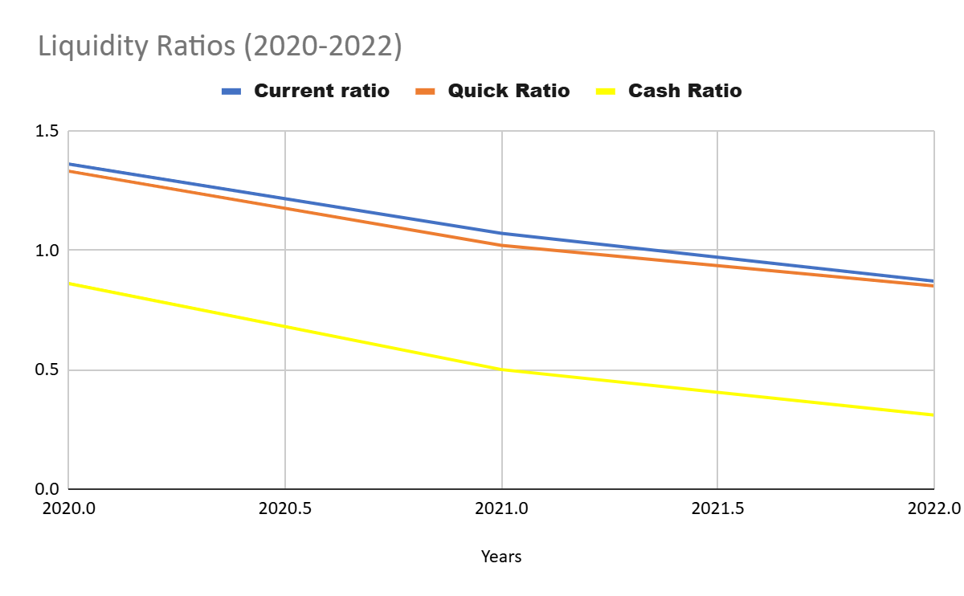

### **A line chart showing the downward trend of current, quick, and cash ratios from 2020 to 2022 to emphasize liquidity risks.**

## **2. Profitability Ratios**

Profitability ratios measure the company’s ability to generate earnings relative to sales, assets, and equity.

### **2.1 Gross Margin**

Gross margin has steadily increased, showing that the company is improving its cost management and is able to retain a larger portion of revenue as gross profit.

### **2.2 EBITDA Margin**

The EBITDA margin has remained strong and consistent, reflecting stable operational profitability. The slight increase indicates that operating costs are well-managed.

### **2.3 Net Profit Margin**

While net margin slightly decreased in 2022, it remains robust and reflects strong overall profitability after all expenses have been accounted for.

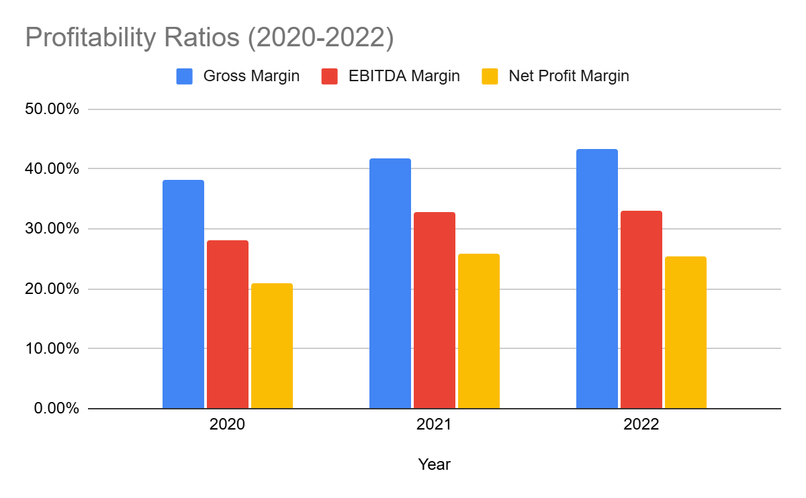

### **A bar chart comparing gross margin, EBITDA margin, and net margin for each year to show profitability trends.**

## **3. Solvency and Debt Management Ratios**

These ratios help evaluate the company’s long-term financial stability and its ability to meet long-term obligations.

### **3.1 Debt-to-Equity Ratio**

The company’s reliance on debt has increased, as shown by the rising debt-to-equity ratio. A higher ratio indicates increased financial leverage and, potentially, higher financial risk.

### **3.2 Times Interest Earned (TIE)**

The high and increasing TIE ratio is a positive sign, suggesting the company has more than sufficient earnings to cover its interest expenses. This indicates low risk of defaulting on interest payments.

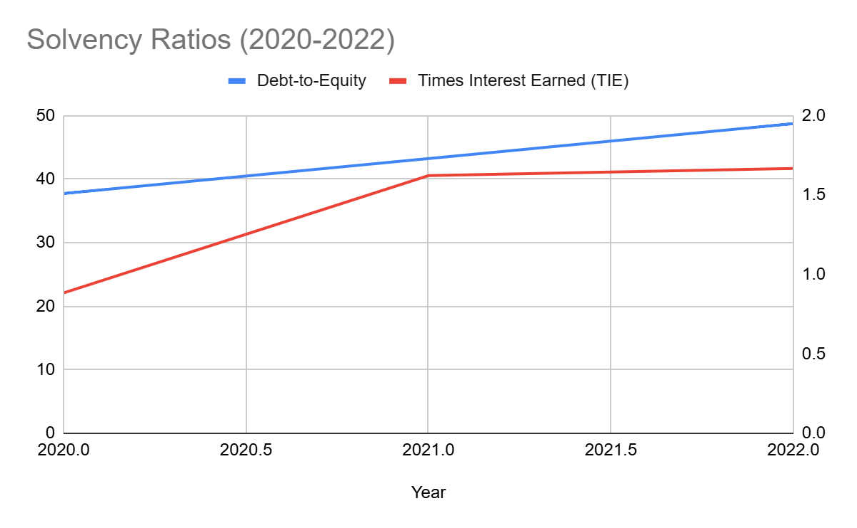

**A dual-axis graph with the debt-to-equity ratio on one axis and TIE on the other to compare the company’s debt levels against its ability to cover interest payments.**

## **4. Asset Utilization Ratios**

Asset utilization ratios assess how efficiently the company uses its assets to generate revenue.

### **4.1 Total Asset Turnover**

An increasing total asset turnover ratio reflects improved efficiency in using the company’s assets to generate sales. This is a positive trend showing the company is making better use of its resources.

### **4.2 Inventory Turnover**

The significant increase in inventory turnover in 2022 indicates that inventory is being sold and replaced at a faster rate, reflecting better inventory management.

### Chart

### **A bar graph to compare the total asset turnover and inventory turnover for each year, showcasing the company’s efficiency in utilizing assets.**

## **5. Investor/Market Ratios**

These ratios provide insight into the company’s stock performance and its attractiveness to investors.

### **5.1 Price-to-Earnings (P/E) Ratio**

The declining P/E ratio indicates that investor expectations of the company’s future earnings growth have moderated. This could suggest either a more reasonable valuation or investor skepticism about growth prospects.

### **5.2 Earnings Per Share (EPS)**

The EPS has improved year-on-year, showing the company’s growing profitability per share. This is a strong signal for shareholders.

### **5.3 Price-to-Book Value (PBV)**

A rising PBV ratio indicates that the company’s stock price is increasing relative to the book value per share, potentially reflecting high market expectations.

### 

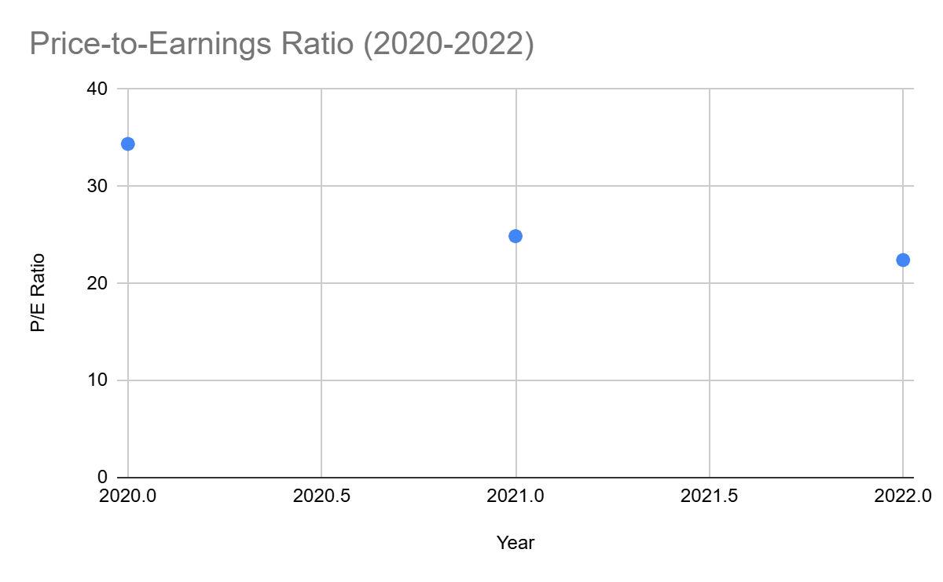

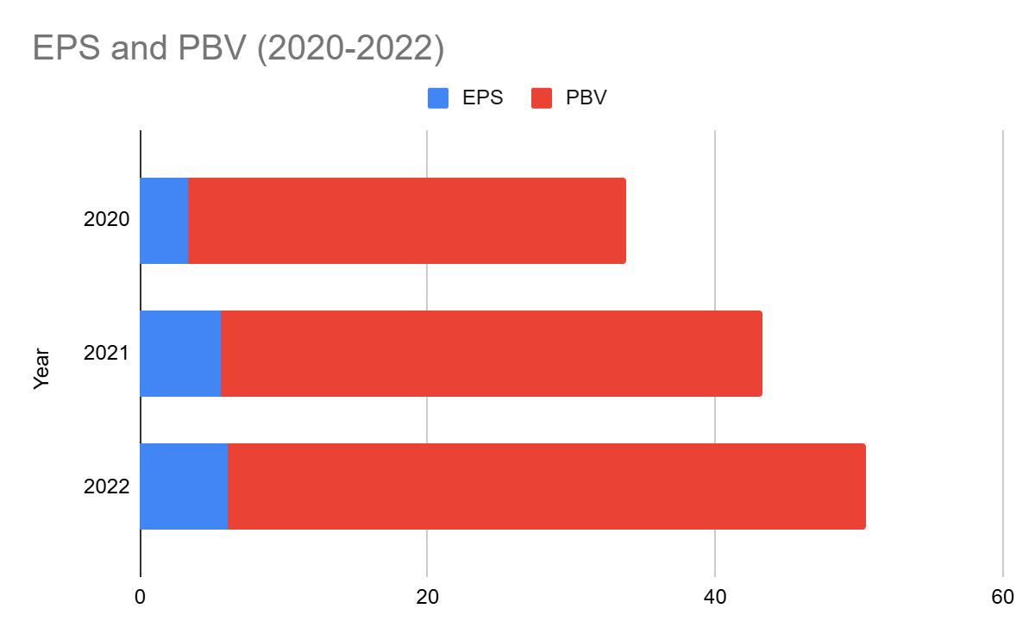

### **A scatter plot for the P/E ratio over time and a bar chart for EPS and PBV to illustrate investor confidence and stock performance.**

## **6. Growth Rates**

Growth rates show how different categories of sales and key financial items have grown over time.

* **Sales Growth**: 7.79% in 2022, down from 33.25% in 2021. This suggests the company’s sales growth has slowed significantly.
* **Gross Profit Growth**: 11.74% in 2022, compared to 45.65% in 2021, indicating a deceleration in profit growth.
* **Net Income Growth**: 5.41% in 2022, compared to 64.92% in 2021, signaling slowing bottom-line growth.

### **Chart**

### **A line graph showing growth rates for sales, gross profit, and net income over the three years.**

## **Conclusion and Recommendations**

Overall, Apple Inctf demonstrates strong profitability, improved asset utilization, and solid debt management, but liquidity concerns are evident. The decline in liquidity ratios could create short-term risks, and the increasing reliance on debt should be monitored. The company’s stock remains attractive, with rising earnings per share and investor confidence, but growth rates have slowed in 2022.

### **Recommendations:**

1. **Improve Liquidity**: The company needs to focus on improving its liquidity position by increasing its current ratio, quick ratio, and cash ratio
2. **Reduce debt**: The company needs to reduce its debt-to-equity ratio and debt-to-total-assets ratio by paying off its debts and reducing its borrowing.
3. **Maintain profitability**: The company needs to maintain its profitability by controlling its costs and maintaining its pricing power.
4. **Improve asset utilization**: The company needs to continue to improve its asset utilization by generating more sales from its assets.