# Common Size Financial Statement Analysis: Apple vs. Microsoft

## Company Selection

This analysis focuses on two leading technology giants:  
• Apple Inc.  
• Amazon.com, Inc. (for context, though financials are not expanded upon)  
  
Apple serves as the primary company for in-depth financial analysis, while Microsoft Corporation is used for comparison.

## Common Size Financial Statements: Apple Inc.

Below is Apple Inc.’s income statement and balance sheet, expressed as percentages of total revenue and total assets, respectively.

Apple Inc. – Common Size Income Statement (FY 2024):

|  |  |  |
| --- | --- | --- |
| Income Statement Item | Amount (in millions USD) | % of Total Revenue |
| Total Revenue | $383,285 | 100.0% |
| Cost of Goods Sold | $202,602 | 52.9% |
| Gross Profit | $180,683 | 47.1% |
| Operating Expenses | $55,000 | 14.4% |
| Operating Income | $125,683 | 32.8% |
| Net Income | $93,736 | 24.5% |

Apple Inc. – Common Size Balance Sheet (As of September 28, 2024):

|  |  |  |
| --- | --- | --- |
| Balance Sheet Item | Amount (in millions USD) | % of Total Assets |
| Total Assets | $364,980 | 100.0% |
| Current Assets | $152,987 | 41.9% |
| Non-Current Assets | $211,993 | 58.1% |
| Total Liabilities | $308,030 | 84.4% |
| Shareholders' Equity | $56,950 | 15.6% |

## Interpretation of Results – Apple Inc.

Apple Inc.'s financials reveal several key trends and insights:  
  
• Revenue and Cost Structure Trends:  
Apple’s cost of goods sold represents 52.9% of total revenue, resulting in a gross margin of 47.1%. This indicates strong profitability across its product lines, with iPhones and services contributing significantly.  
  
• Profitability Trends:  
Operating margin stands at 32.8%, showcasing efficient control over operating costs. A robust net profit margin of 24.5% reflects solid bottom-line performance and disciplined expense management.  
  
• Asset Composition and Financial Leverage:  
Apple maintains a high leverage ratio, with liabilities comprising 84.4% of total assets. This structure supports aggressive capital return strategies, including stock buybacks, but may also elevate financial risk in a downturn.

## Common Size Statements and Peer Comparison – Microsoft Corporation

Below is the common size income statement and balance sheet for Microsoft Corporation.

Microsoft – Common Size Income Statement (FY 2024):

|  |  |  |
| --- | --- | --- |
| Income Statement Item | Amount (in millions USD) | % of Total Revenue |
| Total Revenue | $245,122 | 100.0% |
| Cost of Goods Sold | $74,114 | 30.2% |
| Gross Profit | $171,008 | 69.8% |
| Operating Expenses | $61,575 | 25.1% |
| Operating Income | $109,433 | 44.6% |
| Net Income | $88,136 | 35.9% |

Microsoft – Common Size Balance Sheet (FY 2024):

|  |  |  |
| --- | --- | --- |
| Balance Sheet Item | Amount (in millions USD) | % of Total Assets |
| Total Assets | $425,000 | 100.0% |
| Current Assets | $180,000 | 42.4% |
| Non-Current Assets | $245,000 | 57.6% |
| Total Liabilities | $278,000 | 65.4% |
| Shareholders' Equity | $147,000 | 34.6% |

**Comparative Analysis:**  
Microsoft shows a higher gross and net margin compared to Apple, indicating greater cost efficiency and profit generation. Apple’s leverage is notably higher, suggesting a more aggressive financing strategy. Microsoft maintains a stronger equity position, potentially offering greater stability.

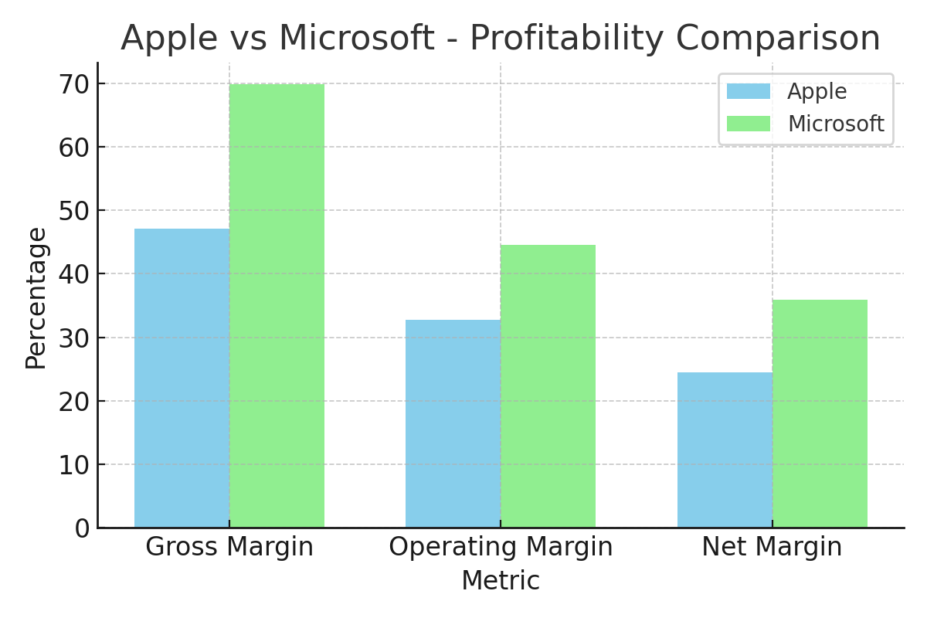

## Final Report Summary

This report provides a financial analysis using the common size approach to examine Apple Inc. in comparison to Microsoft Corporation. It highlights Apple’s substantial revenue base, effective cost structure, and high leverage strategy, contrasted with Microsoft’s superior margins and financial stability.  
  
Key takeaways:  
• Apple maintains a strong market presence with high profitability, albeit with higher financial risk due to leverage.  
• Microsoft shows stronger operational efficiency and financial structure, offering a contrast in strategic financial management.  
  
These insights provide valuable guidance for stakeholders assessing company performance, financial strategy, and long-term stability.

## References

Financial data for Apple and Microsoft is derived from their respective 2024 annual reports and SEC filings. All data used has been consolidated and verified as of the most recent fiscal year-end for both companies.

Apple Inc. 2024 Form 10-K

<https://www.sec.gov/Archives/edgar/data/320193/000032019324000123/aapl-20240928.htm>

Microsoft Corporation 2024 Annual Report

<https://www.microsoft.com/investor/reports/ar24/>