Financial Health Report
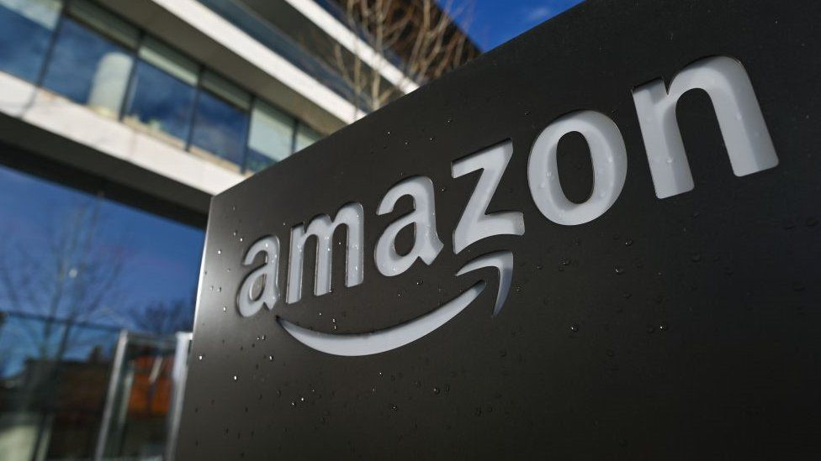
Amazon Inc. (2021/22)
Simon Ansari

Executive Overview
The year of 2021 was characterised by a gradual transition to a welcomed post-pandemic environment, and the habitual change of consumers who started to gain access to a de-restricted world once again. Despite the “short-term logistics and cost challenges” (Amazon, 2021) of expansion, Amazon managed to undergo rapid revenue growth within many parts of their core business; with special mention to their coveted high-margin Amazon Web Services (AWS) model which grew “37% YoY” (Amazon, 2021). However, amidst geopolitical tensions and global inflationary pressures, 2022 proved a more challenging year for many businesses globally, even with the vast diversified operations of Amazon. ”Change is always around the corner. Sometimes, you proactively invite it in, and sometimes it just comes a-knocking” (Amazon, 2022) was the sentiment of the CEO Andy Jassy as Amazon strived to navigate a tough phase of the macro-economic environment with optimism of continued strengthening of their structural integrity and resilience to cyclical downturns. The following report will depict 5 key areas of financial performance to evaluate this notion.

(1) Liquidity
The three ratios that provide coverage across the spectrum of liquid assets to cover short-term liabilities were precisely indicative of the tough macro-economic environment with the current, quick and cash ratio all diminishing from 2021 to 2022. These ratios changed from 1.14:1, 0.91:1 and 0.68:1 to 0.94:1 0.72:1 and 0.45:1 respectively. Amazon’s working capital cycle was affected to a lesser extent however, with effective cash flow management meaning the negative trading cycle changed from -36.13 days to -27.03. This delineates Amazon’s ability to leverage it’s economies of scale and perceived stability to maintain the Payable/Receivable days differential (70.51 days).
The Current ratio is greater than 1 indicating the short-term asset’s ability to meet short term liabilities. Quick and Cash ratios above 0.5 which also indicates that the company can meet more than 50% of its short-term liabilities with its cash in hand. The decline in current ratio was mainly to be attributed to a reduction of marketable securities (following the sale of the company’s stake in Rivian).

As an online marketplace where thousands of vendors are hosted on site, Amazon’s payable days is typically higher than other companies as it is part of its 90-day credit policy. As a result of Amazon’s nature of business, its payable balances are higher than its inventories and receivables where it holds inventory on behalf of its vendors. Therefore, working capital is negative and so is the trading cycle. On a year over year basis the number has worsened, but can be supported with the argument that Amazon has started its own fulfilment services and is a fast growing company.

(2) Profitability
A silver lining for Amazon under the period of 2021/22 is their continuing ability to stimulate sales revenue with relatively significant increases over the two years. The percentage growth was 21.7% (2021) and 9.4% (2022). The difficulty for Amazon came from venturing down the top to bottom line, over the latter year particularly. Jassy lamented that a “critical challenge we’ve continued to tackle is the rising cost to serve in our Stores fulfillment network (i.e. the cost to get a product from Amazon to a customer)” (Amazon, 2022) of which these supply chain issues had a large impact on operating and net profits. These fell from grace in 2022 with margins shrinking to 2.38% from 5.3% and succumbing to a net loss margin of (-) 0.59% from 7.1%.
Amazon’s long-term liabilities have been increasing over the years as the company has increased its Financial lease commitments to facilitate the number of new fulfilment centres opened over the last year. Although the long-term debt remain rather steady, financial lease commitments have dramatically increased which has increased the debt service burden as well. However, the company has adequate levels of interest coverage and free cash flow indicating its financial health. However, the increase in the debt level would also mean that the company’s borrowing capacity in future is strained where it might have to pay higher interests to secure more debt.

(3) Solvency/Debt Management
Given the previous assessments on Amazon’s profitability over 2022, the debt management ratios follow in line with expectations, with expected deteriorations on the income statement transmitting over to the balance sheet. Cause for concern related to borrowing was less detrimental, given their healthy gearing position. Debt proportionately increased from 0.35:1 to 0.46:1 relative to equity, and in comparison to total assets, it changed from 0.12:1 to 0.15:1. However, there may be some investor worries over short-term measures, with Interest/Debt coverage both presenting negative values (-5.17/-3.38 respectively) on the back of the net loss produced by the conglomerate. This was compensated well by Amazon’s free cash flow management, who managed to juice their free cash flow per share (FCFE) from 0.26 to 0.54, driven by recouping more proceeds from short and long-term debt issued.
It is notable that Amazon’s Technology & content and Sales & marketing have seen sharp increases, indicating the heavy spend on AWS and Prime Video content. While the e-commerce segment is seen to be normalizing post the Covid-19 boom, sales reflect the increasing global inflation levels.

(4) Asset Utilisation
The efficiency of Amazon utilising their assets to produce returns was also adversely affected, albeit to a lesser extent. We saw marginal declines in the total & fixed asset turnover ratios, from 1.12 to 1.11, and 2.93 to 2.75 respectively. Return on assets (ROA) followed suit naturally, as losses depicted previously (2) caused a percentage decrease of 8.52% YoY (2021/22). Inventory turnover remained largely unchanged, with a slight rate increase from 8.34 to 8.4.
Amazon has a large portion of goodwill in its asset base, where the Fixed asset turnover is almost three times higher than the total asset turnover. The goodwill and intangibles are manly as a result of acquisitions in addition to the increased R&D spending on AWS which we will have to closely watch for future profitability.

(5) Investor/Market Ratios
The notorious strategy of US technology titans to avoid paying dividends to shareholders, on the basis of their growing power, was tested over the course of 2022. Amazon witnessed a collapse in their market valuation, as investor fears (stimulated by weak/negative earnings) led to a year end change (from 2021 to 2022) in share price of -49.62%. Earnings per share (EPS) and subsequently price-to-earnings (P/E) fell to -0.27 and 0 respectively. Some investors may pose the rationale of Amazon trading at a cheap fundamental value at year end (2022). This notion is supported by a Price to Book (PBV) of 5.86 times, in comparison to 12.2 and 17.44 in the two previous years. Despite this observation, assessments of valuation are subjective, and reliant on Amazon’s future ability to counter the current trend of high operating costs which slashed margins, and also their ability to navigate a dynamic global environment and tense geopolitical landscape.
ROE, ROA and ROCE all are within the health territory, however, have declined slightly compared to previous year. Furthermore, given Amazon’s valuations, one would expect the ratios to be better as there are many other smaller companies with better returns than Amazon, however, it is notable that these valuations are backed by Amazon’s expansion.

References:
Andy Jassy (2022), Amazon Inc. Annual Report, Available at: https://s2.q4cdn.com/299287126/files/doc_financials/2023/ar/Amazon-2022-Annual-Report.pdf, (Accessed 18/11/2023)
Andy Jassy (2021), Amazon Inc. Annual Report, Available at: https://s2.q4cdn.com/299287126/files/doc_financials/2022/ar/Amazon-2021-Annual-Report.pdf, (Accessed 18/11/2023)

