**Marriot Inc.**

**Revnue Drivers**

Q3 2023

**Revenue Breakdown into Price/volume data for Marriott:**

**Base Management Fees:**

$306 million (Increase of 11% from $275 million)

**Franchise Fees:**

$748 million (Increase of 10% from $678 million)

**Incentive Management Fees:**

$143 million (Increase of 35% from $106 million)

**Contract Investment Amortization:**

$(23) million (5% decrease from $(22) million)

**Owned, Leased, and Other Revenue:**

$363 million (Increase of 5% from $345 million)

**Cost Reimbursement Revenue:**

$4,391 million (Increase of 12% from $3,931 million)

Revenue is driven as RevPAR * No. Rooms where,

RevPAR is the function of ADR (price impact) * Occupancy (volume impact)

Note that for each of the segments, North America (full service, limited service), APAC and Other international, RevPAR, Room count Occupancy and ADR are reported by the company. These will be forecasted based on historical trend analysis.

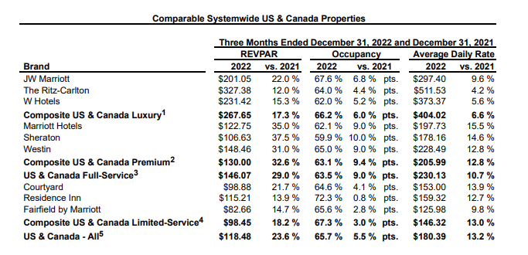

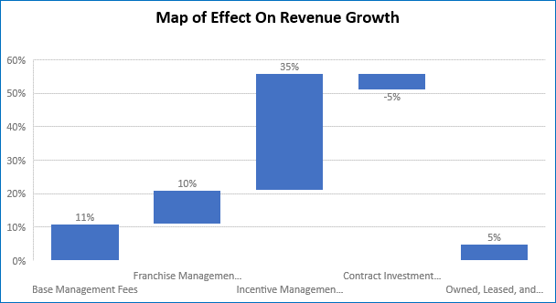

**Cost Drivers**

Large portion of Marriot’s cost is the reimbursed expenses which is directly related to reimbursed revenue. Management and franchise related operating expenses will have be derived as a % of revenue.

Quarterly Sept 2023

* **Cost of Services:** Variable, Depends level of business activity for Marriot.
  + $301 million
* **Depreciation, Amortization, and Other:** Fixed Cost
  + $46 million
* **General, Administrative, and Other:** Variable Cost, these are things like salary, Office Supplies, other business expenses that vary.
  + $239 million
* **Merger-Related Charges and Other:** Does not completely correlate with Revenue is often a one-time thing.
  + $13 million
* **Reimbursed Expenses:** Variable on the number of employees and how much they are spending.
  + $4,238 million

**Performance Analysis:**

The third quarter for Marriot in 2023 was a strong one. Revenue was up in all categories in comparison to this time in 2022. It is noticed that more money was spent in the third quarter of 2023 in comparison to the 3rd quarter of 2022 for contract investment amortization. In regard to cost drivers in Quarter 3 of 2022 there were less costs for “Owned, leased, and other” and “Depreciation, amortization, and other”. Overall, however there was more costs in the third quarter of 2023 compared to 2022. This is not worrisome though the business did see a high increase in total net income over the year. This shows that more money needs to be spent to make more money for the company.

**Comparison to Competition: 3rd Quarter 2023 in millions**

|  |  |  |  |  |
| --- | --- | --- | --- | --- |
| Company | Marriot Inc | Hilton Hotels | Hyatt Hotels | Wyndham Hotels & Resorts |
| Total Revenues | $5,928 | $2,673 | $1,622 | $402 |
| Total expenses | $4,829 | $2,020 | $1,514 | $239 |
| Net Income | $752 | $ 379 | $68 | $103 |

**Johnson & Johnson**

**Revenue Drivers**

Q3 2023

Each of the three segments, Consumer, Pharmaceuticals and Medical Devices have sub segments with product lines like Remicade, Darzalex , Stelara and Tremfya  or Surgery, Orthopaedics and Intervention solutions. All of these lines have US & International sales. US revenue can be driven by annual growth rates, international revenue growth has two components, organic growth and currency impact.

**Revenue Breakdown into Price/volume data for Johnson & Johnson:**

**International Innovative Medicine:** $5,644 Million (2.3% decrease from Q3 2022)

**U.S. Innovative Medicine:** $8,249 Million (10.9% increase from Q3 2022)

**International Med Tech:** $3,711 Million (8.3% increase from Q3 2022)

**U.S. Med Tech:** $3,747 Million (11.6% increase from Q3 2022)

**Cost Drivers**

Q3 2023

Cost Drivers – as % of revenue (trend analysis)

* Selling, Marketing and Administrative Expenses
* Research and Development Expenses
* In-process research and development
* Cost of products sold

1. **Cost of Products Sold:** $6,606 million, Variable Cost because it varies with the amount of production
2. **Selling, Marketing, and Administrative Expenses:** $5,400 million, Variable cost depending on marketing campaigns, staffing, and sales commissions.
3. **Research and Development Expense:** $3,447, Fixed Cost
4. **In-Process Research and Development Impairments:** $206 million (1.0% of revenue)
5. **Interest (Income) Expense, Net:** ($182 million), Impairment Charge
6. **Other (Income) Expense, Net:** $499 million, Fixed Cost
7. **Restructuring:** $158 million, Fixed Cost

**Performance Analysis:** In the Third Quarter of 2023 Johnson and Johnson saw a strong increase in revenue compared to Q3 2022. Overall Revenue was up 6.8%. It is worth noting that the revenue from international innovative medicine saw a decrease of 2.3% compared to Q3 2022. All other categories of revenue did increase, however. Costs did go up as well in Q3 of 2022 they were $14.82 Billion compared to $16.13 Billion in Q3 of 2023. Well, this number is alarming Johnson and Johnson had a much higher net income this quarter, finishing with $26.03 Billion largely due to it net earnings of discontinued operations.

**Comparison to Competition: 3rd Quarter 2023 in Billions**

|  |  |  |  |
| --- | --- | --- | --- |
| Company | Johnson and Johnson | Pfizer. | Moderna |
| Total Revenue | $21.35 | $13.23 | $1.83 |
| Total Costs | $16.13 | $14.5 | $3.4 |
| Net Income | $26.03 | -$2.38 | -$3.63 |