Marriott International Inc.

The 2022 Annual Report states for Marriott International the annual revenue was $20,773 million compared to 2021’s $13,857 million. The quarterly press release and financial tables report for September 2023 –3 months ended- puts the company’s earnings around $5,998 million compared to the previous year’s $5,313 million. Revenue per available room for Marriott Hotel & Resorts (subsidiary) being $168 for comparable company operated for 3 months end and 9 months end, with $141 for comparable system wide.

The biggest revenue driver for Marriott International or Marriott Hotels & Resorts is arguably their strategy. The business relies on brand development, customer loyalty and hotel operations (fee-driven & asset-light). Revenue drivers also include packages, reservations, catering and dining and personalised ‘traveler’ experiences. The global presence of Marriott is also a driver as they possess over 8,200 properties, 1,525,000 rooms and over 30 subsidiaries.

Revenue is driven as RevPAR * No. Rooms where,
RevPAR is the function of ADR (price impact) * Occupancy (volume impact)
Note that for each of the segments, North America (full service, limited service), APAC and Other international, RevPAR, Room count Occupancy and ADR are reported by the company. These will be forecasted based on historical trend analysis.
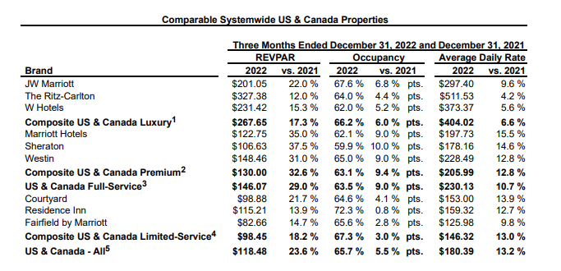

Cost drivers for Marriott International include annual incentives and equity compensation alongside the base salary [Proxy statement 2023]. $17,311 million was the operating cost/expense for Marriott in 2022 with over $15,000 million coming from Reimbursed expenses, this may suggest that the Marriott’s 377,000 employees are quite productive and active in the Marriott business model.

Large portion of Marriot’s cost is the reimbursed expenses which is directly related to reimbursed revenue. Management and franchise related operating expenses will have be derived as a % of revenue.

The performance of Marriott International regarding its revenue and cost drivers is unsurprising as they are the world’s largest lodging company and have the most rooms for hotels and resorts by a wide margin. Economies of scale may also be vital to its success as its global reach and innovative booking (loyalty programs) and employee training generate a stronger brand and business.

Company Peers and their performances compared to Marriott:

- Hilton Worldwide Holdings Inc, revenue of $8.77 billion against an operating expense of $6.679 billion
- Wyndham Hotels and Resorts, net revenue of $1.49 billion against an operating expense of $940 million

As a percentage of revenue Hilton’s operating expenses were 76.16%, compared to Wyndham’s 63.09% although Wyndham had far weaker revenue. The Marriott had a ratio between revenue and operating expenses of 0.667 which is superior to Hilton, which had a more comparable revenue than that of Wyndham but at a higher ratio.

Johnson & Johnson

The 2022 Annual Report states J&J’s (gross revenue) worldwide sales to consumers to be $94,943 million which is $1,168 million more than the previous year. Total consumer health sales decreased by 0.5% from $15 billion to $14.95 billion. The company had net earnings of $17,941 million in 2022.
However, in August of 2023 the consumer healthcare business centre became its own publicly traded company, Kenvue, of which J&J owns 92% of shares.

Each of the three segments, Consumer, Pharmaceuticals and Medical Devices have sub segments with product lines like Remicade, Darzalex , Stelara and Tremfya or Surgery, Orthopaedics and Intervention solutions. All of these lines have US & International sales. US revenue can be driven by annual growth rates, international revenue growth has two components, organic growth and currency impact.

The biggest revenue driver for Johnson and Johnson is the pharmaceutical business as it accounts for more than 50% of the revenue and the biological medications are utilised in inflammatory diseases, arthritis, cancers and schizophrenia. Within the medical devices business J&J focuses on orthopedics, vision, surgery and interventional solutions (i.e. disorders and care professionals). Another revenue driver for J&J may be its over 100-year-old brand name as well as collaboration and innovation as J&J spends more than $10 billion annually on Research and Development (a primary cost driver as well). Oncology and Immunology brought in over $30 billion in revenue.

The operating expense for Johnson and Johnson was a total of $73 billion (revenue – net income); with research and development - as it is one of the largest cost drivers- having been an expense of $14.6 billion with $11 billion spent on pharmaceuticals, $2.5 billion on medical technology and $500 million spent on consumer health. as it is one of the largest cost drivers. Over $40 billion in operating costs were R&D as well as selling, marketing and administrative.

Cost Drivers – as % of revenue (trend analysis)
- Selling, Marketing and Administrative Expenses
- Research and Development Expenses
- In-process research and development
- Cost of products sold

The performance of Johnson and Johnson regarding revenue and its cost drivers shows it is a strong business model and a pharmaceutical company that increases profitability through its continual innovation (spending over 10% of its sales on technological research) and global collaboration with over 30 subsidiaries. J&J is one of only 2 US based companies with a credit rating of AAA, this further shows how Johnson and Johnson are creditworthy and possess a strong capacity for financial commitment.

Company Peers and their performances compared to Johnson & Johnson:

- Novo Nordisk, revenue of $177 billion against an operating expense of $122 billion
- AstraZeneca, revenue of $44.4 billion against an operating expense of $42 billion
- Pfizer, revenue of $100 billion against an operating expense of $60 billion

Novo Nordisk and Pfizer being Johnson and Johnson’s largest competitors had comparable revenues and operating expenses. AstraZeneca had the smallest revenue and the highest operating expense to revenue ratio 0.946, compared with 0.689, 0.6, 0.768 for Novo, Pfizer and Johnson and Johnson respectively.

