Marriot Inc. b82978a6-9d28-4e38-9855-fc4ae2cebe11 (gcs-web.com) (2022 report)
For the full year 2022, gross fee revenues totalled $4.1 billion, a significant increase of more than 50 percent compared to 2021.

Cost Drivers
Increasing prices for food – Variable based general rise in cost of food seen especially with the cost of living crisis.
Advertising Costs ($635 million in 2022, $470 million in 2021, and $276 million in 2020)
Property Taxes – Fixed
Large portion of Marriot’s cost is the reimbursed expenses which is directly related to reimbursed revenue. Management and franchise related operating expenses will have be derived as a % of revenue.

Revenue drivers
Building and maintaining customer relationships#
Managing hotels
Covid 19 restrictions lifting
Revenue is driven as RevPAR * No. Rooms where,
RevPAR is the function of ADR (price impact) * Occupancy (volume impact)
Note that for each of the segments, North America (full service, limited service), APAC and Other international, RevPAR, Room count Occupancy and ADR are reported by the company. These will be forecasted based on historical trend analysis.
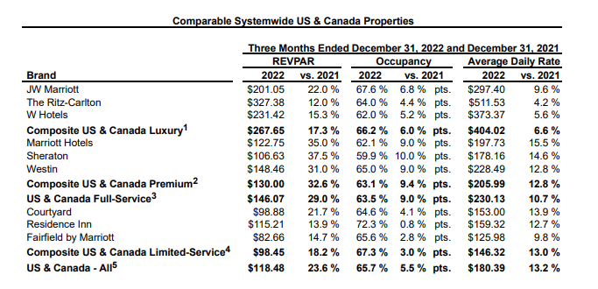
The overall finance performance of Marriot in the year 2022 was a huge increase of more than 50% from 2021. One main driver of this is the fact that the restrictions from covid 19 would have started to be lifted so the hotels could start to open up again which would have seen the revenues increase as the uk tourist numbers start to increase to pre covid levels. Once they were lifted Marriot Inc could then use this as an opportunity build and maintain new and existing customer relationships by offering deals and reward schemes to customers which would encourage spending from people in and out the uk. With customers then spending on rooms this would in turn increase the number of meals sold and breakfast and lunch time for those who purchased this options which would again help to increase the total revenue.

Over the years looked at while the overall revenue increased some major costs also increased. One of the main costs that increased is advertising costs. This figure looks to be on an upward trend over the last couple of years topping out at $635 million in 2022. Another factor which could have caused this increase is the lifting of covid restrictions as during 2020 when the lockdown was occurring the need to advertise will have been very low as they were unable to open in many places. If this cost continues to increase this will have a negative impact on financial health as revenue may not continue to increase at the levels it currently is meaning less and less of the revenue will actually be profits that can be reinvested into renovating hotels.
A hotel chain that can be compared to marriot inc is Hilton. In 2022, Hilton opened its 7,000th hotel worldwide, surpassed 150 million Hilton Honors members, and welcomed nearly 200 million guests. Comparing this to Marriot who accounted for 8,288 properties worldwide in 2022, up from 7,989 the previous year. By looking at these figures that supports the view for Marriots financial performance being at a level that is desirable as they have enough profits left over which they have used in the reinvestment of new hotels as they continue to expand and grow both and the UK and internationally in the US.
Johnson and Johnson

Cost drivers:
Research and development of new drugs (in recent years Olysia drug released for treatment of hepatitis C in adults) Drugs for this illness are among the most expensive in the world
Cost Drivers – as % of revenue (trend analysis)
- Selling, Marketing and Administrative Expenses
- Research and Development Expenses
- In-process research and development
- Cost of products sold

Revenue drivers:
Each of the three segments, Consumer, Pharmaceuticals and Medical Devices have sub segments with product lines like Remicade, Darzalex , Stelara and Tremfya or Surgery, Orthopaedics and Intervention solutions. All of these lines have US & International sales. US revenue can be driven by annual growth rates, international revenue growth has two components, organic growth and currency impact.

Birth rate- There were 605,479 live births in England and Wales in 2022, a 3.1% decrease from 624,828 in 2021 and the lowest number since 2002; the number remains in line with the recent trend of decreasing live births observed before the coronavirus (COVID-19) pandemic.

Johnson & Johnson generated a total revenue of 94.9 billion U.S. dollars in 2022 which is an increase from 2021 where they achieved Full-Year Sales of $93.8 Billion. With the company generating this much through sales and increasing by over 1billion from its previous year the financial health of the company is at a high level. One main factor to this is the production of their consumer products such as baby oil and baby power as there number of newborns for 2022 despite decreasing from 2021 is still over 600,000 meaning there will be a high demand for these products.
Another factor that will contribute to the high revenue is the sale of new drugs for varios illnesses and diseases.

While the sale of new medicines and drugs will be beneficial for Johnson and Johnson this is also a main cost driver that they will face. This is because the amount of research and development that is required to produce, test and sell a new drug is the highest expense that the company will face. While they can sometimes bring large returns as discussed in the previous point there are times where the drug will not be successful and they will not be able to recoup the expenses very easily. This means that some years this sector of the business may not generate them levels of profit desirable and could have caused them a loss which would negatively impact financial health. This means they may have struggled to produce newer medicines the following year while they continue to pay of costs.

A company that can be compared to Johnson and Johnson is Pfizer. This is because they are also a leading pharmaceutical company who are always researching a developing new drugs. Most recently they produced one of the two most popular and effective covid vaccines which was supplied throughout the UK during the worsts periods of the pandemic. The financial health of recent years in terms of profits generate for Pfizer could therefore be much larger as they will have generated large levels of profit which they continuously use to invest in further developing the covid vaccines to those who are still eligible to have more. Pfizer sold $37.8 billion of its Covid vaccine last year, a small increase of 3% compared with 2021 as demand for the shots slowed.

