Revenue Drivers:

1. Management and Franchise Fees: Marriott earns management and franchise fees primarily from its asset-light business model. These fees are calculated based on a percentage of property-level revenue. This is a significant revenue driver as it is a primary source of income for Marriott.

2. Franchise Agreements: Marriott also earns revenue from franchise agreements, which are typically calculated as a percentage of property-level revenue or a portion thereof. This revenue stream is influenced by the number of properties franchised under Marriott's brand.

3. Intellectual Property Fees: Marriott generates revenue from the use of its intellectual property, such as co-branded credit card programs, timeshare, and residential programs. This revenue is tied to the utilization of Marriott's brand and intellectual assets.

Cost Drivers:

1. Operating Costs: While not explicitly mentioned in the provided text, the costs associated with managing and franchising hotels include personnel costs, marketing expenses, and technology investments. These costs are typically variable and may vary with the number of properties managed or franchised.

2. Legal Expenses: Marriott expects to incur significant legal expenses related to the Starwood Data Security Incident. These expenses are related to legal proceedings, regulatory investigations, and potential monetary payments. Legal expenses can vary significantly based on the progress of legal actions.

Performance:
Marriott Inc. has demonstrated remarkable resilience and adaptability in the face of challenging global conditions, particularly the ongoing impact of the COVID-19 pandemic. Key factors influencing the company's performance include:
Revenue Growth: Marriott's revenue streams are driven primarily by management and franchise fees, as well as intellectual property fees. These fees, calculated as percentages of property-level revenue, constitute the backbone of the company's income. Marriott's robust expansion of its hotel portfolio, both in the United States and internationally, has been a pivotal driver of revenue growth. With an asset-light business model that emphasizes managing and franchising hotels rather than owning them, Marriott has successfully capitalized on opportunities in diverse markets worldwide. This expansion strategy not only fuels revenue growth but also bolsters the global reach of Marriott's brand portfolio.
Resilience During Pandemic: Despite facing significant challenges due to the COVID-19 pandemic, Marriott has demonstrated remarkable resilience in its financial performance. The RevPAR (Revenue per Available Room) and ADR (Average Daily Rate) metrics reveal a steady recovery trajectory. Marriott's ability to adapt to evolving market conditions and swiftly recover from pandemic-induced disruptions is evident in the statistics. The decline in RevPAR in the U.S. & Canada segment during 2022, compared to 2019, was minimal (-0.8 percent), reflecting the company's effective strategies for mitigating occupancy rate decreases through creative pricing strategies and marketing initiatives. The steady quarterly improvement in RevPAR and the strong recovery in certain markets within the U.S. & Canada underscore Marriott's capacity to bounce back from adversity.
System Growth: Marriott's strategic focus on expanding its system has yielded impressive results. The company's robust pipeline for development, which includes rooms under construction and approved for development, is a testament to its commitment to growth. A substantial portion of this growth occurs outside the U.S. & Canada, reflecting Marriott's global ambitions. Notably, conversions from competitor brands have contributed significantly to Marriott's expansion, showcasing the attractiveness of Marriott's brand offerings. The signing of new management and franchise agreements, encompassing a diverse range of properties, underscores the strength and versatility of the Marriott brand portfolio.
Legal Expenses: The mention of significant legal expenses related to the Starwood Data Security Incident raises a notable point of consideration. While Marriott remains confident in its long-term financial health, these expenses have the potential to impact the company's cost structure significantly. The uncertainty surrounding the ultimate financial impact underscores the importance of prudent financial management and risk mitigation measures.
In conclusion, Marriott Inc. has displayed commendable performance in navigating a complex global landscape. Its revenue drivers, bolstered by expansion, and its ability to manage costs effectively have positioned the company for continued growth. However, the persistence of evolving global conditions, including the ongoing pandemic, necessitates vigilance and adaptability. Marriott's financial health remains strong, and its ability to seize opportunities in a rapidly changing industry remains a hallmark of its success.

Peer Comparison: In comparison to Hyatt Hotels,

Thank you for providing the management discussion from Hyatt. Based on this information, here's a brief peer comparison between Marriott and Hyatt:

Ownership Model:
- Marriott primarily operates an asset-light business model, focusing on hotel management and franchising. They earn management and franchise fees as a percentage of property-level revenue.
- Hyatt, on the other hand, emphasizes ownership of selected hotels in key markets to enhance its brand presence and capture the full benefit of increases in operating profits.

Revenue Sources:
- Marriott generates revenues from management and franchise fees, intellectual property fees, and owned/leased hotel operations.
- Hyatt's revenues come from hotel operations, management and franchise fees, distribution and destination management services, and other sources, including its vacation ownership program.

Global Reach:
- Marriott has a global presence, with significant operations outside the United States, accounting for a substantial portion of its revenue and assets.
- Hyatt also operates internationally, but its revenue and asset base is slightly more concentrated in the United States.

COVID-19 Recovery:
- Both Marriott and Hyatt have experienced significant improvements in RevPAR and revenues as they recover from the COVID-19 pandemic. Leisure demand has been a key driver of this recovery.
- However, uncertainties remain, such as the impact of new COVID-19 variants and supply chain challenges, which may affect future financial results.

Key Metrics:
- Both companies use key metrics like RevPAR (Revenue per Available Room), ADR (Average Daily Rate), and Occupancy to assess hotel performance.
- They also focus on Adjusted EBITDA as a key performance measure and use it for resource allocation and compensation decisions.

Competition:
- Both Marriott and Hyatt operate in a highly competitive hospitality industry, facing competition from various sources, including online travel agencies and peer-to-peer inventory sources.

Access to Capital:
- Access to capital is crucial for both companies, as they require significant investments for property development and maintenance. The availability and cost of capital can impact their growth strategies.

Expenses:
- Both companies have similar expense categories, including rooms expenses, food and beverage costs, distribution expenses, depreciation, selling, general, and administrative expenses, and more.

This comparison highlights similarities and differences in the business models, revenue sources, and strategies of Marriott and Hyatt, both of which are major players in the global hospitality industry.

Johnson and Johnson

Revenue Drivers:

1. Immunology Products: Sales of immunology products, including STELARA and TREMFYA, increased by 1.1% in 2022. The revenue growth was driven by the following factors:
- Strong Uptake of STELARA: STELARA's performance in treating Crohn's disease and Ulcerative Colitis contributed to revenue growth.
- Strength of TREMFYA: TREMFYA's effectiveness in treating Psoriasis and Psoriatic Arthritis led to increased sales.
- Uptake in Psoriatic Arthritis: Expanded usage of immunology products in treating Psoriatic Arthritis positively impacted revenue.

2. Oncology Products: Sales of oncology products increased by 9.9% in 2022. Key revenue drivers included:
- Strong Sales of DARZALEX: DARZALEX achieved strong sales due to share gains, market growth, and the uptake of the subcutaneous formulation.
- Global Launch of ERLEADA: ERLEADA's global launch contributed to revenue growth.
- Partially Offset by Competitive Pressure: Declining sales of IMBRUVICA and ZYTIGA due to competitive pressures and market suppression offset some of the revenue growth.

3. COVID-19 Vaccine: Sales of infectious disease products were impacted by the COVID-19 vaccine. While there was operational growth in vaccine sales outside the U.S., there was a decline in sales of other infectious disease products due to increased competition and the loss of exclusivity of PREZISTA.

Cost Drivers:

1. Competition: Biosimilar competition affected the sales of certain products. For example, lower sales of REMICADE were due to biosimilar competition, which resulted in reduced revenue.
2. Loss of Exclusivity: The loss of exclusivity of certain drugs, such as PREZISTA and ZYTIGA, in specific markets outside the U.S. impacted sales negatively.
3. Currency Impacts: Negative currency impacts affected the sales of neuroscience products. While there was operational sales growth in certain products, it was offset by currency fluctuations.
4. Competitive Pressure: Sales of IMBRUVICA and ZYTIGA were impacted by competitive pressures in the market.

Policy Changes:
- Johnson & Johnson implemented a policy that restricted direct delivery of products to locations other than the billing location. This policy affected contract pharmacy transactions involving non-grantee 340B covered entities. The company aimed to improve its ability to identify inappropriate duplicate discounts and diversion prohibited by the 340B statute. This policy update had discount implications that positively impacted sales to customers in 2022.
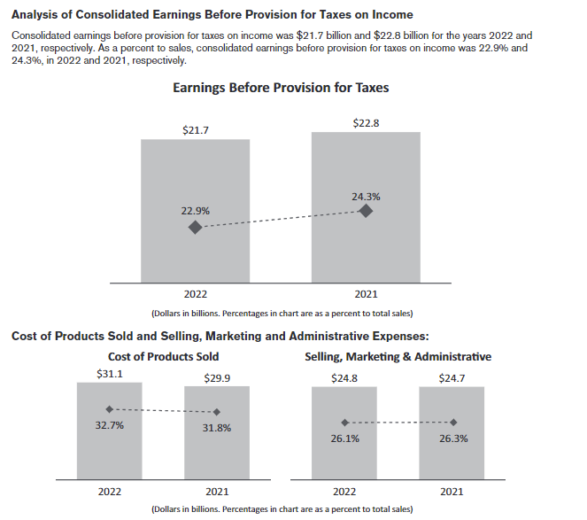
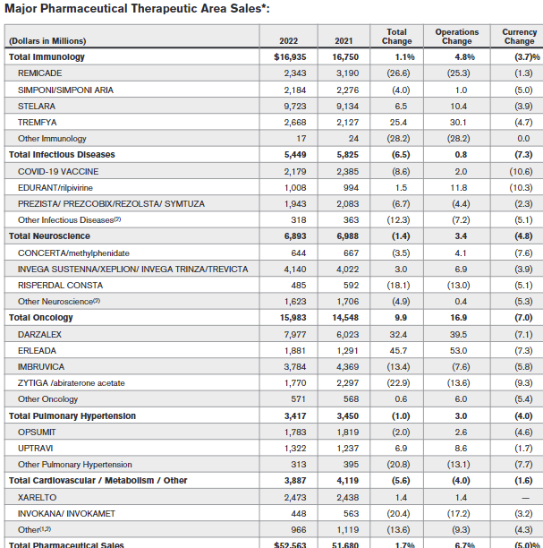

Performance Commentary for Johnson & Johnson (J&J):

In 2022, Johnson & Johnson (J&J) demonstrated a mixed financial performance, navigating through various challenges and opportunities. Several factors influenced the company's results, and a balanced assessment is crucial to understand the broader picture.

Revenue Drivers:
J&J's revenue drivers displayed a diverse landscape. Immunology products, led by STELARA and TREMFYA, showcased resilience, contributing positively to the top line. STELARA's strong performance in Crohn's disease and Ulcerative Colitis, alongside TREMFYA's effectiveness in treating Psoriasis and Psoriatic Arthritis, were notable highlights. These gains, however, were partially offset by competitive pressures and biosimilar competition, particularly impacting REMICADE.

Oncology products, driven by DARZALEX's robust sales and the global launch of ERLEADA, achieved commendable growth. DARZALEX's share gains and the adoption of its subcutaneous formulation underscored its success. However, the decline in sales of IMBRUVICA and ZYTIGA due to competitive pressures posed challenges.
The infectious disease segment felt the significant influence of the COVID-19 vaccine, driving operational growth outside the U.S. Nonetheless, sales of other infectious disease products, like PREZISTA, faced headwinds from increased competition and the loss of exclusivity.
Cost Drivers:
Competition and biosimilar alternatives impacted the cost structure, primarily affecting the sales of REMICADE. Loss of exclusivity in select markets outside the U.S. and competitive pressures led to revenue reductions in certain product categories.
Currency fluctuations had a notable effect, as operational sales growth in neuroscience products was offset by negative currency impacts. Moreover, competitive pressures in the market influenced the sales of IMBRUVICA and ZYTIGA.
Policy Changes:
J&J implemented a policy change regarding product delivery locations, particularly affecting non-grantee 340B covered entities. This shift aimed to enhance the identification of duplicate discounts and diversion prohibited by the 340B statute. The policy change had a positive impact on sales to customers in 2022.
Overall Assessment:
Johnson & Johnson's 2022 performance demonstrated adaptability in the face of market dynamics. The company strategically leveraged growth drivers, such as STELARA and DARZALEX, while addressing challenges like biosimilar competition and currency fluctuations. The impact of the COVID-19 vaccine was evident, but competitive pressures in certain segments required strategic adjustments.
The implementation of policies to strengthen compliance and discount management signifies a commitment to ethical business practices. J&J's ability to navigate evolving market conditions while maintaining a diversified product portfolio positions it for resilience and growth in the future.
As J&J looks ahead, it will likely continue to focus on innovation, market access, and operational excellence to optimize performance and deliver value to its stakeholders.

Comparison with Leading Peers:

Johnson & Johnson (J&J) faces a competitive landscape within the pharmaceutical and healthcare industry, where several leading peers also strive for market leadership. One notable peer is Pfizer Inc., a pharmaceutical giant with a strong presence in both innovative pharmaceuticals and vaccines. While J&J's 2022 results highlighted the impact of biosimilar competition and competitive pressures on certain products, Pfizer demonstrated its resilience with its COVID-19 vaccine, setting a high benchmark in vaccine development. Pfizer's ability to swiftly adapt to the pandemic environment and lead in vaccine distribution contributed significantly to its revenue growth. However, both companies share common challenges, including biosimilar competition, patent expirations, and competitive pressures in specific therapeutic areas. A key differentiator remains J&J's diversified healthcare portfolio, encompassing pharmaceuticals, medical devices, and consumer healthcare products, offering a more extensive range of revenue streams.

Another significant peer is Novartis AG, a global pharmaceutical company with a strong focus on research and development. J&J's 2022 performance reflects its reliance on immunology and oncology products for revenue growth, whereas Novartis boasts a robust pipeline and a well-established presence in areas like oncology, cardiovascular medicine, and ophthalmology. Novartis' emphasis on innovation and strategic acquisitions positions it as a leader in drug development and commercialization. Both J&J and Novartis encounter currency fluctuations, biosimilar competition, and evolving market dynamics, influencing their respective revenue and cost structures. The competition in the pharmaceutical industry will likely continue to be intense, with J&J's success hinging on its ability to innovate and adapt, and its diversified portfolio acting as a buffer against market volatility.

