**Marriott Inc. (Reference: Q1 2023 Report)**

**REVENUE DRIVERS:**

The identified revenue drivers for Marriott are RevPAR (revenue per available room), base management, incentive management, and franchise fees. The RevPAR is the most significant revenue metric, and it is a function of two components: the number of rooms occupied and the price. The relationship between these components and revenue is linear. For instance, the revenue soars in accordance with the number of rooms occupied and their price. Also, an increase in the RevPAR raises the other two revenue streams—base management and franchise fees.

**COST DRIVERS:**

The identified cost drivers are categorized into two: the general, administrative & other expenses; and the interest expenses. In relation to the revenue, increase in the duo components of the cost drivers lowers the revenue. For instance, for higher debt balances, the interest expenses increases and impacts the revenue negatively. A decrease in the general administrative & other expenses translates into higher net revenue.

Revenue is driven as RevPAR * No. Rooms where,

RevPAR is the function of ADR (price impact) * Occupancy (volume impact)

Note that for each of the segments, North America (full service, limited service), APAC and Other international, RevPAR, Room count Occupancy and ADR are reported by the company. These will be forecasted based on historical trend analysis.

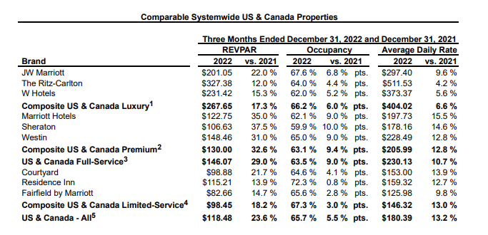

Large portion of Marriot’s cost is the reimbursed expenses which is directly related to reimbursed revenue. Management and franchise related operating expenses will have be derived as a % of revenue.

**PERFORMANCE IN LIGHT OF REVENUE AND COST DRIVERS:**

In Q1 2023, Marriott’s witnessed a 34.3% increase in RevPAR worldwide compared to the 2022 Q1. Across other markets where Marriott operates, like the US & Canada, RevPAR increased 25.6% and 63.1% in international markets. These increment were driven by the additional 79 properties (a total of 11015 rooms) to its worldwide lodging portfolio in Q1 2023.

Across the cost drivers, with a $202million estimated value of General, administrative & other expenses for Q1 2023, Marriott records a 3% decrease compared to Q1 2022 with an estimated cost of $208millions. However, in Q1 2023, the cost on Interest expense stood at $111million, a 26.1% increase compared to the $88 million in Q1 2022. This was driven by higher debt balance. Thus, higher debt balance is a key metrics that drives cost.

**MARRIOTT’S PEER AND ITS PERFORMANCE**

Peer Company: **Hilton Worldwide**.

In comparison to Q1 2022, Hilton’s RevPAR in Q1 2023 increased 30% on a currency neutral basis. This is 4.3% lower than Marriott’s. Hilton added 9200 rooms to its system, 1815 rooms less than Marriott’s.

**Johnson & Johnson Inc. (Reference: Q1 2023 Report)**

**REVENUE DRIVERS:**

The identified revenue drivers for Johnson & Johnson are the three segments of the business. They are **Consumer Health, Pharmaceutical and MedTech.** Pharmaceuticals contributed the highest revenue in sales to the worldwide sales revenue in Q1 2023. In comparison to Q1 2022, the highest change in revenue driver is the **Consumer Health** with 7.4%.

**COST DRIVERS:**

Several fixed cost drivers were researched and few, which are **research and development** and **selling, marketing and administrative expenses** are reported because of their high rate impact on sales.

Each of the three segments, Consumer, Pharmaceuticals and Medical Devices have sub segments with product lines like Remicade, Darzalex , Stelara and Tremfya  or Surgery, Orthopaedics and Intervention solutions. All of these lines have US & International sales. US revenue can be driven by annual growth rates, international revenue growth has two components, organic growth and currency impact.

Cost Drivers – as % of revenue (trend analysis)

* Selling, Marketing and Administrative Expenses
* Research and Development Expenses
* In-process research and development
* Cost of products sold

**PERFORMANCE IN LIGHT OF REVENUE AND COST DRIVERS:**

In Q1 2023, the Pharmaceuticals contributed majorly to the worldwide sales revenue. This is consistent with the previous year’s quarter which signals the Pharmaceuticals segment of the business as a major driver of the revenue. In terms of percentage change in year-on-year, the Consumer Health with 7.4% has the highest margin of revenue generated. Cost wise, the **selling, marketing and administrative expenses’** component of the cost has the highest cost to revenue ratio in Q1 2023. This is the same in Q1 2022. This results indicates a further technique to drive down this cost component while maintaining the effective sales strategy promises a soared revenue generation. Also, the **research and development** component of the cost driver witnessed a 2.9% increase in Q1 2023 compared to Q1 2022 although the marketing and administrative expenses still recorded the highest increase among other cost components.

**JOHNSON & JOHSON PEER AND ITS PERFORMANCE**

Peer Company: **Pfizer**

Unlike Johnson and Johnson, Pfizer are majorly into Pharmaceuticals which represent a subset of Johnson & Johnson’s business segment. In terms of the three revenue segments of each companies’ business, in values and growth rate, Johnson & Johnson performs better than Pfizer year-on-year.