Amazon Inc. Management Report Sidharth Nambiath

**Introduction**

This report aims to provide a comprehensive picture of the financial health of Amazon Inc, based on its performance from 2020 to 2022.

**Liquidity**

The current ratio between 2020 and 2021 was observed to rise, indicating a growth in Amazon Inc’s short term assets relative to its short term liabilities, as seen in Figure 1a. The quick ratio was also observed to rise during this period, demonstrating improved liquidity as a result of an increase in the proportion of highly-liquid assets compared to short-term liabilities. Conversely, the observed reductions of the current ratio and quick ratio between 2021 and 2022 may be a cause for concern; it suggests that short term liabilities grew at a faster rate than short term assets. Due to the fact that current ratio < 1.0, it may imply the firm could struggle to meet its short term obligations.

**Profitability**

There has been slight growth in the gross margin between 2020 and 2022, reaching a level of nearly 44%, suggesting stable and positive levels of retained sales revenue. The other profitability metrics present a mixed picture; the EBIDTA margin and net margin were both negative, with the former fluctuating at a particularly low level and the latter slowly reducing in magnitude. These yearly changes are reflected in figure 1b. It is worth noting that the individual segments of the Amazon conglomerate show vastly different levels of profitability, with the operating loss being almost $2.9 billion without the contribution of one single segment: AWS, which provided an overall operating income of $2.5 billion [1].

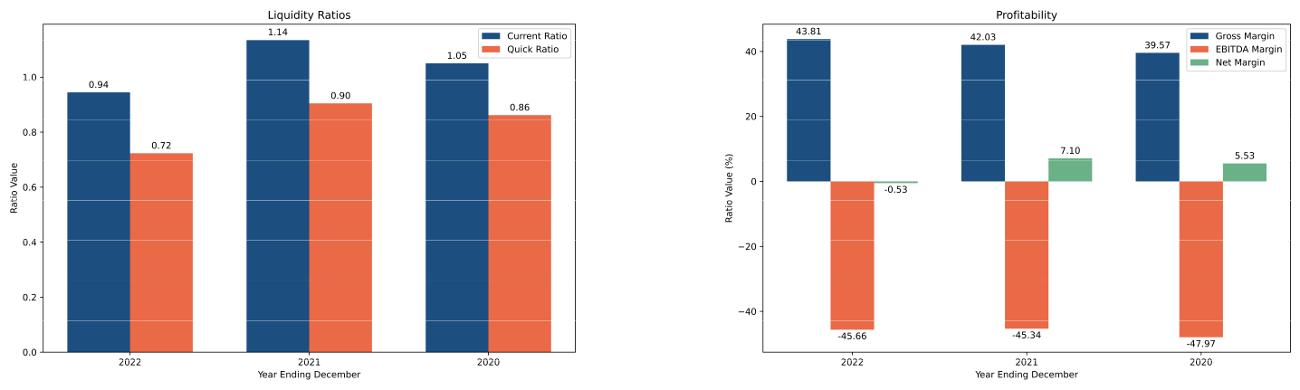

**(a)** The current and quick ratios between 2020-2022. **(b)** Profitability metrics between 2020-2022.

**Figure 1:** Liquidity and Profitability Metrics.

**Solvency and Debt Management**

The debt to equity ratio increased by 35% overall between 2020 and 2022. This indicates an overall increase in the financial leverage and risk. A similar pattern was observed in the debt to total assets ratio which may indicate that the firm’s debt structure has been kept relatively consistent throughout the period. It is possible that this could also be a result using debt financing to drive growth of the company, as per its business strategy [2].

1

Amazon Inc. Management Report Sidharth Nambiath

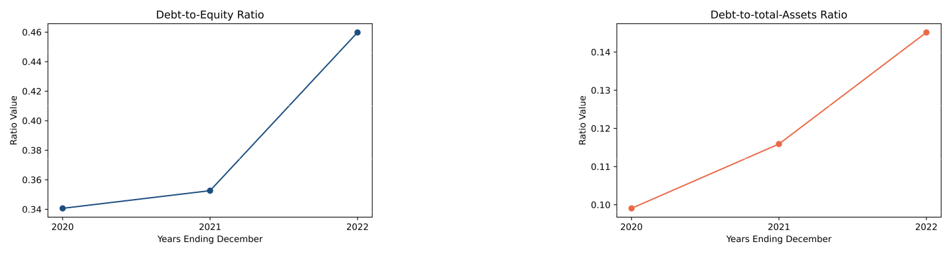

**(a)** Debt to Equity Ratio between 2020-2022. **(b)** Debt to Total Asset Ratio

**Asset Utilisation**

The operational efficiency of a company in terms of utilising assets to generate sales can be quantified via the total asset turnover ratio. For Amazon Inc, this was remarkably stable, only reducing by 7.5% to 1.11 by the end of Q4 2022.

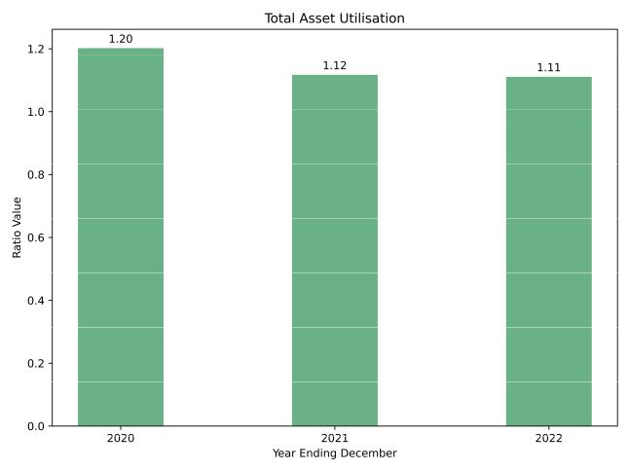

**Figure 3:** Profitability metrics between 2020-2022.

**Investor and Market Ratios**

The enterprise value to EBITDA ratio is a metric that indicates how overvalued or undervalued the market perceives the company to be, based on its current EBITDA. In the case of Amazon Inc, overall growth is observed between 2020 and 2022 as seen in Figure, and in both cases the ratio is rather high, suggesting that the company stock may be overvalued. The return on equity shows a different picture however. In 2020 and 2021, the ratio was positive, but as of 2022, there was a significant reduction to the point that it was negative. This suggests the company may struggle to cover shareholder equity with its net income.

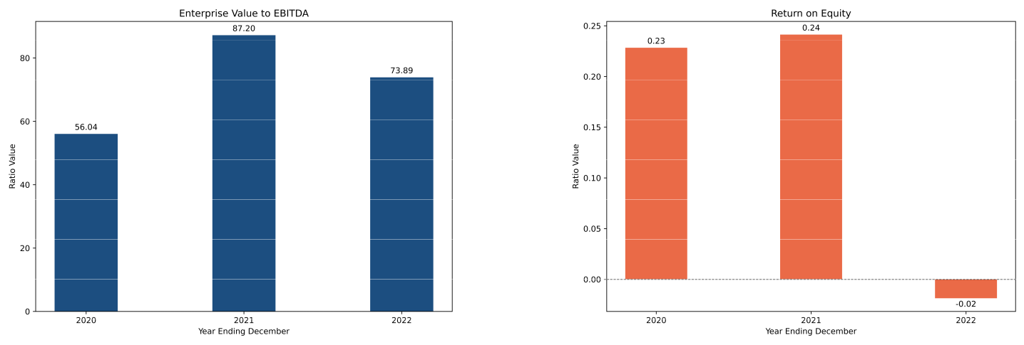

2

**Figure 4:** Investor and Market metrics between 2020-2022.

Amazon Inc. Management Report Sidharth Nambiath

**Conclusion**

In general, the financial health of Amazon Inc between 2020 and 2022, as evidenced by the aforementioned financial ratios, paints a complex picture. Ultimately, the rising solvency and debt management ratios are characteristic of firms that have a strategy to continue growth, which may accurately reflect the profile of Amazon Inc, especially with regard to its desire to expand its advertising revenue [3]. Of course, this time period coincides with the coronavirus pandemic. Indeed, all of the FAANG (Facebook, Amazon, Apple, Netflix and Google) companies saw soaring stock prices and market capitalisation, though by 2022, rising interest rates and a lack of confidence in the economy took its toll and the previously achieved high share prices were seen as overvalued, potentially explaining the high enterprise value to EBITDA ratios.

**Bibliography**

1. *Amazon Global Business Strategy*. URL: [https : / / www . studysmarter . co . uk / explanations / business - studies /](https://www.studysmarter.co.uk/explanations/business-studies/business-case-studies/amazon-global-business-strategy/) [business-case-studies/amazon-global-business-strategy/](https://www.studysmarter.co.uk/explanations/business-studies/business-case-studies/amazon-global-business-strategy/).
2. *Is Amazon Profitable? Amazon Profitability 1994-2022*. URL: [https://fourweekmba.com/is- amazon- profitable/#:~:](https://fourweekmba.com/is-amazon-profitable/#:~:text=in%20operating%20income.-,The%20high%20operating%20costs%20are%20primarily%20due%20to%20the%20high,AWS%20was%20removed%20in%202022.) [text=in%20operating%20income.-,The%20high%20operating%20costs%20are%20primarily%20due%20to%20the%](https://fourweekmba.com/is-amazon-profitable/#:~:text=in%20operating%20income.-,The%20high%20operating%20costs%20are%20primarily%20due%20to%20the%20high,AWS%20was%20removed%20in%202022.) [20high,AWS%20was%20removed%20in%202022.](https://fourweekmba.com/is-amazon-profitable/#:~:text=in%20operating%20income.-,The%20high%20operating%20costs%20are%20primarily%20due%20to%20the%20high,AWS%20was%20removed%20in%202022.).
3. Jason Goldberg. *Amazon Reveals Its Most Profitable Business*. Apr. 2022. URL: [https://www.forbes.com/sites/jasongoldberg/](https://www.forbes.com/sites/jasongoldberg/2022/02/04/amazon-reveals-its-most-profitable-business/) [2022/02/04/amazon-reveals-its-most-profitable-business/](https://www.forbes.com/sites/jasongoldberg/2022/02/04/amazon-reveals-its-most-profitable-business/)