**MARRIOTT INTERNATIONAL**

Marriot operates a fee-driven, asset-light business model. The main drivers are:

|  |  |
| --- | --- |
| ***Revenue Drivers:***   * Base Management Fees * Franchise Fees * Incentive Management Fees * Owned, Leased and Other * Cost Reimbursements | ***Cost Drivers:***   * Owned, Leased and other * Depreciation, Amortization and other * General, Administrative and other * Restructuring, merger-related charges * Reimbursed expenses |

The chart below shows how the revenue drivers have changed in the three most recent financial years; figures shown are in million dollars.

This chart shows the 3-year average weight of each driver on the total revenue.

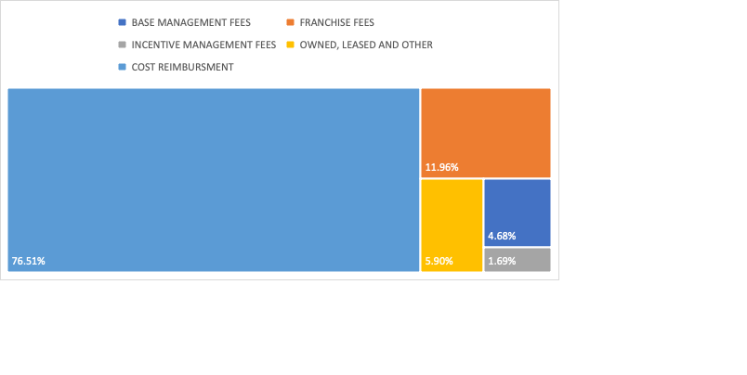

It’s worth noticing the percentage per year of each driver is never excessively detached from the average, but there’s an emerging trend of *cost reimbursement* slightly decreasing while all other drivers are slowly becoming more predominant. This is as well due to an increase in managed, franchised and leased properties which has increased revenue.

As for cost drivers, their growth/decrease is directly correlated to the company total revenue (advertising, salaries, taxes…) with the only exception being *restructuring, merger-related charges* – these are, in fact, very different each year and, while normally account for only 0.07% of the company expenses, in 2020 they accounted for 2.55%, reason being “*restructuring plans initiated in the 2020 second quarter to achieve cost savings in response to the decline in lodging demand caused by COVID-19, and transition costs associated with the Starwood merger*”.

An opposite trend is emerging in the cost drivers, for which the weight of *reimbursed expenses* is accounting for a larger portion in relation to the total expenses.

Marriott has performed better than its peers in the most recent triennium; in the following chart is possible to compares the company’s profits with the ones of some competitors.

It’s evident how Marriott managed to turn much better profits than its rivals and even doubled its profits in 2022 compared to the previous year; although Hilton still had an astonishing performance and succeeded in trebling theirs, Marriott however turned more profit alone than the other direct rivals combined, highlighting the company solidity and establishment in the lodging industry.

More encouraging numbers (relatively to a still challenging macroeconomic environment) are to be found in the stockholders return performance. Although Marriott has slightly underperformed the *S&P 500*, it’s recovering reasonably from the gap recorded at the heights of the global pandemic; furthermore, it reaffirms its sector leadership widely outperforming the *S&P 500 exclusive to Hotels, Resorts & Cruise Lines*.

Overall, the company seem to have had a very positive performance in 2022, but with the lodging industry being one of the most heavily affected ones by the immediate aftermath of the COVID-19 Pandemic, is therefore necessary to extend the research scope and include the 2017-2019 triennium to effectively measure how well the company has fared.

|  |  |  |  |  |  |  |
| --- | --- | --- | --- | --- | --- | --- |
|  | **2017** | **2018** | **2019** | **2020** | **2021** | **2022** |
| Total Revenue | 20,452 | 20,758 | 20,972 | 10,571 | 13,857 | 20,773 |
| Total Operating Expense | 17,948 | 18,392 | 19,172 | 10,487 | 12,271 | 17,311 |
| Gross Profit | 3,813 | 3,674 | 3,217 | 1,769 | 2,801 | 4,558 |
| Net Income | 1,459 | 1,907 | 1,273 | (267) | 1,099 | 2,358 |
| (All figures are in million dollars) | | | | | | |

It’s evident how the 2020 restructuring has paid off in the not-so-long-term.

The company has, in fact, managed to bounce back to its usual total revenue while also recording a sensibly reduced amount of total expenses. This means the net income for 2022 has grown almost 24% compared to 2018 despite a growth in revenue of just 0.07% and still 200 million USD shy of the record hit in 2019.

Not only the company has recorded RevPAR and ADR comparable to the previous years, expanding their portfolio and adding more rooms on a yearly basis, but they also significantly grew in other areas, especially with their co-branded credit card fees which recently launched in the Saudi market as well.

Moreover, the company is expanding into travel offerings as well to attract new and different clients to further enlarge the business while keeping its current customers loyal with an attractive loyalty program.

Cleary market leaders, Marriott have expanded their business and the outlook for the short- and long-term future seems very encouraging.