MARRIOTT INTERNATIONAL

Marriot operates a fee-driven, asset-light business model. The main drivers are:
Revenue Drivers:  - Base Management Fees  - Franchise Fees  - Incentive Management Fees  - Owned, Leased and Other  - Cost Reimbursements | Cost Drivers:  - Owned, Leased and other  - Depreciation, Amortization and other  - General, Administrative and other  - Restructuring, merger-related charges  - Reimbursed expenses

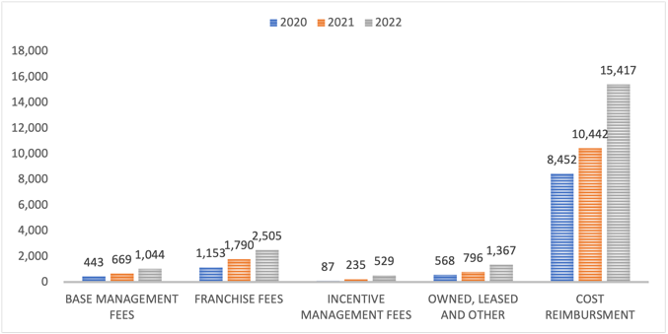 How the revenue drivers have changed in the three most recent financial years (figures shown are in million dollars)  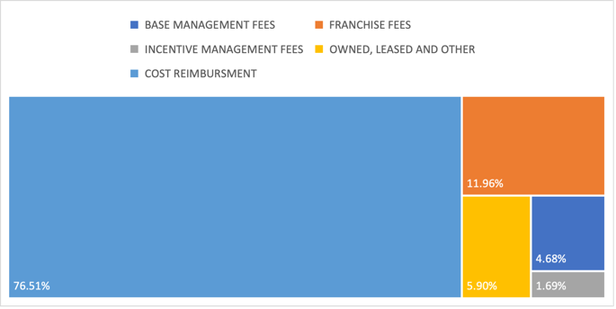  3-year average weight of each driver on the total revenue  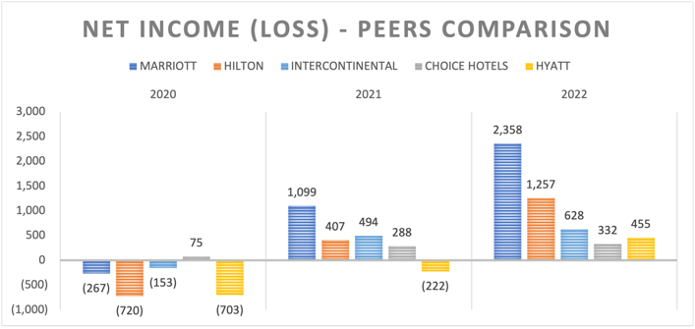  Marriott has performed better than its peers in the most recent triennium returning much higher profits. | Revenue has grown in the last triennium. Despite the percentage per year of each driver is very close to the average, a trend is emerging for which cost reimbursement is slightly decreasing while all other drivers are slowly becoming more predominant; this is due to an increase in managed, franchised and leased properties.  Cost drivers growth/decrease is directly related to the company total revenue with restructuring, merger-related charges being the only exception. These were very predominant in 2020 for cost-saving measures.  An opposite trend is emerging for which the weight of reimbursed expenses is accounting for a larger portion in relation to the total expenses.  Marriott managed to turn much better profits than its rivals and doubled its profits in 2022.  Although the company has underperformed the S&P 500, it’s quickly recovering and reaffirms its sector leadership widely outperforming the S&P 500 exclusive to Hotels, Resorts & Cruise Lines.  Overall, the company had a very positive performance in 2022, but is necessary to extend the research scope and include the 2017-2019 triennium since the lodging industry was one of the most affected ones by the pandemic.

 | 2017 | 2018 | 2019 | 2020 | 2021 | 2022
Total Revenue | 20,452 | 20,758 | 20,972 | 10,571 | 13,857 | 20,773
Total Operating Expense | 17,948 | 18,392 | 19,172 | 10,487 | 12,271 | 17,311
Gross Profit | 3,813 | 3,674 | 3,217 | 1,769 | 2,801 | 4,558
Net Income | 1,459 | 1,907 | 1,273 | (267) | 1,099 | 2,358
(All figures are in million dollars)
The company managed to bounce back to its usual total revenue while also recording a sensibly reduced amount of total expenses. Net income for 2022 has grown almost 24% compared to 2018 despite a growth in revenue of just 0.07%. The company also recorded RevPAR and ADR comparable to the previous years, expanding their portfolio and adding more rooms on a yearly basis, is expanding into travel offerings to attract new clients while keeping its current customers loyal with an attractive loyalty program, and grew in other areas with a co-branded credit card. Market leaders with an encouraging outlook for short- and long-term future.
JOHNSON & JOHNSON

J&J is organised into three segments and generates half of its revenue in the US. Its main drivers are:

Revenue:  - MedTech  - Pharmaceutical  - Consumer Health | Cost:  - Manufacturing costs  - Selling, Marketing and Administrative  - Research and Development

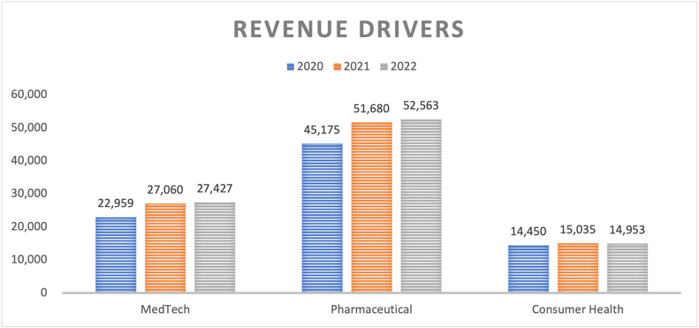  JNJ experienced revenue growth in MedTech and Pharmaceutical, and a minor decrease in Consumer Health in 2022.  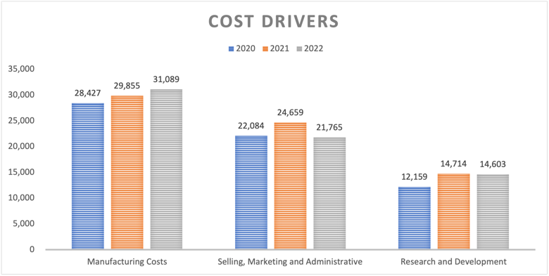  JNJ costs went down mainly in Sales, Marketing and Administrative and secondarily in Research and Development, while Manufacturing Costs arose.  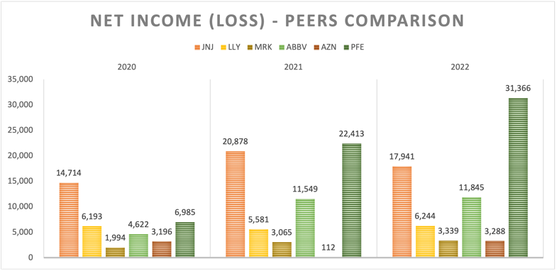  Solid profits for the company, way ahead of several competitors but runner-up to Pfizer for the second year in a row. | Slow but steady growth characterised the recent triennium. Higher revenue was recorded by the MedTech and Pharmaceutical segments (respectively accounting for 34% and 65% of the total revenue), while Consumer Health has been trivially lower; this might be attributed both to reduced advertising expenses but also to the transformation the company is undergoing for which this segment is becoming independent (operating as Kenvue).  Costs have a direct correlation to the company performances. In the most recent year R&D decreased driven by lower milestone payments in the pharmaceutical business, while cost of products increased mostly for currency impacts and commodity inflation.  J&J turned another very profitable year, and despite recording a lower profit than 2021, the company bested almost all of its competitors, being runner-up only to Pfizer for the second year in a row. As for TSR, the company has regained its crown in 2022, outperforming not only its competitors in the Pharmaceutical and Healthcare Equipment Indexes (many of which had outrageous growth in 2021 to then bounce back to pre-pandemic levels last year) but also the wider S&P 500. Remarkably, the company also outperformed this index when considering the 10-years TSR but fell short relatively to the industry index.
A clearly established industry leader, J&J turned a very healthy profit of almost $18B in 2022 although investing nearly $15B in Research & Development and another $18B in acquisition and mergers while increased the shareholders dividend at the same time (redistributing roughly $12B to investors!).

Not only this remarkable results came in a moment where the company and its peers have been affected by high inflation and unrelenting disruptions to the supply chain, but at the same time J&J is progressing toward a separation from its Consumer Health segment to streamline operations and further strengthen its position as a leading pharmaceutical company.

