Instructions:
- After deriving the intrinsic share price based on our model, the next step is to focus on putting together a report with an investment recommendation.
- You are required to fill in the report template below using the sample report attached and your readings on the company’s guidance in terms of key segments and products.
  - Identify two to three key products that are vital for the company’s growth and you can discuss about the trends and expectations. But remember to keep them all short cause and effect sentences.
- You can take up to two days for this task and feel free to reach out to me if you have any questions.

Company Name Nike Inc.
Ticker NKE (NYSE)
Current Share Price $114.59 (2023 average)
Upside/Downside to current share price +14.09%
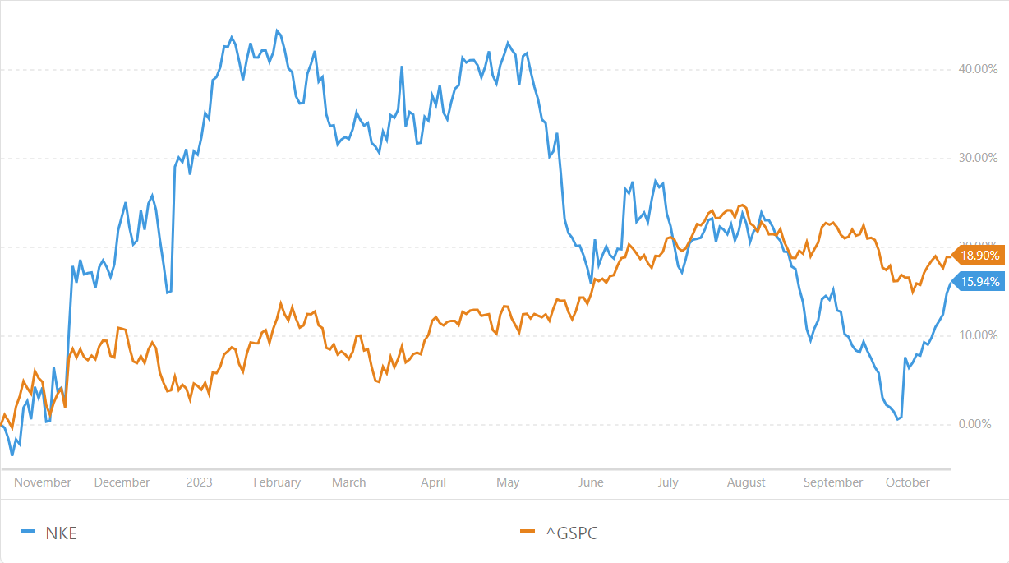  Comparative chart between NKE’s and the S&P500’s performances over the last 12 months.  The tables below show the forecasted values, growth and margins for Nike up to 2025 along 2022 results.  2022 2023E 2024E 2025E  Revenue 46,710 51,161 56,150 61,748  EBITDA 7,573 8,334 9,295 10,506  EPS 3.75 3.92 4.54 5.33  Net debt 4,769 3,828 4,384 4,393  FCFF 3,886 6,094 5,965 6,799  ROE 39.6% 36.9% 40.4% 43.2%  P/E 29.71 34.80 29.02 25.07  EV/EBITDA 23.77 21.55 18.86 16.22  2022 2023E 2024E 2025E  Sales growth (%) 4.9% 9.5% 9.8% 10.0%  EBIT growth (%) -1.0% 10.7% 12.3% 13.8%  Net profit growth (%) 5.6% 2.7% 12.6% 14.2%  EPS growth (%) 5.5% 4.5% 45.0% 35.9%  EBITDA margin (%) 16.2% 16.3% 16.6% 17.0%  EBIT margin (%) 14.7% 14.8% 15.2% 15.7%  Net margin (%) 12.9% 12.1% 12.5% 12.9% | Forecasted group revenue growth for next year is 9.8% and goes into double digits for 2025. The group’s EBITDA margin will constantly improve over the years, going from 16.2% to 18.5% in 2027.  Therefore the forecasted upside sits around 14%, also in line with the 10-years price trendline.
Revenue is projected to grow across all segments and divisions at a different pace.
Greater China has the biggest role as Nike keep expanding their presence in the region; the segment’s revenue is likely to double by 2027, helped by the increasing popularity of the brand’s footwear.
APLA is a close contender in percentage terms, but there’s still a long way to go in regard to the overall figures.
While delivering the most revenue, North America and EMEA are expected to grow at a slower, but steady rate; EMEA is the only region in which apparel and equipment will have a relevant role on the forecasted revenue.
The EBITDA margin is expected to expand by roughly 2 basis points over the years, moving from 16.2% in 2022 to 18.5% in 2027. While this is supposed to marginally shrink in North America, it should however sensibly increase in EMEA.
North America and EMEA are the major contributors to the group, but, over time, EMEA’s EBITDA is expected to grow from $3.4B to $9.8B in 2027 overtaking North America, growing at a much slower rate and not deflecting from $5B. China’s is moving from $2.4B to $4.6B in 2027 keeping in line with the 2015-2022 trajectory.
EPS are forecasted to grow 104% by 2027, from 3.75 to 7.65, while FCFF by 136% from $3.8B to $9.1B, representing the consistent growth of the company’s income. Capex is also increasing as the firm expands both the assets in its portfolio and pushes the transformation into e-commerce.
Nike's commitment to innovation, digital transformation, and sustainability, alongside the development of its other brands such as Jordan and the ever-increasing brand awareness achieved sponsoring major athletes and competitions, shows the strategic direction for the future and the company’s efforts to meet both evolving consumer preferences and arising global challenges.

