Visa Inc. – Market Research Report

- Industry Outlook

Visa, the largest payment processor in the world, is catalogued in the Financial Services sector and, more specifically, in the Credit Services industry.

The global pandemic had a massive impact on cash usage, plummeted by 15% in 2020 and never bounced back after we returned to normality. Digital payments, on the other hand, already on upward trajectory, had an explosive growth since and momentum is still going.

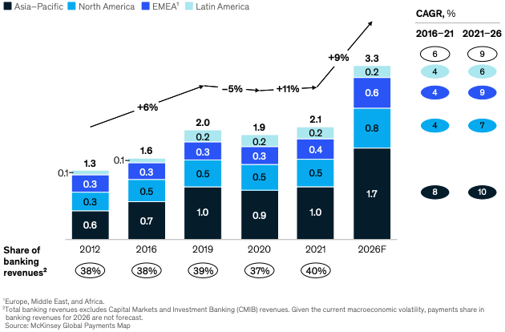  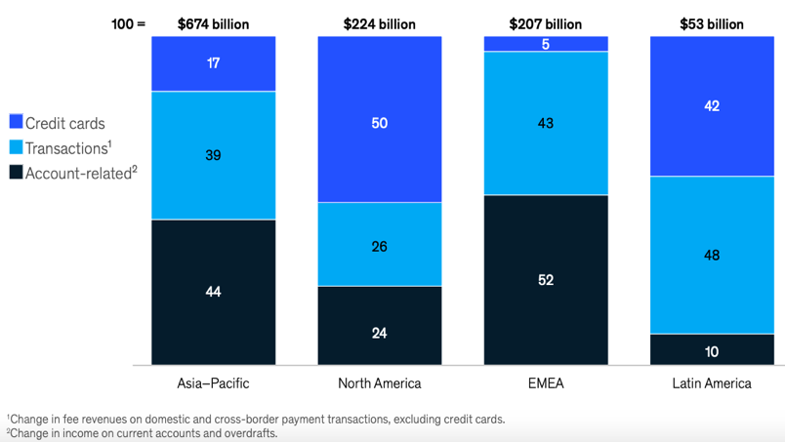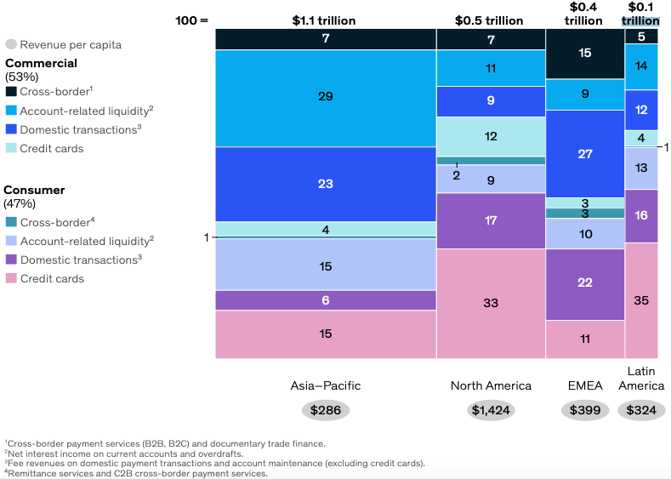 | According to ‘The 2022 McKinsey Global Payments Report’, the payments industry revenues rebounded strongly in 2021, growing 11% and reaching a new high of $2.1 trillion globally; overall electronic payment transactions grew 19%.  Asia-Pacific accounted for 57% of global revenue growth (with China accounting for 88% of it), mainly thanks to A2A activity.  A2A transactions contributed to 29% of 2021’s rise in global revenue, primarily at the expenses of cash and checks. However, debit card and credit card transactions still grew, respectively, by 20% and 18%.  Debit cards are the most used card product with 94 transactions per capita globally, against 49 for credit cards.  Consumer usage of credit cards is predominant in the Americas and roughly accounts for a third of the total yearly revenue.  Payment revenues per capita varies significantly by country and tends to be lower in developing economies, suggesting the existence of new opportunities as the infrastructure improves.  The industry is forecasted to exceed the $3 trillion mark by 2026.
- Peers Comparison

Visa’s biggest US competitors are Mastercard and American Express. According to the Nilson Report, in 2021:
- Visa has 61% of the US market share, while Mastercard has 25% and AMEX only 10%;
- 48% of the adult US population has Visa, 39% has Mastercard and 15% has AMEX;
- of the 1.08 billion US circulating cards, 341 million are Visa (31%), 245 million are Mastercard (22%) and 53 million are AMEX (5%)
- Visa accounts for 50% of the US purchase volume on credit cards, Mastercard for 22% and AMEX for 18%.

The following table compares the total revenue and net income for the last triennium:
 | VISA |  |  | MASTERCARD |  |  | AMERICAN EXPRESS
 | 2022 | 2021 | 2020 | 2022 | 2021 | 2020 | 2022 | 2021 | 2020
US Revenue | 12,851 | 11,160 | 10,125 | 7,809 | 6,667 | 5,473 | 43,801 | 34,945 | 29,345
Intl. Revenue | 16,459 | 12,945 | 11,721 | 14,428 | 12,217 | 9,828 | 9,061 | 7,435 | 6,742
Tot Revenue | 29,310 | 24,105 | 21,846 | 22,237 | 18,884 | 15,301 | 52,862 | 42,380 | 36,087
Net Income | 14,957 | 12,311 | 10,866 | 9,930 | 8,867 | 6,411 | 7,514 | 8,060 | 3,135

All companies had a constant growth of their revenue, mainly due to increased reliance on their services from business and consumer customers.

Despite having a slightly slower growth compared to American Express, which also realised twice the revenue, Visa clearly leads the way in net income growth and, most impressively, recorded twice the American Express profit. All this despite having almost half the revenue, denoting an astonishing effort at containing expenses. It is however worth noting AMEX spent 14 billion dollars in Card Member rewards. Also, American Express is both a credit card payment processors and issuer while Visa and Mastercard are payment processors only, operating networks used by other credit card issuers on which they rely for revenue.

In terms of global market share, the biggest company is still Visa, accounting for 40%, but the closest competitor is now UnionPay, coming in at 32%, while Mastercard is third best with its 24%. So, this leaves just 4% for all the remaining companies.

- Substitutes and New Markets

In recent years, traditional credit services have been challenged by Alternative Payment Providers such as closed commerce ecosystems, BNPL solutions and cryptocurrency platforms (PayPal, Stripe, Square and more), whose primary focus is to enable payments through ecommerce and mobile channels; moreover, some companies are expanding and may offer physical points of sale. These firms can either partner or compete with Visa, using Visa’s proprietary network or developing their own processing platforms.

Growing (and leading) economies might offer fertile land to explore for the credit services industry, but the big challenge is facing both the fierce competition and the ostracism by local governments measures. For instance, in China government-backed UnionPay (is rapidly growing and aiming for international expansion, while APPs the likes of Alipay and WeChat Pay expanded into ecommerce and cross-border payments. In India, new nationalistic regulations might impact the company ability to compete with domestic payment providers or to conduct business altogether.
- Revenue and Cost Drivers – Industry Trends

Revenue increased for Visa and its competitors primarily due to year over year growth in payments volume, processed transactions and cross-border volume (despite revenue being negatively impacted by higher client incentives). The suspension of operations for US companies in Russia and the unfavourable change of the USD also had partial adverse effect on revenue, though it didn’t impact their upward trajectory. Visa’s nominal payments volume in 2022 was $11.6 trillion, up 12% year over year.

Higher number of employees and compensation, marketing, general and administrative expenses (and, for some companies, also litigation provisions) grew across the industry, especially for its leading companies. With the constantly evolving technology and cybersecurity risks many companies saw a sensible growth in the cost to upgrade and upkeep their network.

However, cost increase might be the reflection new of growth strategies being put in place and this is certainly the case for Visa, currently aiming to attract new clients and businesses on their network and expand this alongside new services being provided.

Based on payments volume and number of transactions, Visa is one of the world’s largest electronic payments system.
- SWOT Grid
- PESTEL Grid

- Analysis and Evaluation

Credit Services companies find themselves in a highly competitive and ever-evolving environment in which they constantly face new challengers, adapt to new technologies and regulations, and fight to retain their clients’ business and trust.

Despite offering a multitude of services, each company focuses on a more specialised area of the industry; for instance, while Visa and Mastercard compete in the broader payment technology, American Express focuses on the premium card segment, and other companies like PayPal provide digital payment solutions.

Each company employs unique strategies to maintain and enhance its market position. Visa and its closest competitors are investing a lot of effort and resources to keep up with the market variables so to retain their crown of market leaders; most of their strategy revolves around extensions of their services, diversification of customers and geographies and expansion in new areas and technologies.
In detail, Visa strategy is to expand their core business consisting of Core Products (cards), Tap to Pay Technology, e-commerce (outpacing physical retail), Access & Acceptance (new markets), Partnerships (through fintech development) and Ventures (strategic investments to enrich broader payment systems). In 2019, Visa acquired EarthPort extending its reach 99% percent of the world’s banked population in the top 50 countries and other 33. Furthermore, Visa Value Added Services represent a valuable growth opportunity. AI-powered security services prevented financial institution to be defrauded for $25 billion. Additionally, Visa also provides tokenization services, allows users for much lower fees, proved data analytics, settlement and many other services.

For comparison, Mastercard strategy revolves around perfecting their technologies (mainly through various acquisitions) as both consumers and businesses require enhanced payment options. Focus is given to technology and B2B markets, estimated around $25 trillion a year in the US.

Given the recent growth in revenue and, most importantly, in profit, these approaches seem to have worked, but many aspects still need to be analysed to evaluate if the rise in income is likely to continue for years to come.

A big portion of credit services income still derives from Western markets, while some leading emerging economies yet need to be properly explored. The political aspects mentioned earlier are one of the causes, but not the only one.
Consumer trust is crucial in both adoption and continuous usage of digital payment methods and it relies on security measures, data protection, brand reputation, consumer education, and collaboration with financial institutions.
On the other hand, there’s still a lack of trust in digital payments and more reliance on cash in emerging markets that can mainly be attributed to limited financial infrastructure, low digital literacy, security concerns, cultural factors and/or lack of access to financial services.
The big challenge for Visa and its peers is to retain their stronghold of Western income continually addressing and prioritizing security factors to foster trust and maintain their competitiveness in the market, while overcoming the aforementioned challenges in emerging markets to unlock their growth potential and drive the transition from cash to digital payments.

Brand awareness is also paramount for credit services for building trust, differentiating companies from its competitors, offering a competitive advantage and aid in customers acquisition and retention. Visa and the other big players have a great advantage on emerging competitors; concerns about fraud, cybersecurity vulnerabilities and lack of regulations can lead to mistrust towards new payment companies. Boasting decades of continuous operation, in addition to several measures to protect customers that faced losses or have been defrauded, these more institutional firms still hold a competitive advantage on emerging platform, despite centralization of transactions might not look attractive to some consumers.

It’s also worth mentioning how Visa, Mastercard and American Express significantly improved their revenue in the most recent fiscal year, despite global fears of recession which normally lead reduced streams of income for financial services.

In conclusion, it’s likely for Visa and its closest competitors to retain their position as market leaders for years to come. The growth in revenue, unmatched by the growth in operating expenses and supplemented by a seemingly more positive feeling toward global markets should lead these company to sensibly improve their earnings while reaching new horizons transitioning to new technologies. It’s possible these company will face challenges should major changes to the current economic and geopolitical landscape arise, but until then these names represent more of a safe bet.

All unquoted data in this report has been gathered by Visa, Mastercard and American Express most recent annual reports.

