**MARRIOTT INTERNATIONAL, INC**

**Revenue Drivers**

|  |  |  |  |  |  |  |
| --- | --- | --- | --- | --- | --- | --- |
| **Revenue Drivers** | **Amount ($)** | | | **Contribution (%)** | | |
|  | 2020 | 2021 | 2022 | 2020 | 2021 | 2022 |
| Base management fee | 443 | 669 | 1044 | 4.14% | 4.80% | 5% |
| Franchise fee | 1153 | 1790 | 2505 | 10.77% | 12.85% | 12.01% |
| Incentive management fee | 87 | 235 | 529 | 0.81% | 1.69% | 2.54% |
| Owned, leased, and other revenue | 568 | 796 | 1367 | 5.31% | 5.71% | 6.55% |
| Cost reimbursement fee | 8452 | 10442 | 15417 | 79% | 74.95% | 74% |
| Gross Revenue | 10703 | 13932 | 20862 |  |  |  |
|  |  |  |  |  |  |  |

**Cost Drivers**

|  |  |  |  |  |  |  |
| --- | --- | --- | --- | --- | --- | --- |
| **Cost Drivers** | **Amount ($) in millions** | | | **Contribution (%)** | | |
|  | 2020 | 2021 | 2022 | 2020 | 2021 | 2022 |
| Owned, leased, and other-direct | 677 | 734 | 1074 | 6.46% | 6.06% | 6.20% |
| Depreciation, amortization, and other | 346 | 220 | 193 | 3.30% | 1.82% | 1.11% |
| General, administrative, and other | 762 | 823 | 891 | 7.27% | 6.80% | 5.15% |
| Restructuring, merger-related charges, and other | 267 | 8 | 12 | 2.55% | 0.07% | 0.07% |
| Reimbursed expense | 8435 | 10322 | 15141 | 80.43% | 85.26% | 87.46% |
| Gross Revenue | 10487 | 12107 | 17311 |  |  |  |

**Interpretation**

* Cost reimbursement fee has been contributing the most revenue for Marriott International for the past three years as indicated in the Revenue Drivers. Cost reimbursement includes payroll and related expenses at managed properties and certain operational and administrative costs in contracts with the owners.
* The franchise fee is the second most contributing factor to the revenue of Marriott International, followed by owned or leased properties, basement management fees, and incentive management fees. The company provides franchisees and operators’ licenses to their intellectual property for the use of their brand names. Marriott International is compensated with an initial application fee and royalties.
* For the cost drivers, reimbursement expenses represent the variable with the most cost to the company. It contributes over 80% to the cost of the company as indicated in the Cost Drivers’ table. For instance, in 2022, a reimbursement expense of $69 million was recorded ($52 million after-tax).
* Compared to other competitors such as IHG Hotels & Resorts, IHG Hotels & Resorts’ main revenue driver as recorded in their FY’22 was revenue by reportable segments, followed by system fund revenues. Tax played a major role in affecting the profit of IHG Hotels & Resorts for their cost drivers.

Revenue is driven as RevPAR * No. Rooms where,

RevPAR is the function of ADR (price impact) * Occupancy (volume impact)

Note that for each of the segments, North America (full service, limited service), APAC and Other international, RevPAR, Room count Occupancy and ADR are reported by the company. These will be forecasted based on historical trend analysis.

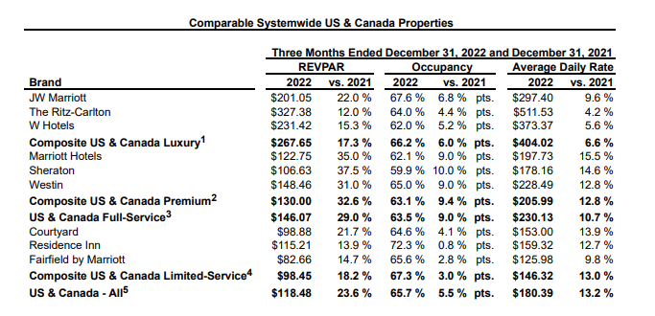

Large portion of Marriot’s cost is the reimbursed expenses which is directly related to reimbursed revenue. Management and franchise related operating expenses will have be derived as a % of revenue.

**JOHNSON & JOHNSON**

**Revenue Drivers**

|  |  |  |  |  |
| --- | --- | --- | --- | --- |
| **Revenue Drivers** | **Amount ($)** | | **Contribution (%)** | |
|  | 2021 | 2022 | 2021 | 2022 |
| Consumer health | 15035 | 14953 | 16.03% | 15.75% |
| Pharmaceuticals | 51680 | 52563 | 55.11% | 55.36% |
| MedTech | 27060 | 27427 | 28.86% | 28.89% |
| Gross Revenue | 93775 | 94943 |  |  |

**Cost Drivers**

|  |  |  |  |  |
| --- | --- | --- | --- | --- |
| **Cost Drivers** | **Amount ($)** | | **Contribution (%)** | |
|  | 2021 | 2022 | 2021 | 2022 |
| Selling, marketing, and administrative expenses | 24659 | 24765 | 61.23% | 61.68% |
| Research and development expense | 14714 | 14603 | 36.54% | 36.37% |
| In-process research and development | 900 | 783 | 2.23% | 1.95% |
|  | 40273 | 40151 |  |  |

**Interpretation**

From the revenue drivers, pharmaceuticals contribute more than 50% in revenue among the various drivers. MedTech also contributed 28.86% of the revenue followed by Consumer health with 15.75% in 2022.

Costs relating to selling, marketing, and administration affect the operations of Johnson & Johnson the most. It has over 60% in cost as compared to other cost drivers. Research and development also reduce the profit of the company by 36.37% in cost, followed by in-process research and development by 1.95% in cost in 2022.

Competitors like Pfizer Inc. recorded 82% in direct sales or alliance product revenue in aggregate in 2022. Also, the loss or expiration of intellectual property rights had a significant adverse effect on the revenue as contracts with customers were at lower selling prices and lower volumes due to added generic competition.

Each of the three segments, Consumer, Pharmaceuticals and Medical Devices have sub segments with product lines like Remicade, Darzalex , Stelara and Tremfya  or Surgery, Orthopaedics and Intervention solutions. All of these lines have US & International sales. US revenue can be driven by annual growth rates, international revenue growth has two components, organic growth and currency impact.

Cost Drivers – as % of revenue (trend analysis)

* Selling, Marketing and Administrative Expenses
* Research and Development Expenses
* In-process research and development
* Cost of products sold