Overview

Visa Inc (Visa) is one of the world’s leaders in digital payments. Visa is a provider of payment cards, which are used to facilitate secure, dependable and efficient money movement among consumers, issuing and acquiring financial institutions and merchants.

Geographic segments: US and International

The core Business is captured below.

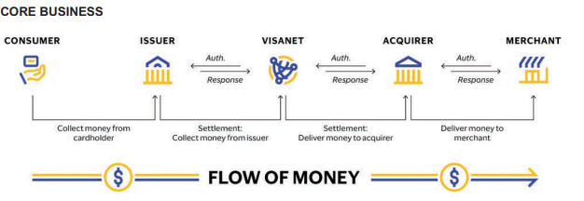

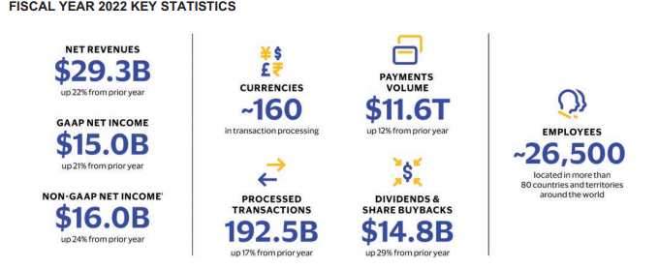

Excerpt 2022 annual report

Visa inc is major player in the transaction and payment processing services industry with market capitalisation of $489.65B and Enterprise Value of $493,24b.

The major competitors of visa are 1.Mastercard inc with market capitalization of $374.85b and Enterprise Value of $383.57b. 2. Fiserv inc with market capitalization of $72.70b and Enterprise Value of $ 95.83b.

**Key revenue and cost drivers.**

**Revenue Drivers-Volume**

There are three primary areas that drive the revenue growth of the business

1. Consumer payments 2. New Flows 3. Value –added Services

Consumer payments: The core products-credit, debit and prepaid cards drive the revenue volume

The key revenue drivers for Visa Inc are payment volume on visa products for purchased goods and services.

Revenue per transaction * transaction volume.

Based on payments volume and number of transactions, Visa is one of the world’s largest electronic payments system.

2. Excerpt from 2022 annual report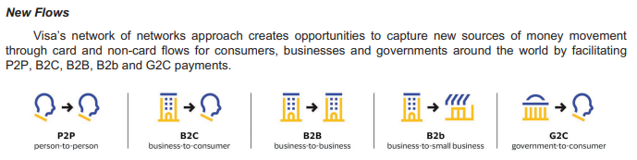

3. Value-added Services

**Cost Drivers**

**The following are the key cost drivers of Visa Inc**

• Personnel expenses (include salaries, employee benefits, incentive compensation, share-based compensation and contractor expenses. )

• Marketing expenses (include expenses associated with advertising and marketing campaigns, sponsorships and other related promotions of the Visa brand).

• General and administrative (expenses consist mainly of card benefits, facilities costs, indirect taxes, travel and meeting costs, foreign exchange gains and losses and other corporate expenses incurred in support of our business.

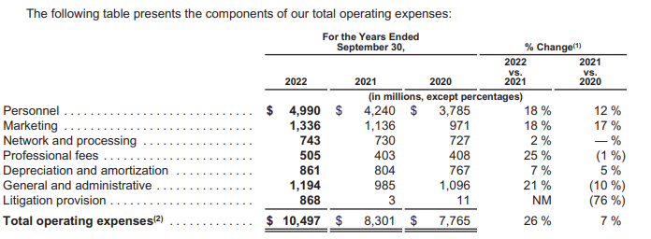

Excerpt 2022 annual report

Porters Analysis of five key forces that influence competition in the Transaction and payment processing services industry.

1. Threat to new entrants-Though the industry has many untapped market especially the emerging market, Visa faces a moderate threat of new entrants. The barriers to entry are high as the industry requires huge capital, extensive network of banks, merchants and consumers making it difficult for new entrant to gain market share.
2. The bargaining power of suppliers-This is considered low for Visa. Some of the factors that reduce the bargaining power of suppliers for Visa include 1. The ease of Visa to switch to other suppliers 2.The availability and the number of suppliers is large with no concentration of power in any of the suppliers. Also, they maintain good relationship with their suppliers and can easily renegotiate favourable terms as a result of its size and market share.
3. Bargaining Power of Buyers. The bargaining power of buyers for Visa is **HIGH**. Transaction and payment processing services industry is very competitive industry where the customers have access to wide range of choices and can switch to competitors of the unsatisfied with the offerings and services of Visa. In order to lower the bargaining power of buyers and remain relevant in the industry, Visa must always work on developing and improving its products and services while maintaining strong relationship with its customers.
4. Threat of substitutes. This is HIGH for Visa as there are many payment solutions methods and platforms that offer similar services as in the industry. Examples are Mastercard, American Express etc
5. Industry Rivalry. The industry is generally intense and highly competitive which necessitate continuous development, innovation and improvement of its services in order to remain relevant in the industry.

A SWOT GRID

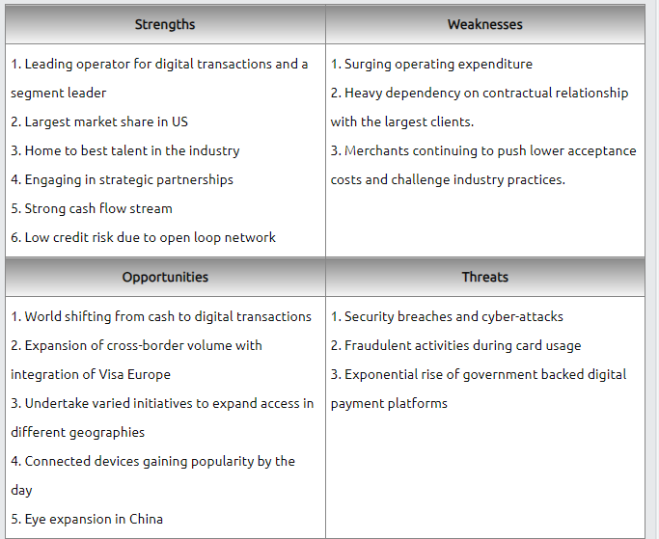

Excerpt from https://www.swotandpestle.com/visa/

Strengths

* Leading operator for digital transactions and segment leader .Most customers prefer Visa to its competitors as research has shown that majority of debit and credit card holders prefer Visa over others.
* Largest Market Share. Visa Inc had a market share of about 52% among all the competitors and this gives them a competitive advantage.

Weakness

* + Surging Operating Expenditure. The industry is a very competitive one and hence the need for improvement and development resulting in increased operating expenditure. The Except below shows increased operating expenses of 26%.

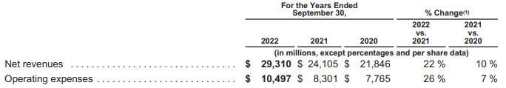

* + Heavy dependency on contractual relationship. This exposes the company to contract renegotiations and also control over some of the process flow.

**Strengths**

Strong and secure payment infrastructure

* Strong distribution network

Market leadership and strong brand value

Strong strategic partnerships with card issuers and merchants

Resilient business model that protects against inflation

**Weakness**

Lack diversification in business model

Lack of product development to combat new and emerging payment methods

Lack of innovation

**Opportunities**

Increasing preference for online shopping and cash-less transactions due to the pandemic

Opportunities to collaborate with emerging competitors like PayPal and mobile wallets

Loyal and large customer base that can be introduces with new or add on products

Availability of vast data that can be researched for product development

**Threats**

Threat of becoming obsolete due to new and emerging payment technologies

Increased competition owing to duopoly market

Lack of differentiation from competitor

Large amount of personal data that needs to be secured for privacy

Threat of fraudulent activities

Threat of money laundering and terrorism financing

PESTLE GRID

The PESTLE analysis gives insight of the impact of key external factors (Political, Economic , Social, Technological, Legal and Environmental)on the macro environment of an organisation. Below is the PESTLE grid for Visa Inc

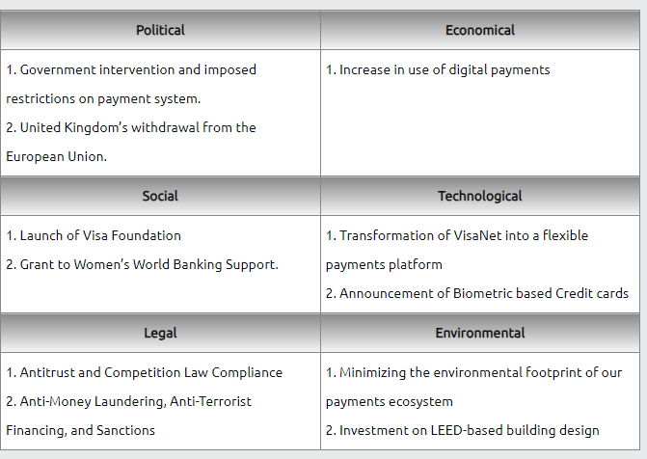 Excerpt from https://www.swotandpestle.com/visa/

**Political**

Demonetization (India)

Attitude of ruling party about cards instead of cash

Government backed local competitors

Tax legislations

**Social**

Attitude towards credit cards/savings

Card penetration in developing countries

Increasing number of elderly people becoming digitally literate

**Technological**

Impact of technology helping competitors and new entrants

Costs for new technology adoption and prevention of fraud and crime

Crypto currency gaining market share

Emerging mobile wallets like paypal

Penetration of ATMs and Point of sale

Tokenization, Biometrics, Machine learning

Tap to pay, Scan to pay

**Environmental**

Global warming impact on weather issues which affect spending patterns

Seasonality impact on spending patterns

Covid and work from home culture increasing the use of cards in e-commerce compared to cash

**Legal**

KYC and privacy laws in various countries

Anti money-laundering laws

Privacy and data protection laws

Industry Analysis/Key strategies

The global payments industry has been growing rapidly ever since the aftermath of the 2008 recession, in 2018 the industry totaled revenues of 1.9 trillion.

The strategy for Visa is to expand their core Business which consists of Core Products (cards), Tap to pay technology, Ecommerce (outpacing physical retail), Access & Acceptance (new markets), Partnerships (through fintech development) and Ventures (strategic investments to enrich broader payment systems). In 2019 Visa acquired earth por EarthPort that allows Visa to reach 99 percent of the world’s banked population in 88 countries, including the top 50.

Visa provides auxiliary or value – added services which is a growth opportunity. Visa’s fraud and security services run by artificial intelligence-powered risk scoring engine helped financial institutions prevent about $25 billion in fraud. In addition, Visa provides tokenization services and their product, developed by their provider Bell ID, allows users for much lower fees. Visa also provides data analytics, settlement and other services within this group of services.

Mastercard’s strategy is to broaden their capabilities as consumers and merchants demand enhanced payment options, with Mastercard focusing its technology on the business-to-business market which Mastercard estimated is a $25 trillion market annually in the U.S. Mastercard have begun implementing this strategy through various acquisitions.