**Johnson & Johnson.**

**Excerpt from 2020 annual report**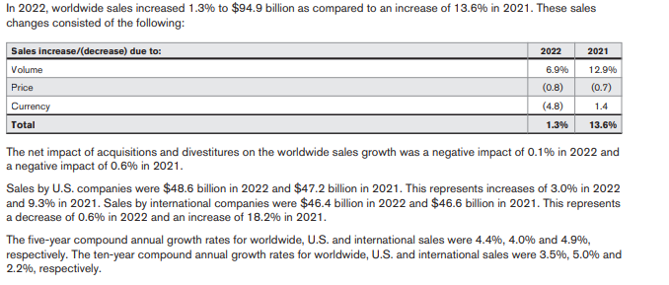

**Below is a representation of sales by geographical region and segment**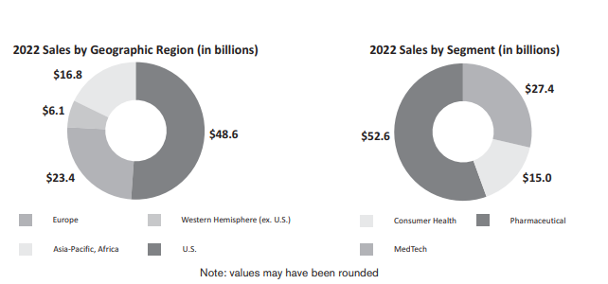

**Key Drivers:Volume**

There are two major drivers of sales volume- Geographic Regions and Segments

Based on the geographical area the US region contributes over 50% of the sales volume while the Pharmaceutical drives the revenue by segments 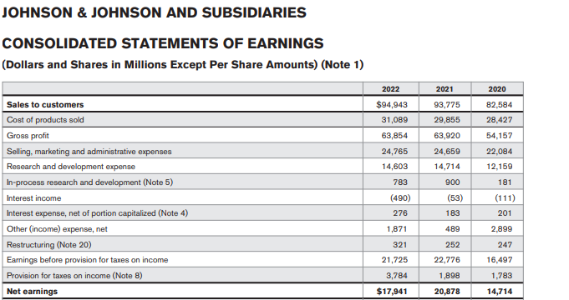

**Key Drivers-Prices**

The price flexibility was only significant in 2020, 2021 as a result of COVID however there was marginal price flexibility in 2022.

**Cost drivers:**

The key cost drivers are the cost of goods and Selling and Administrative expenses. However, research and development contribute to significant part of the expenses

The investment on research and development has increased over the years with a marginal decline in 2022