**Johnson & Johnson.**

**Excerpt from 2020 annual report**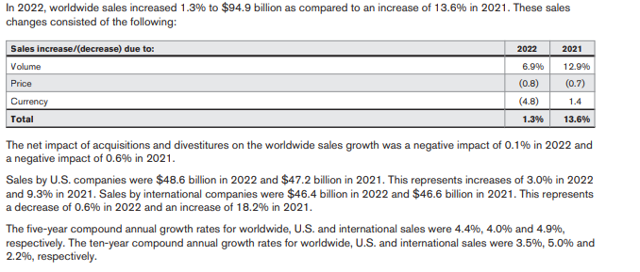

**Below is a representation of sales by geographical region and segment**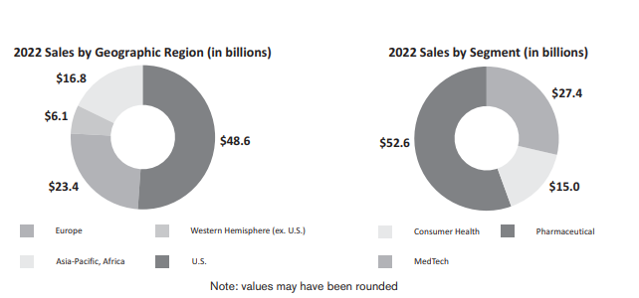

**Key Drivers:Volume**

There are two major drivers of sales volume- Geographic Regions and Segments

Based on the geographical area the US region contributes over 50% of the sales volume while the Pharmaceutical drives the revenue by segments 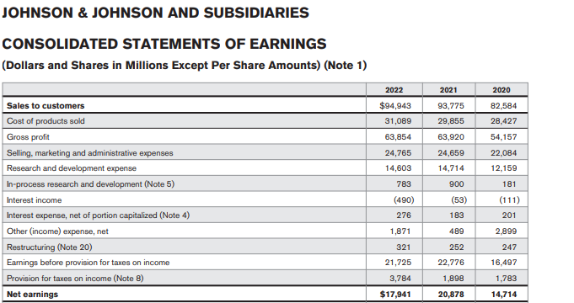

**Key Drivers-Prices**

The price flexibility was only significant in 2020, 2021 as a result of COVID however there was marginal price flexibility in 2022.

Each of the three segments, Consumer, Pharmaceuticals and Medical Devices have sub segments with product lines like Remicade, Darzalex , Stelara and Tremfya  or Surgery, Orthopaedics and Intervention solutions. All of these lines have US & International sales. US revenue can be driven by annual growth rates, international revenue growth has two components, organic growth and currency impact.

**Cost drivers:**

The key cost drivers are the cost of goods and Selling and Administrative expenses. However, research and development contribute to significant part of the expenses

The investment on research and development has increased over the years with a marginal decline in 2022

Cost Drivers – as % of revenue (trend analysis)

* Selling, Marketing and Administrative Expenses
* Research and Development Expenses
* In-process research and development
* Cost of products sold