Ticker symbol | AMZN
Market cap | 1,327T
Stock price | $129.33
Exchange | Nasdaq
Beta | 1.26
Earnings date | 26/7/2023-31/7/23
Financial health of amazon-
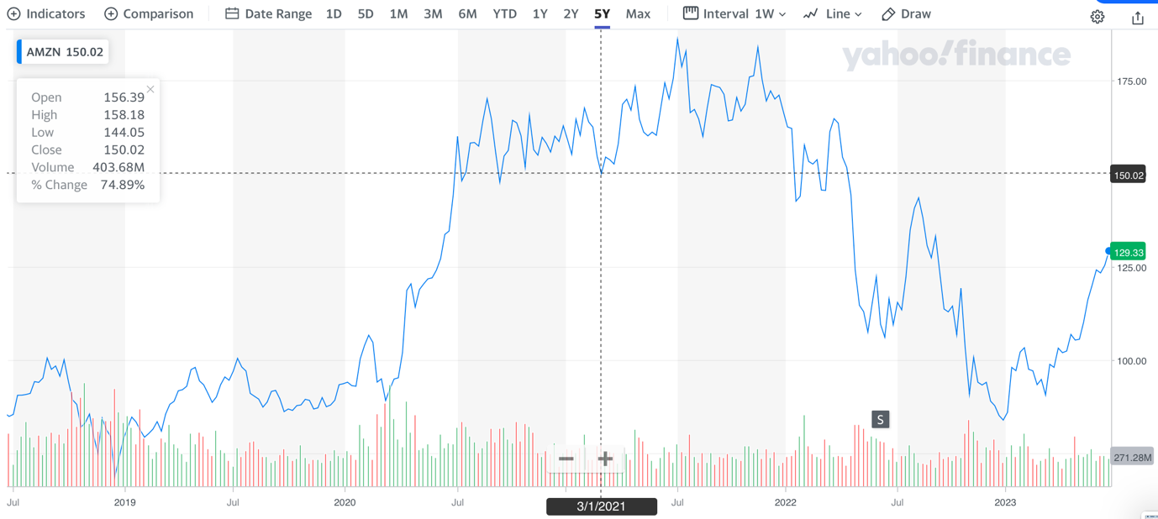
Graph shows, amazon stock over 5 year period and the rise AMZN in 2020, due to increased online sales during the covid lockdown, stock price rose, to decline in 2022 due to a stock split of shares, market cap also surpassed $1Trillion. Increased levels of volume of trading for AMZN, showing strong investor involvement.

Regional segments 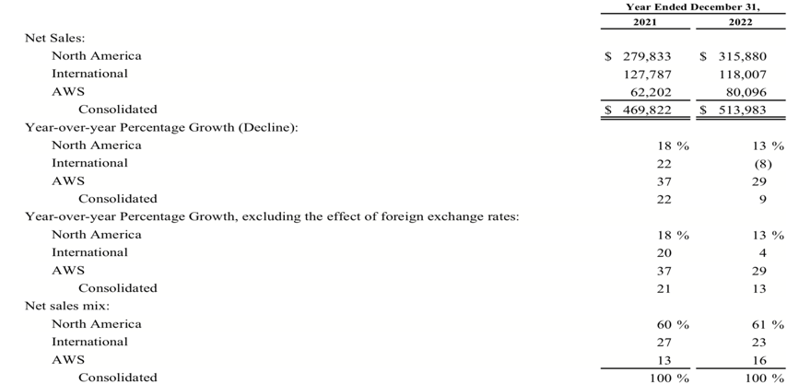
AMZN saw yoy growth of its business in all sectors in 2021 and saw growth in 2022, in north America AMZN grew by 13%, showing increased unit sales, and 22% international in 2021, with new warehouse openings in Europe. However in 2022, international sales dropped by 8%, showing a slowdown growth in amazon international sector.
AMZN saw, its sales in AWS increase by 29%, which has been a primary focus on amazon, in entering new market segment.

Free cash flow statement –
AMZN saw its free cash flow fall in 2021, to a minus (-9,069) negative free cash flow, however, this was due to increased investments in amazon and increase in operating expense and purchases for plant, property and equipment, which also saw, revenue increase, however free cash flow decline further negative to -11,569(millions) drastically reducing AMZN free cash flow, increased cashflow use in investing activities and lease payments.

Financial ratios--

Liquidity ratio analysis
Current ratio, for amazon for 2021, was 1.13 but decreased to below 1 in 2022, indicating amazon increased its current liabilities and decrease in assets, indicating a poor financial health compared to its competitor Alibaba, at 1.6 and 1.7 in 2022 and 2021 respectively, AMZN face issues in its ability to cover for obligation if they are due at once.
Quick ratio- amazon has a quick ratio of less than 1 indicating poor liquidity if need to cover current liabilities. AMZN had 0.66p liquid assets to cover for liabilities. Poor quick ratio, compared to industry competitors.
Cash ratio – cash ratio for AMZN is 0.3 less than 1 indicating there is too much current liabilities in amazon than there is cash, suggesting company not able to cover short obligation with cash.
Defensive interval days, amazon has a strong DIR of 251 and 341 in 2022 and 2021 strong ability to operate with current assets before selling long term assets.

As an online marketplace where thousands of vendors are hosted on site, Amazon’s payable days is typically higher than other companies as it is part of its 90-day credit policy. As a result of Amazon’s nature of business, its payable balances are higher than its inventories and receivables where it holds inventory on behalf of its vendors. Therefore, working capital is negative and so is the trading cycle. On a year over year basis the number has worsened, but can be supported with the argument that Amazon has started its own fulfilment services and is a fast growing company.

Profitability ratio analysis

Gross margin- for amazon was at 43% and 42% indicating amazon recorded a high profit margin indicating business operation are able to generate a positive profit.

EBITDA company operating profit was at 10% in 2022, strong positive ability to generate profit from earnings.

Profitability ratios indicate AMZN has a positive return on profitability, for the firm showing firm is able to generate business profit for the past 2 years.

It is notable that Amazon’s Technology & content and Sales & marketing have seen sharp increases, indicating the heavy spend on AWS and Prime Video content. While the e-commerce segment is seen to be normalizing post the Covid-19 boom, sales reflect the increasing global inflation levels.

Solvency ratio

Debt to equity indicates company has $2 in debt for every $1 in equity indicating firm is highly in debt compared to its equity, showing share holders equity.

Debt to assets – the D/A for AMZN is high as 68% of debt financed assets in 2022, indicating a strong reliance on amazon on debt to finance company rather than equity.

Debt coverage – amazon had a 6% debt coverage ratio in 2022 indicating company a lot of its cash its used in the service of debt.

Amazon’s long-term liabilities have been increasing over the years as the company has increased its Financial lease commitments to facilitate the number of new fulfilment centres opened over the last year. Although the long-term debt remain rather steady, financial lease commitments have dramatically increased which has increased the debt service burden as well. However, the company has adequate levels of interest coverage and free cash flow indicating its financial health. However, the increase in the debt level would also mean that the company’s borrowing capacity in future is strained where it might have to pay higher interests to secure more debt.

Asset utilization

Total asset turnover- total asset turnover for AMZN indicates that for every dollar of asset amazon generated 1.10 in sales revenue, indicating the company has slow sales on inventory.

Fixed asset turnover for amazon was 1.6 compared to industry it was high than Alibaba at 0.5 indicating among the industry AMZN has a higher turnover of fixed assets.

Inventory turnover – the amount of days it takes for AMZN to turnover inventory, was 8,3 days, compared to industry competitors it was a good number.

Amazon has a efficient asset utilization and is able to make use of its fast and more effiecent that its industry competitors such as Alibaba.

Amazon has a large portion of goodwill in its asset base, where the Fixed asset turnover is almost three times higher than the total asset turnover. The goodwill and intangibles are manly as a result of acquisitions in addition to the increased R&D spending on AWS which we will have to closely watch for future profitability.

Investor ratios-

Price to equity – the p/e ratio for 2022 was negative, due to stock split in 2022, which saw reduction of earnings, in 2021 the earnings was $51 indicating growth and good earning potential for AMZN stock.

Earnings per share – EPS for 2022 was negative at $0.27 a share, and $3.24 in 2021, this indicates a decline in EPS this could be due to slowdown of economy and potential recession warnings which saw amazon value drop in 2022 and the stock split.

Price to book value – AMZN book price to ratio was 8.7 in 2022 a drop from 12.3 in 2021. The stock is trading 8x its book value indicating the stock may be overpriced compared to its book value.

Return on equity – ROE in 2022 was negative due to increase in shares as stock split and in 2021 ROE was at 24% indicating AMZN has a positive ROE for shareholders in 2021.

ROA- AMZN return on assets was low and negative showing poor return on assets. In 2021 there was a positive return on assets as the company was more efficient.

ROE, ROA and ROCE all are within the health territory, however, have declined compared to previous year. Furthermore, given Amazon’s valuations, one would expect the ratios to be better as there are many other smaller companies with better returns than Amazon, however, it is notable that these valuations are backed by Amazon’s expansion.

Investment grade- AA
Shares outstanding- 10,189
Total value of equity of share holders – 146,043

