**Marriot Inc.**

Excerpt from Marriot’s 2022 annual report outlining the firm’s strategic objectives and business will help to identify the revenue and cost drivers.

*Corporate Structure and Business*

*We are a worldwide operator, franchisor, and licensor of hotel, residential, timeshare, and other lodging properties under numerous brand names at different price and service points. Consistent with our focus on management, franchising, and licensing, we own or lease very few of our lodging properties (less than one percent of our system).*

**Revenue Drivers**

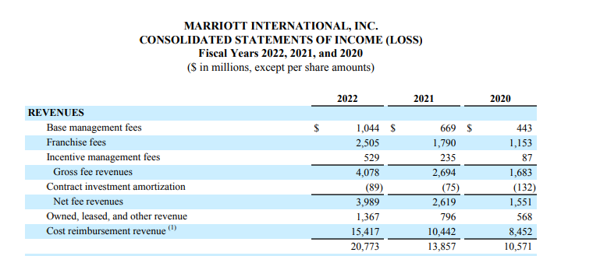

**Table 1.**

As Table 1 shows, Marriot displayed a significant growth in revenue from 2020 to 2022.This can be attributed to recovery from COVID. The significant growth in revenue also was attributed to the cost reimbursement revenue (payroll and related expenses, operational administrative cost reimbursed under the business management and Franchise agreement).

Though there are many risk factors such as industry, business and governance that affect the financial performance of the Marriot, the key revenue drivers are highlighted below.

**Key Drivers: Volume**

Revenue per Available Room. This is calculated by dividing the room sales for comparable properties by room nights available for the period.

Also, Occupancy, which is calculated by dividing occupied rooms by total rooms available (including rooms in hotels temporarily closed due to issues related to COVID-19), measures the utilization of a property’s available capacity –Volume,

The annual reports segmented the business into two operating segments based on locations (US & Canada, and International) of which the US & Canada has over 71% and 64% of the business properties and rooms respectively.

|  |  |  |  |
| --- | --- | --- | --- |
|  | **2022** | **2021** | **2020** |
| **Properties** | 8,288 | 7,989 | 7,349 |
| **Rooms** | 1,525,407 | 1,479,179 | 1,380,921 |

There was 3% growth of number of rooms added to the business in 2022 as against 7 % growth in 2021.This points to other revenue divers such as prices.

**Key Drivers: Prices**

The major driving factor for pricing is Average Daily Rate (ADR), which is calculated by dividing property room revenue by total rooms sold. This measures average room price and is useful in assessing pricing levels.

In 2022, Marriot inc recorded an ADR of 21 % against 2021 figures and this resulted in significant increase in revenue

**Cost Drivers**

The key cost drivers of the business are reimbursed expense (payroll and related expenses, operational administrative cost reimbursed under the business management and Franchise agreement) and General and Administrative costs. **See excerpts below from 2022 annual report**

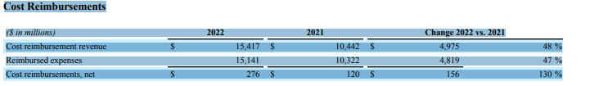 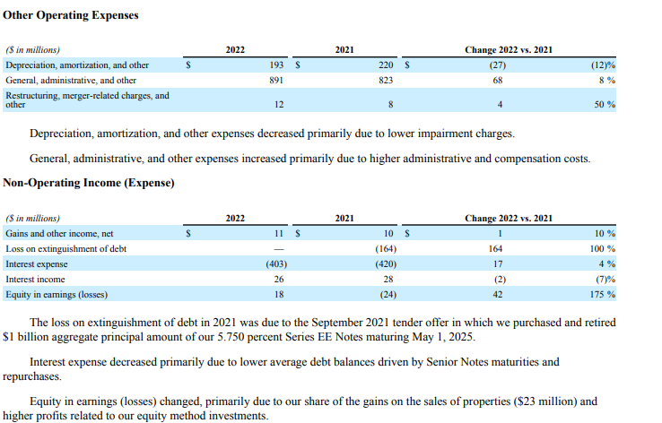 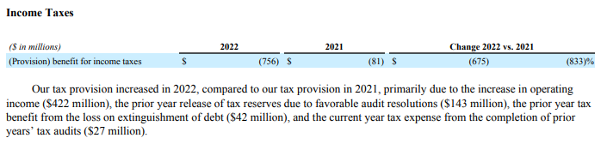

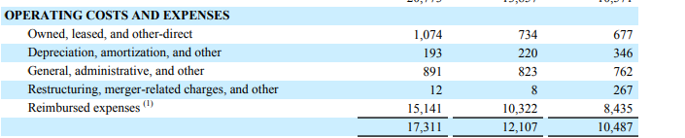

The reimbursed expenses which captured the labour cost and operational administrative cost increased over time as a result of inflation and increase in occupancy reflecting higher revenue.

The general, administrative and others showed a fairly marginal growth representing effective management of administrative and compensation costs.