Amazon Inc. Management Report Sidharth Nambiath

**Introduction**

This report aims to provide a comprehensive picture of the financial health of Amazon Inc, based on its performance from 2020 to 2022.

**Liquidity**

The current ratio between 2020 and 2021 was observed to rise, indicating a growth in Amazon Inc’s short term assets relative to its short term liabilities, as seen in Figure 1a. The quick ratio was also observed to rise during this period, demonstrating improved liquidity as a result of an increase in the proportion of highly-liquid assets compared to short-term liabilities. Conversely, the observed reductions of the current ratio and quick ratio between 2021 and 2022 may be a cause for concern; it suggests that short term liabilities grew at a faster rate than short term assets. Due to the fact that current ratio < 1.0, it may imply the firm could struggle to meet its short term obligations.

The Current ratio is greater than 1 indicating the short-term asset’s ability to meet short term liabilities. Quick and Cash ratios above 0.5 which also indicates that the company can meet more than 50% of its short-term liabilities with its cash in hand. The decline in current ratio was mainly to be attributed to a reduction of marketable securities (following the sale of the company’s stake in Rivian).

As an online marketplace where thousands of vendors are hosted on site, Amazon’s payable days is typically higher than other companies as it is part of its 90-day credit policy. As a result of Amazon’s nature of business, its payable balances are higher than its inventories and receivables where it holds inventory on behalf of its vendors. Therefore, working capital is negative and so is the trading cycle. On a year over year basis the number has worsened, but can be supported with the argument that Amazon has started its own fulfilment services and is a fast growing company.

Operating with a negative Trading Cycle became a source of cash for the company, instead of being a cost for it. However, it can be observed that the Trading Cycle days have reduced over the years indicating that the number of days that they can hold on to the cash has reduced.

**Profitability**

There has been slight growth in the gross margin between 2020 and 2022, reaching a level of nearly 44%, suggesting stable and positive levels of retained sales revenue. The other profitability metrics present a mixed picture; the EBIDTA margin and net margin were both negative, with the former fluctuating at a particularly low level and the latter slowly reducing in magnitude. These yearly changes are reflected in figure 1b. It is worth noting that the individual segments of the Amazon conglomerate show vastly different levels of profitability, with the operating loss being almost $2.9 billion without the contribution of one single segment: AWS, which provided an overall operating income of $2.5 billion [1].

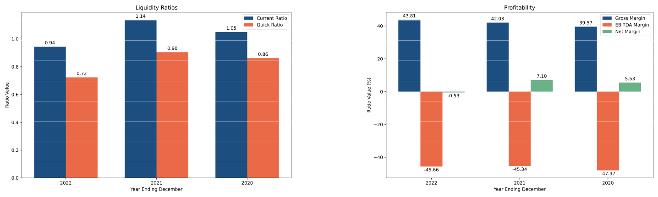

**(a)** The current and quick ratios between 2020-2022. **(b)** Profitability metrics between 2020-2022.

**Figure 1:** Liquidity and Profitability Metrics.

It is notable that Amazon’s Technology & content and Sales & marketing have seen sharp increases, indicating the heavy spend on AWS and Prime Video content. While the e-commerce segment is seen to be normalizing post the Covid-19 boom, sales reflect the increasing global inflation levels.

**Solvency and Debt Management**

The debt to equity ratio increased by 35% overall between 2020 and 2022. This indicates an overall increase in the financial leverage and risk. A similar pattern was observed in the debt to total assets ratio which may indicate that the firm’s debt structure has been kept relatively consistent throughout the period. It is possible that this could also be a result using debt financing to drive growth of the company, as per its business strategy [2].

Amazon’s long-term liabilities have been increasing over the years as the company has increased its Financial lease commitments to facilitate the number of new fulfilment centres opened over the last year. Although the long-term debt remain rather steady, financial lease commitments have dramatically increased which has increased the debt service burden as well. However, the company has adequate levels of interest coverage and free cash flow indicating its financial health. However, the increase in the debt level would also mean that the company’s borrowing capacity in future is strained where it might have to pay higher interests to secure more debt.

1

Amazon Inc. Management Report Sidharth Nambiath

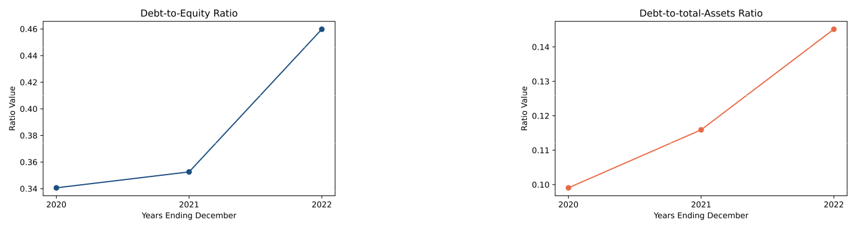

**(a)** Debt to Equity Ratio between 2020-2022. **(b)** Debt to Total Asset Ratio

**Asset Utilisation**

The operational efficiency of a company in terms of utilising assets to generate sales can be quantified via the total asset turnover ratio. For Amazon Inc, this was remarkably stable, only reducing by 7.5% to 1.11 by the end of Q4 2022.

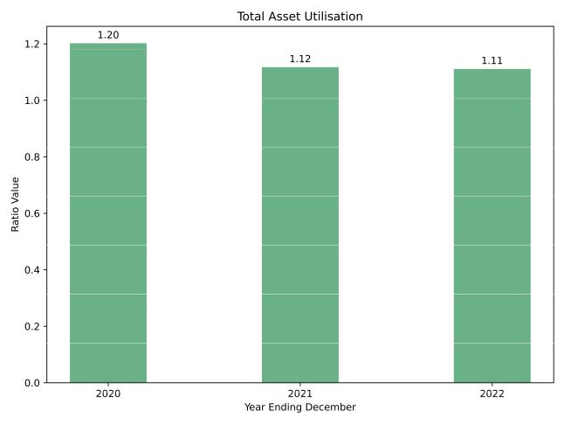

**Figure 3:** Profitability metrics between 2020-2022.

Amazon has a large portion of goodwill in its asset base, where the Fixed asset turnover is almost three times higher than the total asset turnover. The goodwill and intangibles are manly as a result of acquisitions in addition to the increased R&D spending on AWS which we will have to closely watch for future profitability.

**Investor and Market Ratios**

The enterprise value to EBITDA ratio is a metric that indicates how overvalued or undervalued the market perceives the company to be, based on its current EBITDA. In the case of Amazon Inc, overall growth is observed between 2020 and 2022 as seen in Figure, and in both cases the ratio is rather high, suggesting that the company stock may be overvalued. The return on equity shows a different picture however. In 2020 and 2021, the ratio was positive, but as of 2022, there was a significant reduction to the point that it was negative. This suggests the company may struggle to cover shareholder equity with its net income.

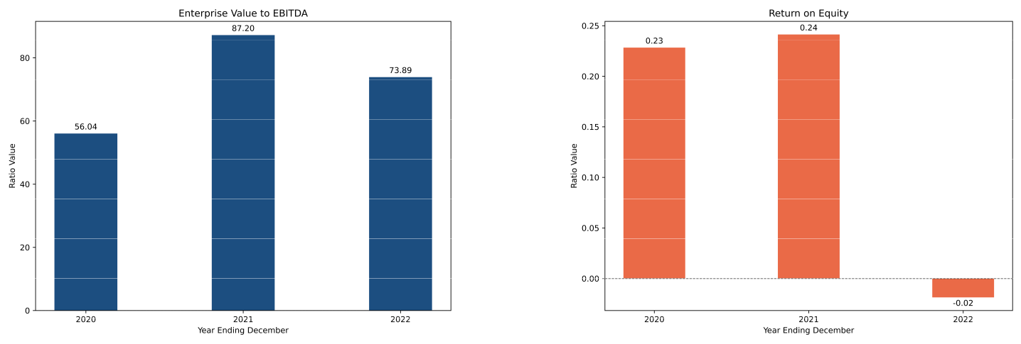

2

**Figure 4:** Investor and Market metrics between 2020-2022.

ROE, ROA and ROCE all are within the health territory, however, have declined slightly compared to previous year. Furthermore, given Amazon’s valuations, one would expect the ratios to be better as there are many other smaller companies with better returns than Amazon, however, it is notable that these valuations are backed by Amazon’s expansion.

Amazon Inc. Management Report Sidharth Nambiath

**Conclusion**

In general, the financial health of Amazon Inc between 2020 and 2022, as evidenced by the aforementioned financial ratios, paints a complex picture. Ultimately, the rising solvency and debt management ratios are characteristic of firms that have a strategy to continue growth, which may accurately reflect the profile of Amazon Inc, especially with regard to its desire to expand its advertising revenue [3]. Of course, this time period coincides with the coronavirus pandemic. Indeed, all of the FAANG (Facebook, Amazon, Apple, Netflix and Google) companies saw soaring stock prices and market capitalisation, though by 2022, rising interest rates and a lack of confidence in the economy took its toll and the previously achieved high share prices were seen as overvalued, potentially explaining the high enterprise value to EBITDA ratios.

**Bibliography**

1. *Amazon Global Business Strategy*. URL: [https : / / www . studysmarter . co . uk / explanations / business - studies /](https://www.studysmarter.co.uk/explanations/business-studies/business-case-studies/amazon-global-business-strategy/) [business-case-studies/amazon-global-business-strategy/](https://www.studysmarter.co.uk/explanations/business-studies/business-case-studies/amazon-global-business-strategy/).
2. *Is Amazon Profitable? Amazon Profitability 1994-2022*. URL: [https://fourweekmba.com/is- amazon- profitable/#:~:](https://fourweekmba.com/is-amazon-profitable/#:~:text=in%20operating%20income.-,The%20high%20operating%20costs%20are%20primarily%20due%20to%20the%20high,AWS%20was%20removed%20in%202022.) [text=in%20operating%20income.-,The%20high%20operating%20costs%20are%20primarily%20due%20to%20the%](https://fourweekmba.com/is-amazon-profitable/#:~:text=in%20operating%20income.-,The%20high%20operating%20costs%20are%20primarily%20due%20to%20the%20high,AWS%20was%20removed%20in%202022.) [20high,AWS%20was%20removed%20in%202022.](https://fourweekmba.com/is-amazon-profitable/#:~:text=in%20operating%20income.-,The%20high%20operating%20costs%20are%20primarily%20due%20to%20the%20high,AWS%20was%20removed%20in%202022.).
3. Jason Goldberg. *Amazon Reveals Its Most Profitable Business*. Apr. 2022. URL: [https://www.forbes.com/sites/jasongoldberg/](https://www.forbes.com/sites/jasongoldberg/2022/02/04/amazon-reveals-its-most-profitable-business/) [2022/02/04/amazon-reveals-its-most-profitable-business/](https://www.forbes.com/sites/jasongoldberg/2022/02/04/amazon-reveals-its-most-profitable-business/)