**Visa Inc. Market Research Report**

Quill Capital Partners Exercise

**Sidharth Nambiath**

**Mentor: Paul Martin**

September 3, 2023

Visa Inc. Market Research Report Sidharth Nambiath

**Introduction**

Visa Incorporated, shortened as Visa Inc for the purposes of this report, is a technology company that operates in the digital payments industry. with a market capitalisation of $493.7 billion in 2022 [1], it is the dominant firm in its field.

**Peer Analysis**

In order to assist with SWOT and PESTLE analysis, the following companies have been identified as peers:

• Mastercard Inc

• PayPal Holdings Inc

• American Express Co

|  |  |  |
| --- | --- | --- |
| **Company** | **Annual Revenue (2022)** | **Market Capitalisation (2022)** |
|  |  |  |
|  |  |  |
| Visa Inc | $29.3 billion | $493.7 billion |
| Mastercard Inc | $22.2 billion | $379.6 billion |
| Paypal Holdings Inc | $27.5 billion | $67.2 billion |
| American Express Co | $54.4 billion | $116.6 billion |
|  |  |  |

**Table 1:** Key metrics comparison between the identified peers. Data acquired from [2].

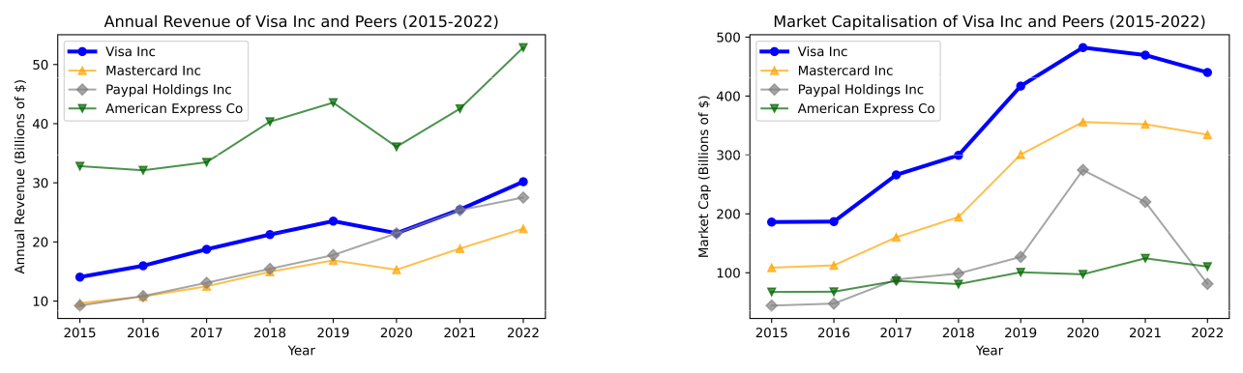

**(a)** The annual revenue for Visa Inc and its peers (2015- **(b)** The annual revenue for Visa Inc and its peers (2015-

2022). 2022).

**Figure 1:** A comparison of various financial metrics for Visa Inc and its peers between 2015 and 2022. All data acquired from [3]

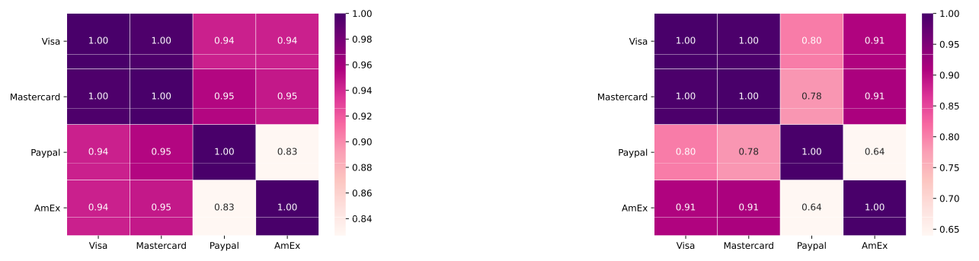

**(a)** Annual revenue heat-map (2015-2022). **(b)** Market capitalisation heat-map (2015-2022).

**Figure 2:** Two heatmaps indicating the correlation between growth in (2a) **Annual Revenue** and (2b) **Market Capitalisa-tion**. Darker purples represent higher positive correlation and lighter pinks represent lower positive correlation.

1

Visa Inc. Market Research Report Sidharth Nambiath

It can be seen in Table 1 that all four companies have similar financial statistics with regard to annual revenue and market capitalisation. By observing the historical evolution of said metrics, as in Figure 1, it can be seen that Visa Inc, Mastercard Inc and American Express Co all followed similar growth patterns. Paypal Holdings Inc notably deviates from this, perhaps as a result of its presence solely in the online market, compared to the other companies which also issue physical debit and credit cards. The deviation is especially prominent in between the end of FY 2019 and FY 2020, perhaps as a result of online payments becoming dominant in that time period due to the coronavirus pandemic. In any case, the heat-maps in Figure 2 show that growth in any one company showed a moderate to strong correlation with growth in any other company, in particular Visa Inc and Mastercard Inc showing near perfect correlation, and American Express Co and Paypal Holdings Inc showing the weakest correlation, as expected.

**Subsitutes and New Markets**

The following were identified as substitute services:

* Cash and cheque related payments
* Services offered by the peers
* Online payment services

The first item, cash and cheque related payments, are unlikely to grow over time, due to the inconvenience of carrying cash, thus it is unlikely to become a serious competitor. The peer companies do offer alternatives to the Visa payment card, although it should be noted that Visa Inc is still the dominant payment processor. American Express Co operates under a "closed-loop" network, meaning that it extends credit itself to its clients, whilst charging annual fees to cardholders. Additionally, its clients are typically wealthier and higher spenders, thus it generates large revenue from a relatively small customer base. In contrast, Visa and Mastercard operated under an "open-loop" network, meaning that it is banks and other financial institutions that extend credit instead, with Visa and Mastercard generating revenue by taking a small transaction fee per transaction. These companies therefore rely more on the volume of cardholders. Finally, online payment services (such as what is provided by Paypal, but also by Stripe, Venmo, Google Pay, Apple Pay, Amazon Pay etc), may prove to be the most viable substitutes, due to the ever-increasing popularity of online shopping. The market share of various online payment methods is shown in Figure 3, where the 2026 forecast market shares were acquired from [4].

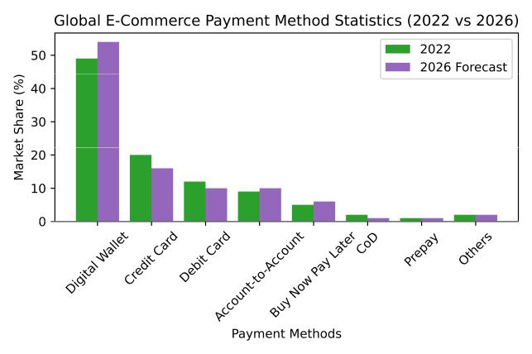

**Figure 3:** The market share of various payment methods in 2022, and a forecast for their market shares in 2026, provided by [4].

2

Visa Inc. Market Research Report Sidharth Nambiath

The following has been identified as a potentially new market for Visa Inc to operate in:

* Blockchain technology and cryptocurrencies
* Fintech partnerships

The former could be manifested through partnerships with cryptocurrency wallets to allow for linkage with Visa cards, or equivalently, by creating Visa cards which allow for payment in cryptocurrencies, thus allowing for the mainstream acceptance of cryptocurrencies by merchants. The latter has already begun in some capacity, though it seems fintech firms such as Monzo, Starling Bank and Revolut, tend to issue their debit cards through Mastercard. Thus, it is imperative that Visa forms partnerships with fintech firms, as the forecast suggested in [4] indicate that digital wallets are only set to grow, whilst credit and debit card payments are set to fall.

**Revenue and Cost Drivers**

The volume of "sales" for Visa inc can be represented by the number of transactions. By plotting the yearly volume of sales [5] between 2015 and 2022 against the revenue earned in that year, it can be seen in Figure 4 that there is a strong positive correlation between the volume of sales and the revenue earned, thus it is in the interest of Visa to increase the number of transactions that occur through its network. Considering the costs,

The key revenue drivers for Visa Inc are payment volume on visa products for purchased goods and services.

Revenue per transaction * transaction volume.

Based on payments volume and number of transactions, Visa is one of the world’s largest electronic payments system.

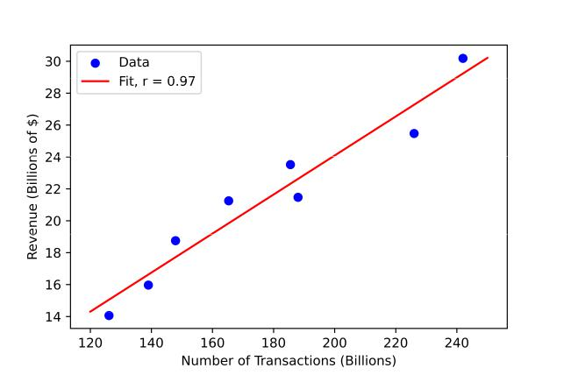

**Figure 4:** The revenue associated with a specific number of transactions in a year (2015-2022).

which are mainly driven by the costs associated with expanding the infrastructure to account for increased number of transactions, seen in Figure 5a we can see that there has been strong correlation between the operating expenses and the revenue in 5b.

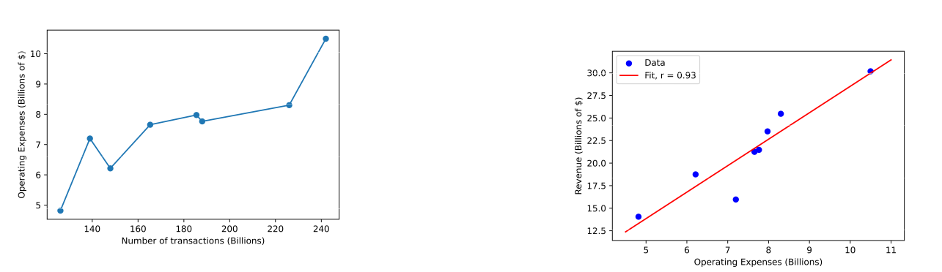

1. No. of transactions vs operating expenses (2015-

2022). **(b)** Operating expenses vs revenue (2015-2022).

**Figure 5:** Indications of cost drivers

3

Visa Inc. Market Research Report Sidharth Nambiath

**SWOT Analysis**



STRENGTHS WEAKNESSES

1. **Global brand -** Visa is a brand known across the world, with infrastructure already in place in the vast majority of countries.
2. **Strong and resilient financial performance -** As demonstrated previously, Visa Inc’s finan-cial statistics show growth overall.
3. **Presence in a market with high barriers to entry -** Given the large costs of setting up the infrastructure to allow for card acceptance amongst merchants, it is unlikely that any new direct competitors can arise in the market that Visa currently operates in.



1. **Dependance on financial institutions -** As Visa does not extend credit itself, it relies on banks and building societies to do this. The number of transactions performed by a consumer may depend on the interest rate charged on the credit card, which is set by the bank or building society, which Visa Inc has no control over.
2. **Strong competitors -** Although there is little scope for new participants in Visa Inc’s spe-cific market, this means the existing competi-tor (Mastercard Inc) is of similar size to Visa Inc, and thus there is a viable alternative for many merchants.
3. **Societal shift to e-commerce -** In recent years, e-commerce has become a huge market, and many consumers prefer the simplicity of using digital providers, e.g. Paypal, compared to the laborious task of providing card details.



OPPORTUNITIES THREATS

1. **Collaboration with Fintech -** As discussed previously, Visa Inc can partner with Fintech firms, e.g. Monzo, Starling, Revolut.
2. **Entry into Newly Emerging Economies (NEEs) -** The increased growth of the middle class in NEEs demand more goods which can be accessed with the help of credit cards.
3. **Blockchain and cryptocurrencies -** As afore-mentioned, there is scope for Visa Inc to link with cryptocurrency wallets.
4. **Economic uncertainty -** As demonstrated by the 2020 Coronavirus pandemic, unpre-dictable changes in societal behaviour can result in a sudden switch in how consumers shop.
5. **Growth of digital payment platforms -** Com-panies like Paypal provide a simple, secure way of performing transactions, compared to the relatively multi-stepped process of paying with a Visa card.
6. **Cyber security threats -** It has been demon-strated that cyber-criminals tend to attack pay-ment processes for financial gain.

**Strengths**

Strong and secure payment infrastructure

* Strong distribution network

Market leadership and strong brand value

Strong strategic partnerships with card issuers and merchants

Resilient business model that protects against inflation

**Weakness**

Lack diversification in business model

Lack of product development to combat new and emerging payment methods

Lack of innovation

**Opportunities**

Increasing preference for online shopping and cash-less transactions due to the pandemic

Opportunities to collaborate with emerging competitors like PayPal and mobile wallets

Loyal and large customer base that can be introduces with new or add on products

Availability of vast data that can be researched for product development

**Threats**

Threat of becoming obsolete due to new and emerging payment technologies

Increased competition owing to duopoly market

Lack of differentiation from competitor

Large amount of personal data that needs to be secured for privacy

Threat of fraudulent activities

Threat of money laundering and terrorism financing

4

Visa Inc. Market Research Report Sidharth Nambiath

**PESTLE Analysis**



POLITICAL ECONOMIC

1. **Government regulation -** Financial services are heavily regulated in most countries, and firms operating in that sector must be open and mobile to respond to changes in govern-ment policy.
2. **Political stability -** Countries with a stable gov-ernment nationwide allow for easy regional expansion and growth.
3. **Trade Blocs -** Common financial and mone-tary policies across countries makes it easier for financial institutions (who provide the in-terest rates for Visa credit cards) to set their interest rates without variation between coun-tries.



1. **Economic growth -** Growth in GDP (and par-ticularly GDP per capita if distributed equi-tably) represent increased purchasing power and a growing middle class - they tend to spend more, and be more willing and able to take on credit.
2. **Inflation rates -** High inflation could mean goods and services become unaffordable, thus consumer expenditure falls. As Visa Inc’s rev-enue is tied to the number of transactions, this means that too high inflation can put down-ward pressure on annual revenue. Conversely, deflation means prices are constantly falling, and thus people tend not to make transactions as they continuously defer consumption in the belief that goods and services will be cheaper in the near future. Thus, an economy with moderate inflation (e.g. 2%) is favourable for Visa Inc.



SOCIAL TECHNOLOGICAL

1. **Demographics -** Nations with a strong young and employed workforce will be more benefi-cial for Visa Inc, as they tend to be more willing to take on credit.
2. **Class structure -** As aforementioned, a strong middle class is beneficial as they have a higher marginal propensity to spend, thus their num-ber of transactions increase.
3. **Social values -** Certain cultures value saving and being frugal over spending. It is worth being mindful of Visa Inc’s revenue’s depen-dance on the number of transactions.
4. **Technological advancements -** As aforemen-tioned, technology is playing a huge part, through e-commerce. It is crucial that Visa Inc takes advantage of increased penetration as a result of mobile phones, and the new tech-nology involved in blockchain.

5

|  |  |  |
| --- | --- | --- |
| Visa Inc. Market Research Report | | Sidharth Nambiath |
|  |  |  |
|  | LEGAL | ENVIRONMENTAL |



1. **Anti-trust and competition law compliance**
   * Given Visa Inc’s dominant position in what is essentially an oligopolistic market, it will be subject to scrutiny with regard to competition law.
2. **Anti-terrorist and money laundering laws -** Due to Visa’s global network, they are under pressure to ensure that criminal and terrorist financing is detected and eliminated.
3. **Paper usage -** As Visa’s network is electronic and replaces the use of paper money, it may be looked favourably as it minimises paper waste.
4. **Carbon footprint -** Visa Inc may be under in-creased pressure to reduce the carbon foot-print associated with its network - through electronic payment processing, carbon emis-sions are still emitted through the electricity generation.

**Political**

Demonetization (India)

Attitude of ruling party about cards instead of cash

Government backed local competitors

Tax legislations

**Social**

Attitude towards credit cards/savings

Card penetration in developing countries

Increasing number of elderly people becoming digitally literate

**Technological**

Impact of technology helping competitors and new entrants

Costs for new technology adoption and prevention of fraud and crime

Crypto currency gaining market share

Emerging mobile wallets like paypal

Penetration of ATMs and Point of sale

Tokenization, Biometrics, Machine learning

Tap to pay, Scan to pay

**Environmental**

Global warming impact on weather issues which affect spending patterns

Seasonality impact on spending patterns

Covid and work from home culture increasing the use of cards in e-commerce compared to cash

**Legal**

KYC and privacy laws in various countries

Anti money-laundering laws

Privacy and data protection laws

**Industry Analysis/Key strategies**

The global payments industry has been growing rapidly ever since the aftermath of the 2008 recession, in 2018 the industry totaled revenues of 1.9 trillion.

The strategy for Visa is to expand their core Business which consists of Core Products (cards), Tap to pay technology, Ecommerce (outpacing physical retail), Access & Acceptance (new markets), Partnerships (through fintech development) and Ventures (strategic investments to enrich broader payment systems). In 2019 Visa acquired earth por EarthPort that allows Visa to reach 99 percent of the world’s banked population in 88 countries, including the top 50.

Visa provides auxiliary or value – added services which is a growth opportunity. Visa’s fraud and security services run by artificial intelligence-powered risk scoring engine helped financial institutions prevent about $25 billion in fraud. In addition, Visa provides tokenization services and their product, developed by their provider Bell ID, allows users for much lower fees. Visa also provides data analytics, settlement and other services within this group of services.

Mastercard’s strategy is to broaden their capabilities as consumers and merchants demand enhanced payment options, with Mastercard focusing its technology on the business-to-business market which Mastercard estimated is a $25 trillion market annually in the U.S. Mastercard have begun implementing this strategy through various acquisitions.

6

**Bibliography**

1. *Visa Inc: Overview*. 2022. URL: <https://www.globaldata.com/company-profile/visa-inc/>.
2. *Visa Inc: Competitors*. 2022. URL: [https://www.globaldata.com/company- profile/visa- inc/](https://www.globaldata.com/company-profile/visa-inc/competitors/) [competitors/](https://www.globaldata.com/company-profile/visa-inc/competitors/).
3. *Largest Companies by Market Cap*. 2023. URL: <https://companiesmarketcap.com>.
4. *The Global Payments Report 2023*. Tech. rep. FIS, 2023, p. 8. URL: [https://www.fisglobal.com/-/media/fisglobal/files/campaigns/global-payments-report/FIS_TheGlobalPaymentsReport](https://www.fisglobal.com/-/media/fisglobal/files/campaigns/global-payments-report/FIS_TheGlobalPaymentsReport_2023.pdf)_ [2023.pdf](https://www.fisglobal.com/-/media/fisglobal/files/campaigns/global-payments-report/FIS_TheGlobalPaymentsReport_2023.pdf).
5. Raynor de Best. *Number of purchase transactions on global general purpose card brands American Express, Diners/Discover, JCB, Mastercard, UnionPay and Visa from 2014 to 2022*. 23 Aug 2023. URL: [https:](https://www.statista.com/statistics/261327/number-of-per-card-credit-card-transactions-worldwide-by-brand-as-of-2011/#:~:text=Roughly%20242%20billion%20purchase%20transactions,estimates%20on%20general-purpose%20cards.) [//www.statista.com/statistics/261327/number-of-per-card-credit-card-transactions-worldwide - by - brand - as - of - 2011 / # : ~ : text = Roughly % 20242 % 20billion % 20purchase %](https://www.statista.com/statistics/261327/number-of-per-card-credit-card-transactions-worldwide-by-brand-as-of-2011/#:~:text=Roughly%20242%20billion%20purchase%20transactions,estimates%20on%20general-purpose%20cards.) [20transactions,estimates%20on%20general-purpose%20cards.](https://www.statista.com/statistics/261327/number-of-per-card-credit-card-transactions-worldwide-by-brand-as-of-2011/#:~:text=Roughly%20242%20billion%20purchase%20transactions,estimates%20on%20general-purpose%20cards.).

7