Marriot Inc.

* Increase in base management and franchise fee due to the higher RevPAR from exiting COVID conditions.
* Cost reimbursed revenue is around 80% of total revenue, which is much higher than peers who are around 35-40%. This is due to having many hotels under management[1]
* Reimbursed expense varies to cost reimbursed due to timing differences, over long term will not provide any benefit
* D&A decreasing due to lower impairment
* G&A higher from higher admin costs

Revenue is driven as RevPAR * No. Rooms where,

RevPAR is the function of ADR (price impact) * Occupancy (volume impact)

Note that for each of the segments, North America (full service, limited service), APAC and Other international, RevPAR, Room count Occupancy and ADR are reported by the company. These will be forecasted based on historical trend analysis.

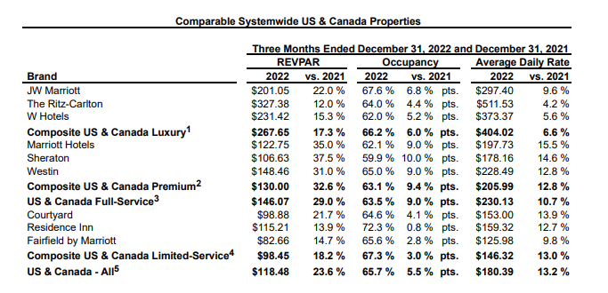

Large portion of Marriot’s cost is the reimbursed expenses which is directly related to reimbursed revenue. Management and franchise related operating expenses will have be derived as a % of revenue.

Johnson & Johnson

* Revenue has been increasing YoY with a large 13.5% increase in 21 vs 20
* PFE has had higher revenue between 2020-2022, due to the Pfizer COVID vaccine.

Each of the three segments, Consumer, Pharmaceuticals and Medical Devices have sub segments with product lines like Remicade, Darzalex , Stelara and Tremfya  or Surgery, Orthopaedics and Intervention solutions. All of these lines have US & International sales. US revenue can be driven by annual growth rates, international revenue growth has two components, organic growth and currency impact.

Cost Drivers – as % of revenue (trend analysis)

* Selling, Marketing and Administrative Expenses
* Research and Development Expenses
* In-process research and development
* Cost of products sold
* COGS is roughly 33% of revenue, similar to PFE between 2022-21 but much higher pre 2020
* R&D has been increasing from 13% to 15.38% of revenue from 2016 to 2022 respectively, showing an increased investment in R&D
* SG&A has been decreasing portion of revenue, roughly around 26% of revenue.

1. https://marketrealist.com/2016/01/understanding-cost-reimbursements-key-part-marriott-internationals-revenues/