**COST AND REVENUE DRIVERS**

**Marriott International, Inc** has several revenue drivers that contribute to its financial success. These drivers can include:

* Occupancy Rates: Most of the revenue is generated from occupied rooms, higher occupancy rates lead to increased room revenue.
* Average Daily Rate (ADR): represents the average price at which rooms are sold. The revenue can increase by room prices adjustment.
* Revenue per Available Room (Rev Par): measures both occupancy rates and average daily rate. Increasing Rev Par is a significant driver of revenue.

Revenue is driven as RevPAR * No. Rooms where,

RevPAR is the function of ADR (price impact) * Occupancy (volume impact)

Note that for each of the segments, North America (full service, limited service), APAC and Other international, RevPAR, Room count Occupancy and ADR are reported by the company. These will be forecasted based on historical trend analysis.

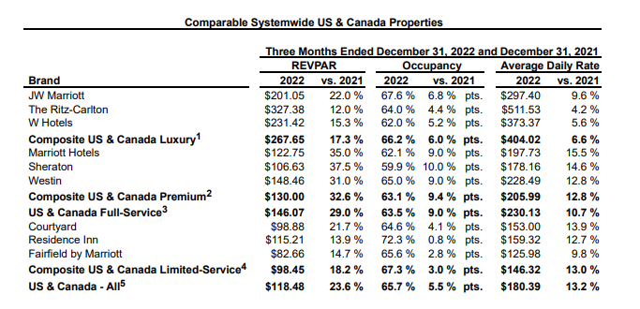

Large portion of Marriot’s cost is the reimbursed expenses which is directly related to reimbursed revenue. Management and franchise related operating expenses will have be derived as a % of revenue.

* Geographical expansion: Marriot International can increase revenue by expanding into new markets and regions which is associated with new customers and higher revenue.
* Brand Portfolio: Marriott’s diverse brand portfolio offers various customer segment, from luxury to budget travellers. Effective brand management is indicative of wide range of customers and boost revenue.
* Management and Franchise Fees: Marriott generates revenue through management and franchise agreements with property owners. This fee-based model allows them to expand without significant capital investment.
* Food and Beverage Operations: Marriott properties generate additional revenue by providing catering services and opportunity to use their restaurants.
* Meeting and Events: Hosting conferences, meetings and events at Marriott properties add additional revenue.

**Marriott International, Inc** has several cost drivers that has imperative impact on cost structure. These cost drivers can include:

* Labour costs: wages and benefits for hotel staff, including front desk, housekeeping, restaurants and management personnel are significant part of Marriott’s expenditure.
* Real Estate Costs: Leasing or owning hotel properties, land and real estate impact Marriott’s costs.
* Utilities: Expenditures related to electricity, water and heating can add up to cost structure and can be a substantial for a large hotel properties.
* Maintenance and Repairs: the maintenance of Marriott’s properties is imperative in order to achieve guest satisfaction; however, it comes with costs.
* Advertising: In order to gain customers and generate revenue, Marriott has to invest in marketing and advertising which is associated with costs. These expenses can vary based on marketing campaigns and initiatives.
* Technology and IT: These costs are associated with implementing and maintaining technology infrastructure, reservation systems and cybersecurity.
* Insurance: The insurance is mandatory to protect against various risks, including property damage and liabilities claims.
* Franchise and Management Fees: These costs generate revenue but on the other hand , they involve costs related to supporting franchisees and managed properties.
* Food and Drinks Costs: For Marriott properties with dining facilities, the costs of purchasing, preparing, and serving food and drinks are a significant expense.
* Property Taxes: Property taxes are mandatory expenses imposed by a local governments that has to be paid annually for each property.
* Depreciation and Amortization: The allocation of costs related to property and equipment depreciation and intangible assets affects financial reporting.
* Interest Expenses: If Marriott has any financial obligations, interest expenses has to be incorporated as a significant cost driver.

**Johnson & Johnson**  has several revenue drivers that contribute to its financial success. These drivers can include:

* Pharmaceutical Sales: Johnson & Johnson's pharmaceutical segment, including well-known brands like Remicade and Janssen, generates a substantial portion of its revenue. Revenue drivers in this segment include: sales of prescription drugs and biologics, successful research and development leading to new drug approvals, expanding the use of existing drugs for new indications and market share and growth in therapeutic areas.
* Consumer Health: This segment includes consumer healthcare products like over-the-counter drugs, skincare, and baby care products. Ultimately, key revenues drivers are sales of consumer health products, marketing and brand recognition, product innovation and launches.
* Medical Devices: Johnson & Johnson's medical device segment produces a range of products, from surgical instruments to orthopaedic devices. Revenue drivers include sales of medical devices and equipment, advances in medical technology, expansion into emerging markets.
* Research and Development Collaborations: Collaborative research agreements and partnerships with other pharmaceutical companies can lead to revenue.
* Acquisitions and Partnerships: Strategic acquisitions and partnerships with other healthcare companies can drive revenue growth by expanding the product portfolio and market research.
* Supply Chain and Operational Efficiency: Optimizing the supply chain and operational processes can help reduce costs and improve profitability, indirectly impacting revenue.

Each of the three segments, Consumer, Pharmaceuticals and Medical Devices have sub segments with product lines like Remicade, Darzalex , Stelara and Tremfya  or Surgery, Orthopaedics and Intervention solutions. All of these lines have US & International sales. US revenue can be driven by annual growth rates, international revenue growth has two components, organic growth and currency impact.

Cost Drivers – as % of revenue (trend analysis)

* Selling, Marketing and Administrative Expenses
* Research and Development Expenses
* In-process research and development
* Cost of products sold

**Johnson & Johnson**  has several cost drivers that has imperative impact on cost structure. These cost drivers can include:

* Research and Development (R&D): Developing new drugs and bringing them to market is expensive. Johnson & Johnson invests heavily in research and clinical trials.
* Manufacturing and Production: The cost of manufacturing pharmaceuticals, including raw materials, labour, and equipment is a significant expense.
* Marketing and Sales: In order to generate revenue, Johnson & Johnson has to promote products and services, including direct consumer advertising which comes with substantial costs.
* Regulatory Compliance: The compliance is an important factor in pharmaceutical industry. Johnson & Johnson has to ensure strict pharmaceutical regulations and quality standards which requires dedicated resources.
* Distributing and Supply Chain: Managing a complex global supply chain, including transportation, warehousing, and inventory costs, is a significant cost driver.
* Legal Expenses: Johnson & Johnson might face legal challenges and litigations, resulting in legal expenses.
* Employee Compensation and Benefits: Salaries, benefits, and healthcare for a large workforce, including scientists, researchers, sales teams, and administrative staff.
* Acquisitions and Integrations: Costs associated with acquiring other healthcare companies, integrating new businesses, and managing the associated complexities.
* Operational Costs: General expenditures has to be incorporated such as administrative, facility and overhead costs.
* Interest Expenses: If Johnson & Johnson has any financial obligations, interest expenses have to be incorporated as a significant cost driver.
* Sustainability Initiatives: Investments in environmental and social sustainability initiatives, which can involve costs to meet corporate responsibility goals.