***Johnson & Johnson***

* Johnson & Johnson’s key sources of revenues are Pharmaceuticals, Medical Devices and Consumer Healthcare, with the Pharmaceuticals segment making 55% of 100 billion dollars in total revenues for the company over the 2023 financial year, while Medical Devices segment, being the second most important segment, will also become key to its revenue growth over the coming years
* Johnson and Johnson consumer segment offers a variety of products for oral care, baby care, skincare, and many other personal healthcare products
* The company’s major brands include Clean & Clean, Neutrogena, Aveeno, Benadryl, Nicorette, Listerine, Staysafe, Carefree, Band aid, Neosporin amongst many others
* Its medical devices segment includes various types of devices used in Surgery, Interventional Solutions, Orthopaedics and Vision fields
* The Pharmaceutical segment focuses on Immunology, Pulmonary, Hypertension, Neuroscience, Infectious Diseases, Cardiovascular and Metabolism and Oncology and its major brands include Stelara, Remicade, Risperdal Consta, Opsumit and Invokamet SR
* The company recognizes revenue from product sales when obligations under the terms of a contract with a customer are being met. The company’s global payment terms are typically between 30 to 90 days. Provisions for certain rebates, sales incentives, trade promotions, coupons, product returns, discounts to customers and governmental clawback provisions are accounted for as variable consideration and recorded as a reduction in sales.
* The sales returns for the total company has been approximately 1% of annual net trade sales during each of the fiscal years 2020, 2021 and 2022
* Profit share payments were less than 2% of the total revenues in 2022 and less than 3% of the total revenues in 2021 and 2020 and are included in sales to customers

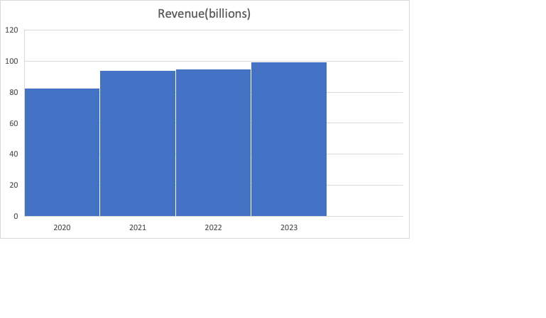

* The organisation’s revenue increased about 12 billion dollars from 2020 to 2022, with the highest increase being in 2020 to 2021, with Pharmaceuticals having the greatest increase from 45.6 million dollars inn 2020 to 52.2 million dollars in 2021
* The company has both US and International sales and hence international revenue growth has 2 components, organic growth and currency impact
* The net impact of acquisitions and divestitures on the worldwide sales growth was negative impact of 0.1% in 2022 and negative impact of 0.6% in 2021
* In 2022 most of the company’s sales were in the US with a total revenue of 48.6 billion dollars, followed by 23.4 billion dollars in Europe, 16.8 billion dollars sales in Asia-Pacific and Africa and the smallest amount of sales were in Western Hemisphere (excluding US)
* The company has approximately 152,700 employees around the world, engaged in research and development, manufacture and sale of a broad range of products in the healthcare field all of which are associated with some fixed and variable costs
* Variable costs usually include inventory costs because they are often associated with production units and accounts of recorded inventory, such as the cost sold to customers that fluctuate with the volumes of production
* On the other hand, fixed costs, do not fluctuate and mainly include manufacturing overhead costs and indirect costs
* Other fixed costs include the payment for rent of warehouses or manufacturing plants, or the machinery used in production, salaries paid to the company’s executives, expenses on interests, insurance and depreciation expenses
* Variable costs that the company is expected to pay also include direct material and labour costs
* Shipping and handling costs were 1.1 billion dollars in 2022 and 2021 financial years and 1 billion dollars in 2020
* Johnson & Johnson invests heavily in R&D to develop new pharmaceuticals, medical devices, and consumer healthcare products. The cost of conducting research, clinical trials, and innovation is a significant driver of expenses
* Additionally the healthcare industry is heavily regulated, and Johnson & Johnson must comply with various government regulations and quality standards. Ensuring compliance and managing associated costs, such as documentation and testing, leases etc
* Costs associated with advertising are expensed in the year incurred and are included in selling, marketing and administrative expenses. Advertising expenses worldwide, which comprised television, radio, print media and Internet advertising, were $2.1 billion, $2.7 billion and $2.1 billion in fiscal years 2022, 2021 and 2020, respectively

* Main cost drivers as a percentage of revenue in 2022 FY

***Company Performance:***

Johnson & Johnson is an American multinational pharmaceutical, medical devices and consumer packaged goods manufacturer, engaged in the research and development, manufacture and sale of a range of products in the health care field with more than 250 operating companies conducting business worldwide. Its drugs are used for the treatment of diseases including cancer, heart-related, infectious, among others.

Its business model possesses some durable competitive advantages necessary to continue generating attractive returns on invested capital and at the same time fending off heavy competition in the healthcare, consumer products and pharmaceutical spaces. The main driver behind this is the company’s string innovating capabilities, replenished by its heavy investments in research and development, spending around 1.3 billion dollars a year on medical device research and development, each of these projects generating around 7 billion dollars on an annual basis in marginal sales. Another competitive advantage of the company compared to its peers is the size and scale of the business alongside its status as a worldwide leader in a number of healthcare and consumer products categories. Another reason of the company’s reputation is its impressive track record and solid outlook. The company has grown earnings over the past 10 years at a rate of 4.8% and has managed to grow earnings during and after the last recession continuing its long lasting success.

Since the pandemic the healthcare industry has seen an unprecedent level of growth and consequently many healthcare companies were in stronger position in 2022 than ever before so Johnson & Johnson has now more rivals than before, despite of still being the world’s largest healthcare company. Johnson & Johnson’s main competitors now include Pfizer and GlaxoSmithKline. Notably, J&J is one of the companies that successfully developed a Covid-19 vaccination, though it saw less success than rivals like Pfizer. Following a disappointing first quarter of 2022 for vaccine sales, Johnson and Johnson dropped its Covid-19 vaccine revenue projections. The company’s vaccine sales for Q1 were [$457 million](https://www.fiercepharma.com/pharma/johnson-johnson-after-weak-quarter-vaccine-sales-will-no-longer-include-it-guidance) – considerably less than Wall Street’s estimate of $785 million, but the corporation does not only operate in one sector of the healthcare industry, but many being less vulnerable.

GSK is one of the world’s largest pharmaceutical companies, currently, it is ranked [264](https://fortune.com/company/glaxosmithkline/global500/) on Forbes’ Fortune 500 list, behind J&J and P&G. When the pandemic hit, GSK was already in a strong position due to its previous work on vaccines and other vital medications. In 2020, the UK government signed a contract for 60 million doses of GSK’s Covid-19 vaccine, which it developed with Sanofi. The US also ordered 100 million vaccine doses in a [$2.1 billion deal](https://www.cnbc.com/2020/07/31/us-agrees-to-pay-sanofi-and-gsk-2point1-billion-for-100-million-doses-of-coronavirus-vaccine.html). Since then, GSK has unsurprisingly [announced](https://www.gsk.com/en-gb/media/press-releases/new-gsk-to-deliver-step-change-in-growth-and-performance-over-next-ten-years/) it will prioritize investment in R&D for vaccines, and other speciality medicines, which it expects will grow to roughly three-quarters of company sales by 2026. To reinforce its investment in vaccine-based R&D, GSK announced in 2022 that it was acquiring clinical-stage pharmaceutical company Iffinivax, Inc., for a [$2.1 billion upfront payment](https://www.gsk.com/en-gb/media/press-releases/gsk-to-acquire-clinical-stage-biopharmaceutical-company-affinivax-inc/). Affinivax is pioneering the development of a novel class of vaccines to fight illnesses like pneumonia and meningitis. In 2021, GSK hit £34.1 billion in revenue, still behind Johnson and Johnson.

To summarize, JNJ is still the biggest organisation in the pharmaceutical industry, but competition is getting bigger year after year. At the end of the day, success in this industry comes down to how much money an organisation can invest in new technology and whether you can outbid your competitors for government contracts. So far, Johnson and Johnson is in a strong position to do both.