**Marriott International**

Revenue is driven as RevPAR * No. Rooms where,

RevPAR is the function of ADR (price impact) * Occupancy (volume impact)

Note that for each of the segments, North America (full service, limited service), APAC and Other international, RevPAR, Room count Occupancy and ADR are reported by the company. These will be forecasted based on historical trend analysis.

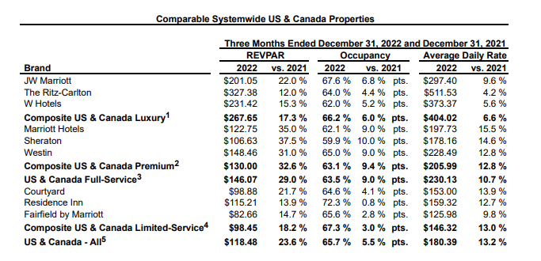

Large portion of Marriot’s cost is the reimbursed expenses which is directly related to reimbursed revenue. Management and franchise related operating expenses will have be derived as a % of revenue.

* As shown in the above pie chart, the most of the organisation’s revenue is generated by cost reimbursements, mainly consisting of salaries paid to the employees
* Under Marriott’s management model, day to day operations of the hotels run in return for a fee, which is a percentage of the total amount generated by the hotel and an incentive fee, based on the percentage of operating income
* Even though Marriot is technically the employer of the workers who run the day to day operations, their salaries are reimbursed by the hotel owners and are shown as part of the hotel’s revenue and as part of operation expenses
* Other revenue include Global Design fees, termination fees, and other property and brand revenues
* Based on the conditions existing at December 31 2022 and holding other factors constant, a one percent decrease in the estimate of the breakage of points could result in an increase in the liability for guest loyalty program of approximately 50 million dollars
* On the contrary franchise fees include initial application fees and continuing royalties for the use of Marriott’s brand names
* Marriot charges about 4-6% of room revenues and 2-3% of food and beverage revenues in full service hotels as royalty fees
* Owned and leased hotels include revenues from room sales and guest service provided for Marriott’s owned and leased properties when they are occupied
* The key cost driver of the organisation is again reimbursed expenses, and then the main expenses include general and administrative which include salaries and employers who work in departments like security and human resources, and any applicable payroll expenses, and direct expanses which include the purchases and production of goods and services
* Depreciation and amortization costs and restructuring, merger-related charges and other indirect expanses make a far smaller percentage of the total operating costs of the organisation
* Generally, on a depreciation schedule, hotels are set to depreciate over 39 years
* Under the management and franchise agreements of the organisation, hotel owners and franchises participate in certain centralized programs and services, like marketing, sales, reservations and insurance programs exclusively for the benefit of our hotel owners and not in order to generate profit over the long term and when the costs incurred for these programs and services are recovered from the hotel owners the organisation does not seek any mark-ups.

***Company performance:***

Marriot International has been consistently for many years a leading force in the hospitality industry. Marriot’s dedication to excelling in customer satisfaction, innovation, and continuous growth has indeed increased the standards in the industry over the years.

Marriot International primarily makes money through its diverse portfolio of hotels and resorts offering different types of accommodations, services and amenities that cater to different types of clients; business and leisure. With a remarkable amount of properties under its Umbrella, Marriott generates revenue through room bookings, food and beverage sales, events and conference services, and other ancillary services like spa treatments and parking fees. Marriott also benefits from a franchise model, allowing independent hotel owners to operate under the Marriot brand, collecting franchise fees and royalty income. Lastly, the company leverages its Marriot Bonvoy loyalty program to encourage repeat business and loyalty, leading to increased revenue by maintaining a stable and dedicated customer base.

Under its business model, cost reimbursements contribute on average 80% of the total revenue declared by Marriot, much higher than most of its peers such as Hyatt Hotels Corporation and Hilton worldwide holdings, whose cost reimbursements contribute about 35% to 40% of their total revenue. The main reason for this is the fact that Marriot had under its management model a greater percentage of hotels than its peers have. As mentioned by the president and CEO of Marriott International, their fee driven, asset light business model generated significant cash during 2022, two years after experiencing the sharpest downturn in their company’s history due to the pandemic, allowing the company not only to invest in the growth of their business, but also return 2.9 billion dollars to shareholders.

It is also evident that owners and franchises continue to show their strong preference for the company’s brands, since they have signed additionally nearly 108,000 rooms globally in 2022. However, adjusted operating income increased to 926 million dollars in the 2022 fourth quarter, compared to 2021 fourth quarter which was equal to 578 million dollars. Base management and franchise fees totalled 945 million dollars in the 2022 fourth quarter, compared to base management and franchise fees of 737 million dollars in previous year quarter. The year-over-year increase in these fees is primarily attributable to RevPAR increases due to the continued recovery in lodging demand, and unit growth, partially offset by 16 million dollars of unfavourable foreign exchange. Fees in the quarter surpassed 2019 levels, with 60 percent earned in International markets.

Owned, leased and other revenue, net of direct expenses, totalled 101 million dollars in the 2022 fourth quarter, compared to 33 million dollars in the year-ago quarter. The year-over-year increase in revenue net of expenses largely reflects the continued recovery in lodging demand and $21 million of increase in termination fees.

To summarize, the organisation has had a steady growth every year so far and is persistently the world’s leading hotel chain proving that it has a very effective and profitable business model. However, recently the organisation added some more ‘affordable’ properties to its portfolio. However, given the uncertain economic conditions of the upcoming years it can be less profitable since it is now more exposed to travellers who are less resilient in economic downturns, so it might create some complications in the future.