Task 3 – Peer Companies

Company | Peer Companies | Justification
Marriot Inc | Hilton Worldwide Holdings Inc, Accor SA, Hyatt Hotel corporation | - All publicly owned companies  - Similar annual revenue figures ($8 billion vs $4.4 billion, $5.9 billion, $5.89 billion respectively  - Similar no. of employees  - Same industry  - Market Cap of $61.27 billion vs $39.7 billion, $8.57 billion and $11.85 billion respectively.  - Similar share price growth trends
Tesla Inc | Bayerische Motoren Werke AG (BMW), Mercedes-Benz Group AG, General Motors Co. | - Similar annual revenue, for Tesla this is $81.5 billion, compared to peers, $150 billion, $157.7 billion, $156.7 billion.  - Similar industries: luxury car market (Tesla only focused on EV, peers trying to break into EV).  - Similar number of employees  - Market Cap of $687 billion vs $64.45 billion, $71.241 billon, $45.98 billion. Tesla’s market cap is significantly higher due to investor confidence that Tesla will make a breakthrough in autonomous driving?  - Tesla’s share price growth has not been consistent with its peers, again perhaps due to its status as a company at the frontier, compared to its peers which have strong bases in traditional car manufacturing.
Netflix Inc | Paramount Global, Amazon Inc, Warner Bros | - Same industry  - Amazon and Disney are far larger companies, involved in numerous markets. However, they have specific divisions: Amazon Prime Instant Video, Disney+ and Hulu which operate as competitors  - Netflix has annual revenue of $31.6 billion, compared to its peers, $514 billion and $33.8 billion.  - Market cap of $177.9 billion vs $9.63 billion, $1.35 trillion and $30.85 billion  - Paramount shares plunged in May 2023 due to reporting earnings below street expectations, and an unexpected cut to dividends.
Nvidia Inc | Advanced Micro Devices Inc (AMD), Intel Corporation, Graphcore | - Nvidia has traditionally competed with only AMD in the graphics card market, but today AI enabled chips have propelled stock growth in Nvidia and lead to new competitors arising: AMD, Intel, Graphcore amongst others.  - Nvidia’s annual revenue of $27 billion (2023) is roughly comparable to its peers, $23 billion (2022), $63.1 billion (2022). Graphcore’s is far smaller, in the hundreds of millions of dollars range, but it operates in the same market.  - Market cap of $1.045 trillion vs $167.57 billion, $136.14 billion. Graphcore is privately owned.  - The publicly owned companies follow similar share price growth trends
Pfizer Inc | Johnson & Johnson, F. Hoffmann-La Roche Ltd (Roche), Merck & Co Inc | - Pfizer’s annual revenue of $100 billion is roughly similar to its peers, $94.9 billion, $66.3 billion, $59.3 billion  - Market cap of $205.85 billion compared to $415 billion, $234.67 billion, $275.69 billion

Share Price Growth

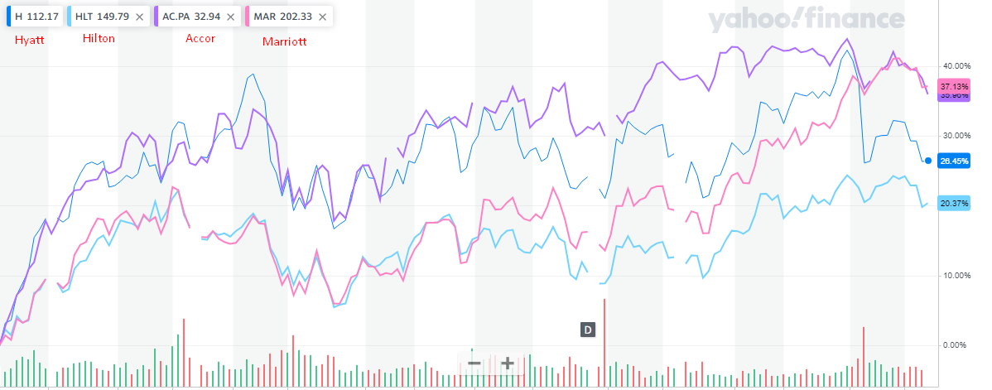

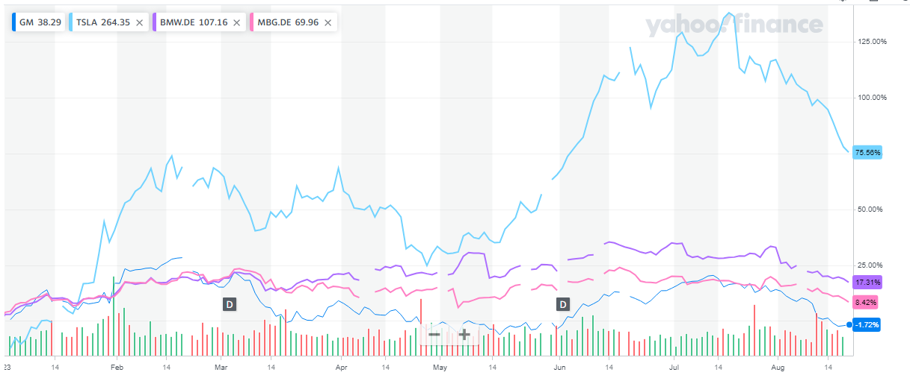

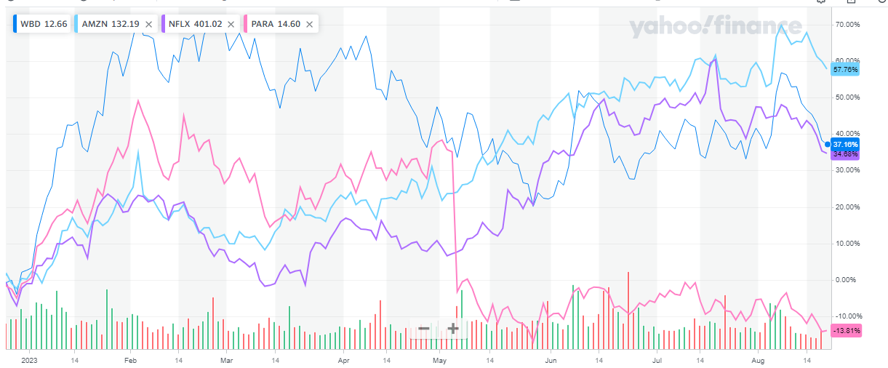

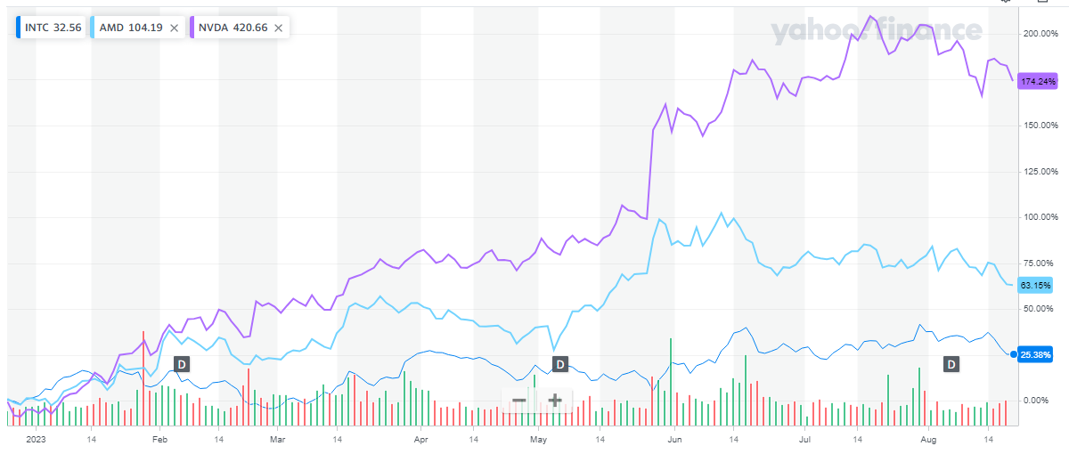

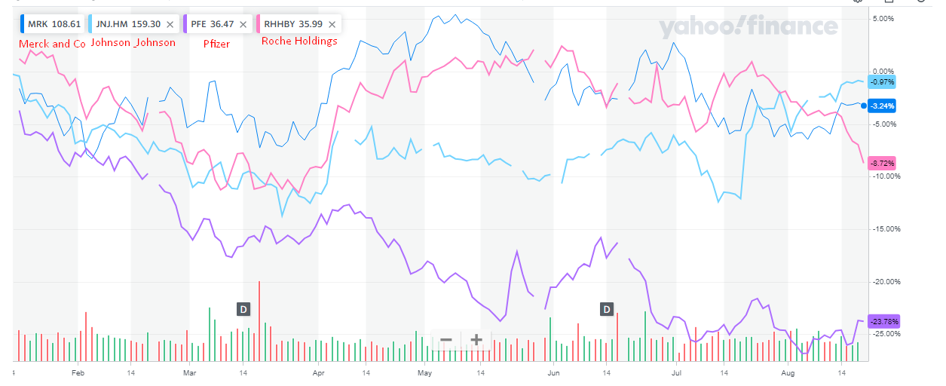

Sources:
https://www.globaldata.com/company-profile/marriott-international-inc/competitors/
https://uk.finance.yahoo.com
https://www.fool.com/investing/2023/05/04/why-paramount-global-stock-plunged-this-week/

