Revenue Driver and Cost Driver Analysis Sidharth Nambiath

**Introduction**

This report aims to provide an analysis of the cost and revenue drivers of two companies, Marriott Inc and Johnson & Johnson.

**Marriott Inc**

**Effects of varying price on revenue**

Elementary analysis of Mariott Inc’s revenue growth between 2010 and 2022, by considering at the revenue per available room (RevPar) and average daily room rates (ADR) per year [1], shows a noticeable correlation between the two (*r* = 0.68). This only takes effect up to a point, however, as it seems that RevPar flattens at *ADR* > $180, as seen in Figure 1b.

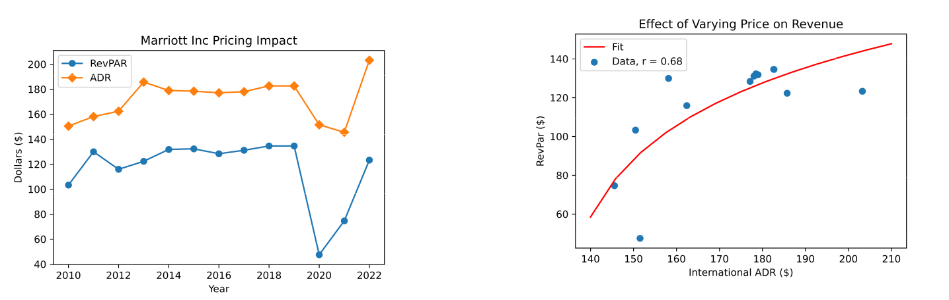

**(b)** The correlation between Revenue per Available Room (RevPar) and Aver-

**(a)** The yearly change in Revenue per Available Room (RevPAR) and Average age Daily Room Rate (ADR) between 2010-2022. The correlation coefficient,

Daily Room Rate (ADR) between 2010-2022. represented by *r* , implies a positive correlation.

**Figure 1:** Pricing Impact on Revenue

**Effect of varying volume on revenue**

Here, it was volume was represented as the global occupancy rate across all of Marriott Inc’s hotel rooms [1]. It can be seen in 2a that the general trend over the period 2010-2022 is very similar in shape to that observed in 1a. Then, when analysing the effect of varying volume on revenue, it can be seen that there is an extremely strong positive correlation (*r* = 0.94). This means that, based on this data, increasing occupancy rate should result in increased revenue. It is worth noting that a more accurate inference can be obtained by using even more historical data, and of course occupancy rate by nature is capped at 100%.

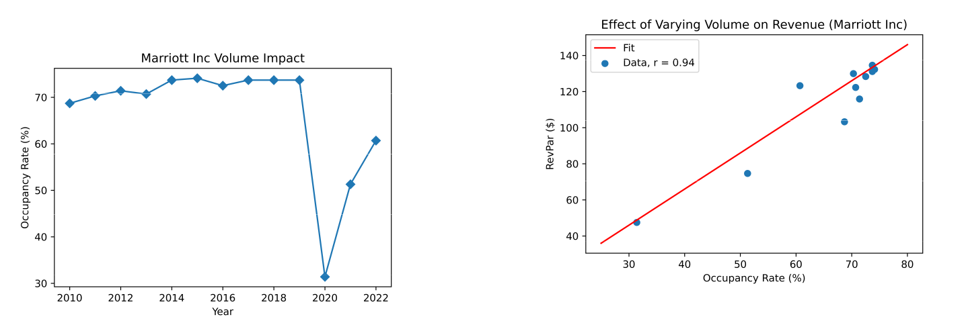

**(b)** The correlation between occupancy rate and revenue per available room (RevPar) between 2010-2022. The correlation coefficient, represented

**(a)** The yearly change in occupancy rate between 2010-2022. by *r* , implies a strong positive correlation.

**Figure 2:** Volume Impact on Revenue

1

Revenue Driver and Cost Driver Analysis Sidharth Nambiath

h! 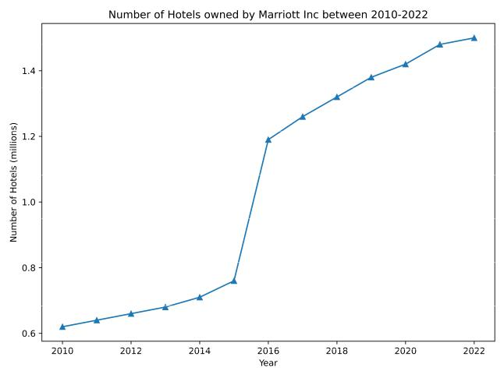

**Figure 3:** The change in the number of hotel rooms owned by Marriott Inc between 2010-2022.

H 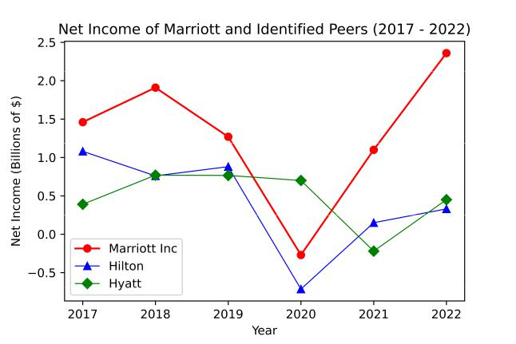

**Figure 4:** The evolution of net income amongst peers in the hospitality sector (2017-2022). Net income data acquired from Macrotrends.

**Cost Drivers**

Cost drivers are defined as factors and variables which influence the costs that a firm may experience. In the case of Marriott Inc, the following were identified as potential cost drivers:

* **Labour Costs (Variable)** - proportional to the number of employees; larger number of employees means labour costs increase.
* **Operational Expenses (Variable)** - operational expenses include utility costs, which tend to increase as occupancy rates increase.
* **Rent (Fixed)** - Rent is generally fixed, assuming that the number of properties does not increase, i.e. regardless of the occupancy rate, the same rent is paid per hotel building.

It can be seen in Figure 3 that Marriott has continued to increase the number of rooms in its portfolio, with a particularly pronounced increase between 2015 and 2016. This implies that Marriott has chosen to consistently grow in size, and thus it can be expected that the variable costs would all increase. Since this type of growth would involve acquiring more property, it is likely that the total cost of renting would increase, despite it being a fixed cost under certain circumstances.

**Company Performance and Peer Comparison**

Using net income (or net profit) as a metric to gauge performance, it can be seen in Figure 4 that all of the peers were performing relatively similarly prior to the pandemic in 2020, with Marriott Inc earning the largest profits. Hilton and Hyatt both struggled relative to Marriott in the post-pandemic recovery period, which saw a strong recovery. It was to be expected that the hospitality sector would suffer during the pandemic due to lower tourist numbers and lockdown orders.

2

Revenue Driver and Cost Driver Analysis Sidharth Nambiath

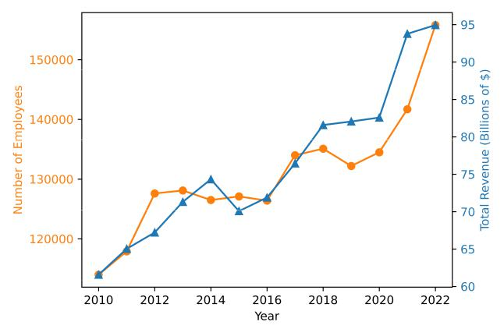

**Figure 5:** The number of employees at Johnson & Johnson over time compared to the total revenue over the same period.

**Johnson & Johnson**

**Effect of varying price and volume on revenue**

**Table 1:** The impact on sales due to changes in volume and price.

|  |  |  |  |
| --- | --- | --- | --- |
|  | Sales Increase/(Decrease) Due to: | 2022 | 2021 |
|  |  |  |  |
|  |  |  |  |
|  | Volume | 6.9% | 12.9% |
|  | Price | (0.8) | (0.7) |
|  |  |  |  |

In Table 1, taken from the 2022 Johnson & Johnson SEC Filing 10-K annual report [2], it can be seen that changes in volume led to positive changes in sales revenue, whereas changes in price led to negative changes in sales revenue.

**Cost Drivers**

For Johnson & Johnson, the cost drivers are broadly the same as for Mariott Inc. It can be seen in Figure 5 that in spite of increased costs as new employees are hired, total revenue continues to climb. Additionally, by considering the operating expenses [3], it can be seen in Figure 6a that it follows the annual revenue almost perfectly. In fact, by plotting them against eachother and calculating the correlation coefficient, it can be seen in Figure 6b that there is very strong positive correlation between the two.

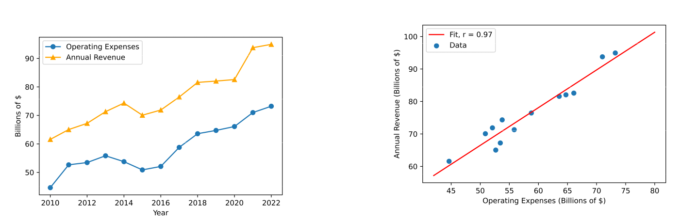

1. The yearly change in Operating Expenses and Annual Revenue for John-son & Johnson between 2010-2022.
2. The correlation between Operating Expenses and Annual Revenue for Johnson & Johnson between 2010-2022. The correlation coefficient, repre-sented by *r* = 0.97, implies a very strong positive correlation.

**Figure 6:** Pricing Impact on Revenue

3

Revenue Driver and Cost Driver Analysis Sidharth Nambiath

H 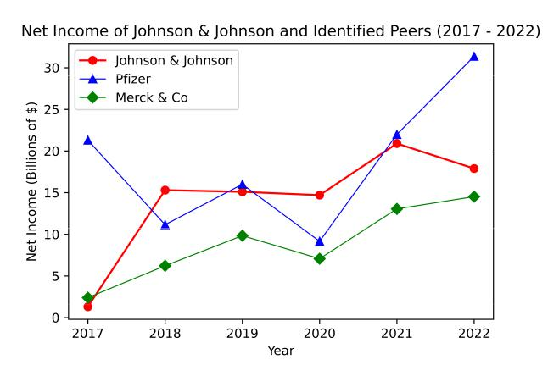

**Figure 7:** The evolution of net income amongst peers in the pharmaceutical sector (2017-2022). Net income data acquired from Macrotrends.

**Company Performance and Peer Comparison**

It can be seen in Figure 7 that all of the peers were performing relatively similarly prior to the pandemic in 2020, with Johnson & Johnson earning the largest profits. During and after the pandemic, all of these companies saw growth, perhaps due to the increased demand for hygiene products and pharmaceuticals, but Pfizer in particular saw far more pronounced growth, potentially as a consequence of its successful Pfizer-BioNTech vaccination rollout.

4

**Bibliography**

1. *Marriott International - statistics facts*. 19 Jul 2023. URL: [https://www.statista.com/topics/1872/marriott-international/](https://www.statista.com/topics/1872/marriott-international/#topicOverview) [#topicOverview](https://www.statista.com/topics/1872/marriott-international/#topicOverview).
2. *Johnson Johnson (JNJ) SEC Filing 10-K Annual Report for the fiscal year ending Sunday, January 1, 2023*. Tech. rep. 16 Feb 2023, p. 22. URL: <https://last10k.com/sec-filings/jnj#i51a46167ef364951bf70ae9d6493776c_109>.
3. *Johnson Johnson Operating Expenses 2010-2023 | JNJ*. 2023. URL: [https://www.macrotrends.net/stocks/charts/JNJ/](https://www.macrotrends.net/stocks/charts/JNJ/johnson-johnson/operating-expenses) [johnson-johnson/operating-expenses](https://www.macrotrends.net/stocks/charts/JNJ/johnson-johnson/operating-expenses).

5