Visa Inc. Market Research Report

Visa Inc. (Visa ) is a global payments technology company. The company provides digital payments across more than 200 countries. The company connects consumers, merchants, financial institutions, businesses and strategic partners. Ultimately, it operates through the payments services segment and its core business solution, including credit, debit, prepaid and cash access programs for individual, business and government account holders.
Peer Analysis
Mastercard- similar to Visa, Mastercard is a global payment technology company that facilitates electronic payments between banks, merchants and cardholders.
American Express- while different in its business model(it issues its own cards), American Express is a major player in the payment industry, offering credit cards, charge cards, and traveller’s services.

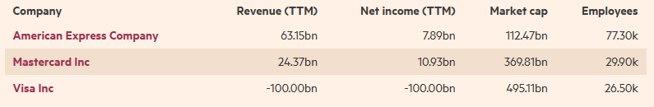
Financial Times (2023)
Substitutes
Substitutes for Visa Inc. come from emerging financial technologies and evolving payment system. Some potential substitutes include:
- Cryptocurrencies – as digital currencies gain traction; they pose a potential alternative to traditional payment systems like Visa. Cryptocurrencies offer decentralized, peer -to -peer transactions, challenging the centralized nature of payment networks.

- Fintech Startups – numerous startups offer innovative payment solutions, such as mobile wallets, peer- to -peer payments apps, and alternative payment methods, which could pose competition to Visa’s services.

New Markets
Regarding new markets, Visa inc. has been expanding into several areas:
- Emerging Economic – targeting regions with growing economies and populations, Visa is expanding its presence in developing countries where electronic payments are being established.
- Contactless Payments- with the rise of contactless transaction, visa has been focusing on markets embracing this technology.
- E- commerce- Visa is continuously tapping into the expanding ream of online commerce, aiming to enhance its services and security measures for online transactions.
Visa is consistently looking into innovation in new markets and ways to adapt to changing consumer behaviours and technologies to maintain its position in the payments industry.
Key Revenues
Visa Inc has a few significant sources of revenue, primarily they come from various sources within the payment’s ecosystem:
- Transaction Fees – Visa charges fees to merchants for processing transaction made using their card system payment. Most of the time the fees are typically a percentage of the transaction amount.
- Service Fees- another source of income comes from various services to financial institutions, merchants, and other partners in the payment ecosystem, including authorization, clearing, settlement, and risk management services.
- Data Processing Fees- Visa generates revenue by processing huge amounts of transaction data and providing analytics and other value-added services to its customers.
- Cross-border Fees – another stream of revenue comes from transactions that occur across international borders, facilitating currency conversion and international payments.
- Licensing Fees – additional revenue comes from licensing agreement with financial institutions that issue Visa-branded cards and its payment network.

Key Costs
Visa Inc. has several cost drivers that has imperative impact on cost structure. These cost drivers can include:
- Network and Processing Costs- these costs are related to maintaining and expanding Visa’s global payment network infrastructure, which involves technology, data centres and security measures.
- Personal Costs – employees wages, benefits and other related expenses for its workforce have to be taken into consideration as a key expenditure.
- Marketing and Advertising- costs associated with promoting Visa’s brand, services, and products globally to consumers, financial institutions and merchants.
- Compliance and Regulatory Costs – Visa has to take into account expenses related to compliance with various financial regulations and industry standards across different regions where Visa operates.
- Research and Development- Visa Inc. has to continuously invest in technology advancements, innovations, and new payment solutions to enhance its offerings and stay competitive in rapidly evolving payments landscape.
- Legal and Administrative Expenses - Visa has to incorporate expenditures related to legal and administrative operations.

It is necessary to say that Visa Inc by managing these costs while continuing to invest in innovation and infrastructure keeps its competitive edge in the payments industry.

Visa’s Key trends
- Rise of Contactless Payments- during Pandemic there was acceleration of contactless transactions, they became popular due to their convenience and hygiene. Visa has been adapting to this trend by enhancing its contactless payment infrastructure.
- E- commerce Growth- as there is increase demand for online shopping, Visa is focusing on improving its e-commerce services and security measures.
- Fintech Disruption – Fintech startups are disrupting traditional payment systems with innovative solutions, challenging established players like Visa. It is necessary to say that Visa has been collaborating with some fintech companies and investing in others to stay ahead of competition.
- Digital Wallets- the growth of digital wallets and mobile payment apps changed how customers pay for goods and services. Visa is working on partnerships and integrations with various digital wallet providers to remain relevant in this industry.
- Regulatory changes- evolving regulations, particularly regarding data privacy and security, impact how payment companies like Visa handle and protect consumers data.
- Cross- Border Transactions – with global commerce expanding there is a demand for efficient and cost- effective cross-border payment solutions. Visa is continually improving its offerings in this are and facilitate smooth international transactions.
- Trend- beyond paying with card or mobile wallet, Visa is looking to introduce a new form of payments. For instance, Visa’s working on turning a luxury car into a fully secure, always- on payment device- that can enable drivers to make in – cars payments using just their fingerprints.

SWOT analysis
Visa became a leading brands in the banking and financial services sector. The SWOT analysis will be fully examined in order to find out the strengths and weaknesses along with opportunities.
Visa Strengths:
- Visa has the largest market share in the world, offering services in numerous countries.
- Visa’s global network processed 62 billion transactions and became the well- known and trusted brand in the payment industry.
- Technology and Innovations- the company continuously invest in technology security and innovation to stay ahead of other competitive players in the market.
- It has over 7000 employees and over 8500 branches globally
- Diversified revenue streams come from transaction fees, service fees and licensing.
- Strong supply chain and branding through advertising
- Visa has been known for sponsoring a lot of major global sporting events.

Visa Weaknesses:
- Visa is fully dependent on partners, particularly it relies on banks and financial institutions to issue the cards and ultimately use its network.
- High exposure to risk and fraud
- Regulatory challenges- compliance with different variety of regulations across different regions can be difficult and costly.
- Visa as leading company in banking and financial services sector can face competition from established players and emerging fintech setups.
- Ultimately the company can face litigation risks.

Visa Opportunities:
- Growing Digital payments – the ongoing shift towards digital payments present opportunities for Visa to expand its services.
- Visa expands their services into developing economies where electronic payments are on the rise.
- Partnership and Collaboration – forming alliances with fintech companies to stay competitive.
- Cashless economies in developing and emerging economies

Visa Threats:
- Cybersecurity Risks involve the threat of data breaches and cyber- attacks which is a constant challenge in the payments industry.
- Fintech Disruption could be a major disruption for Visa Inc as Fintech could offer alternative payment solutions.
- Regulatory Changes- evolving regulations could impact Visa’s operations and increase compliance costs.
- Competitive environment in financial market could be dangerous for Visa Inc. It has a significant competitors, including Mastercard as well as digital payments companies such as PayPal.

PESTEL analysis
Visa Inc. PESTEL analysis is a strategic tool to analyse the macro environment of the organization. PESTEL stands for - Political, Economic, Social, Technological, Environmental & Legal factors that impact the macro environment of Visa Inc.
Political factors play a significant role in determining the factors that can impact Visa Inc.'s long term profitability in a certain country or market.
Political Factors
- government regulations affect cross- border transactions and market entry.
- Political stability and importance of credit services sector in the country’s economy
- Risk of military invasion
- Level of corruption in particular regulations in the financial sector
- Taxation – tax rates and incentives
- Trade regulations and tariffs related to financial.

The Macro environment factors such as – inflation rate, savings rate, interest rate, foreign exchange rate and economic cycle determine the aggregate demand and aggregate investment in an economy. Economic factors that Visa Inc. should consider while conducting PESTEL analysis are:

Economic Factors
- Fluctuations in exchange rates impact revenue, economic growth impacts consumer spending
- Government intervention in the free market
- Efficiency of financial markets – Does Visa Inc. need to raise capital?
- Infrastructure quality in Credit Service industry
- Skill level of workforce in Credit Service industry
- Education level in the economy
- Labour costs and productivity in the economy
Social Factors
- Changing consumer preferences towards digital payments influence Visa’s services and products.
- Demographics and skill level of the population
- Education level as well as education standard in the Visa Inc.’s industry
- Culture (gender roles, social conventions)

Technological Factors
- Advancements in payment technology drive innovation and requires continuous investment.
- Technology impact on product offering
- Impact on cost structure in Credit Service industry
- Impact on value chain structure in Financial sector

Environmental Factors
- Weather, climate change
- Laws regulating environment pollution.
- Air and water pollution regulations in Credit services industry
- Waste management in Financial sector
- Attitudes toward and support for renewable energy

Legal Factors
- Compliance with diverse financial regulations globally affects operations and expansions.
- Anti-trust law in Credit Services industry and overall, in the country
- Consumer protection and e-commerce
- Employment law
- Data protection

This PESTEL analysis provides how each factor may influence Visa Inc operations, strategies and decision – making processes.

Technical Analysis Visa Inc.

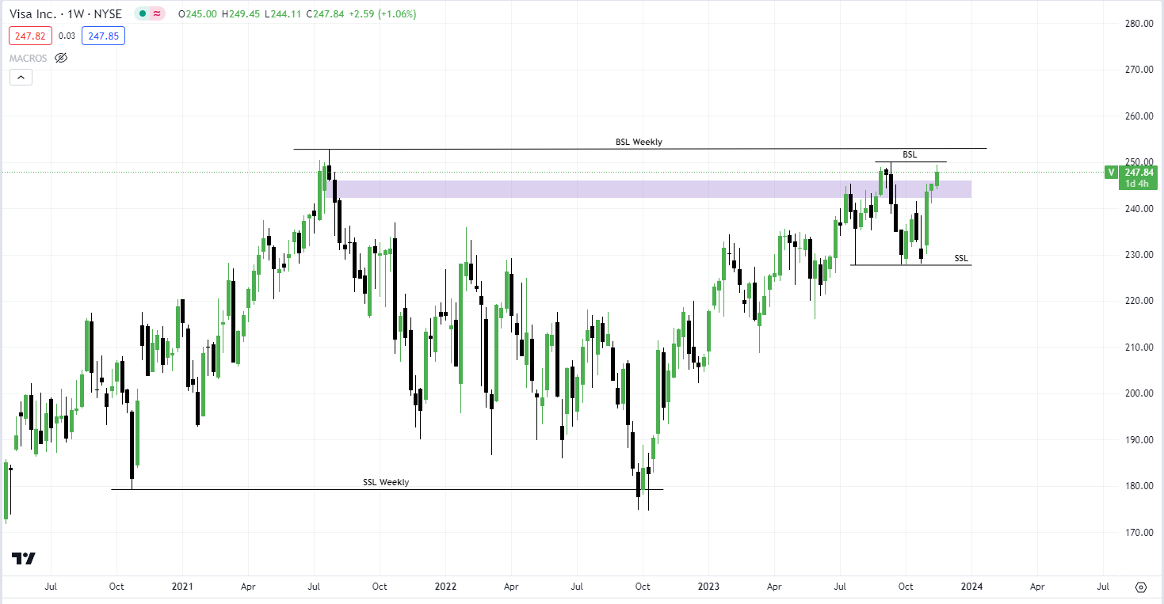
Visa Inc.’s stock is currently trading above $240; the overall order flow is bullish on the Weekly time frame. This indicates a positive trend as stock moves consistently higher. I anticipate the price to take the sell side liquidity at £253 and continue moving higher with the bullish sentiment in the market. The stock has a potential of good return of investment, but currently the price is in premium, it has to move back to a discount for smart money to enter the market - execute more long orders. Ultimately, Visa In. is listed on Nasdaq 100 which just recently turned back into the bullish market. The highest analyst price target is $310, the lowest forecast is $240. Visa Inc. analyst rating consensus is a strong buy. It is necessary to say that the recent economic CPI (Consumer Price Index) data in US came weaker than expected, this is associated with US Federal Reserve to cut interest rates which could be indicative of stocks to rally further.

Visa Inc. Key Strategies
Visa takes into consideration several key strategies in order to maintain its position in the payments industry:
- Global expansion - Continuously expanding its global reach by entering new markets and forming strategic partnerships with financial institutions and merchants worldwide. This expansion allows Visa to tap into emerging markets and increase its user base.

- Innovation in Payment Technology - Visa has been investing heavily in research and development to innovate and adapt to changing payment trends. This includes advancements in contactless payments, mobile wallets, and other digital payment solutions.

- Enhancing Security- Visa takes the security enhancement seriously, by prioritizing data security and fraud prevention they developed robust security measures. Visa consistently invests in technologies to ensure safe and secure transactions for both consumers and merchants.

- Diversification of Services - Expanding beyond traditional credit and debit card transactions into new areas such as business-to-business payments, cross-border transactions, and data analytics services, diversifying its revenue streams.

