Overview

Visa Inc (Visa) is one of the world’s leaders in digital payments. Visa is a provider of payment cards, which are used to facilitate secure, dependable and efficient money movement among consumers, issuing and acquiring financial institutions and merchants.

Geographic segments: US and International

The core Business is captured below.

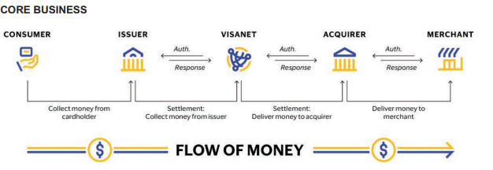

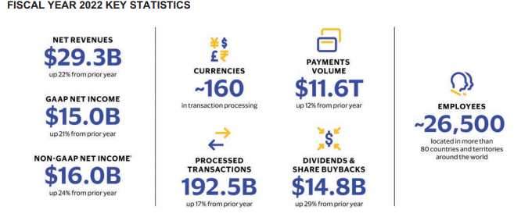

Excerpt 2022 annual report

Visa inc is major player in the transaction and payment processing services industry with market capitalisation of $489.65B and Enterprise Value of $493,24b.

The major competitors of visa are 1.Mastercard inc with market capitalization of $374.85b and Enterprise Value of $383.57b. 2. Fiserv inc with market capitalization of $72.70b and Enterprise Value of $ 95.83b.

**Key revenue and cost drivers.**

**Revenue Drivers-Volume**

There are three primary areas that drive the revenue growth of the business

1. Consumer payments 2. New Flows 3. Value –added Services

Consumer payments: The core products-credit, debit and prepaid cards drive the revenue volume

2. Excerpt from 2022 annual report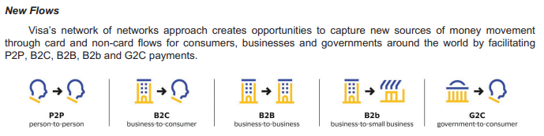

3. Value-added Services

**Cost Drivers**

**The following are the key cost drivers of Visa Inc**

• Personnel expenses (include salaries, employee benefits, incentive compensation, share-based compensation and contractor expenses. )

• Marketing expenses (include expenses associated with advertising and marketing campaigns, sponsorships and other related promotions of the Visa brand).

• General and administrative (expenses consist mainly of card benefits, facilities costs, indirect taxes, travel and meeting costs, foreign exchange gains and losses and other corporate expenses incurred in support of our business.

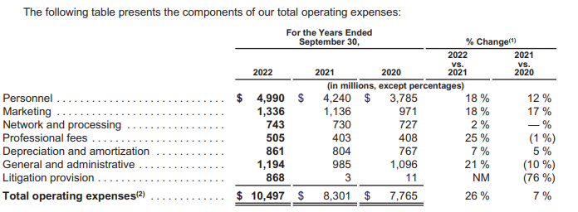

Excerpt 2022 annual report

Porters Analysis of five key forces that influence competition in the Transaction and payment processing services industry.

1. Threat to new entrants-Though the industry has many untapped market especially the emerging market, Visa faces a moderate threat of new entrants. The barriers to entry are high as the industry requires huge capital, extensive network of banks, merchants and consumers making it difficult for new entrant to gain market share.
2. The bargaining power of suppliers-This is considered low for Visa. Some of the factors that reduce the bargaining power of suppliers for Visa include 1. The ease of Visa to switch to other suppliers 2.The availability and the number of suppliers is large with no concentration of power in any of the suppliers. Also, they maintain good relationship with their suppliers and can easily renegotiate favourable terms as a result of its size and market share.
3. Bargaining Power of Buyers. The bargaining power of buyers for Visa is **HIGH**. Transaction and payment processing services industry is very competitive industry where the customers have access to wide range of choices and can switch to competitors of the unsatisfied with the offerings and services of Visa. In order to lower the bargaining power of buyers and remain relevant in the industry, Visa must always work on developing and improving its products and services while maintaining strong relationship with its customers.
4. Threat of substitutes. This is HIGH for Visa as there are many payment solutions methods and platforms that offer similar services as in the industry. Examples are Mastercard, American Express etc
5. Industry Rivalry. The industry is generally intense and highly competitive which necessitate continuous development, innovation and improvement of its services in order to remain relevant in the industry.

A SWOT GRID

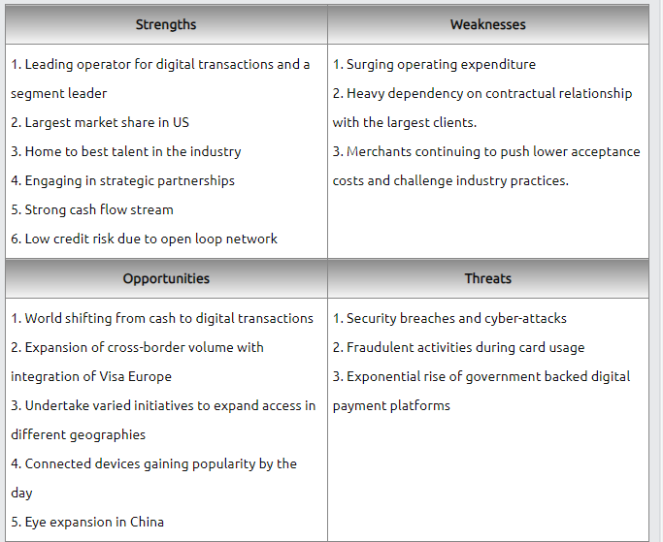

Excerpt from https://www.swotandpestle.com/visa/

Strengths

* Leading operator for digital transactions and segment leader .Most customers prefer Visa to its competitors as research has shown that majority of debit and credit card holders prefer Visa over others.
* Largest Market Share. Visa Inc had a market share of about 52% among all the competitors and this gives them a competitive advantage.

Weakness

* + Surging Operating Expenditure. The industry is a very competitive one and hence the need for improvement and development resulting in increased operating expenditure. The Except below shows increased operating expenses of 26%.

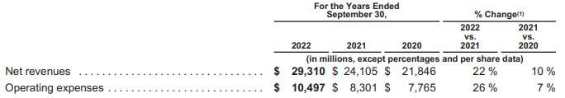

* + Heavy dependency on contractual relationship. This exposes the company to contract renegotiations and also control over some of the process flow.

PESTLE GRID

The PESTLE analysis gives insight of the impact of key external factors (Political, Economic , Social, Technological, Legal and Environmental)on the macro environment of an organisation. Below is the PESTLE grid for Visa Inc

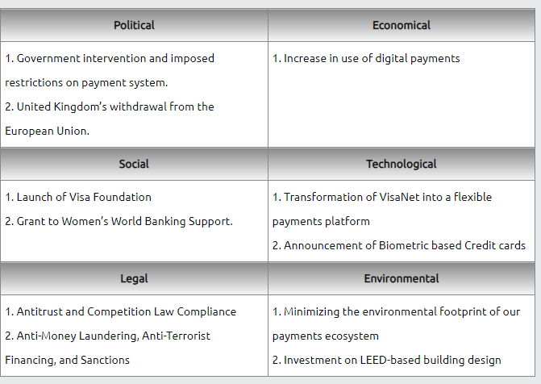 Excerpt from https://www.swotandpestle.com/visa/