Ticker symbol | AMZN
Market cap | 1,327T
Stock price | $129.33
Exchange | Nasdaq
Beta | 1.26
Earnings date | 26/7/2023-31/7/23
Financial health of amazon-
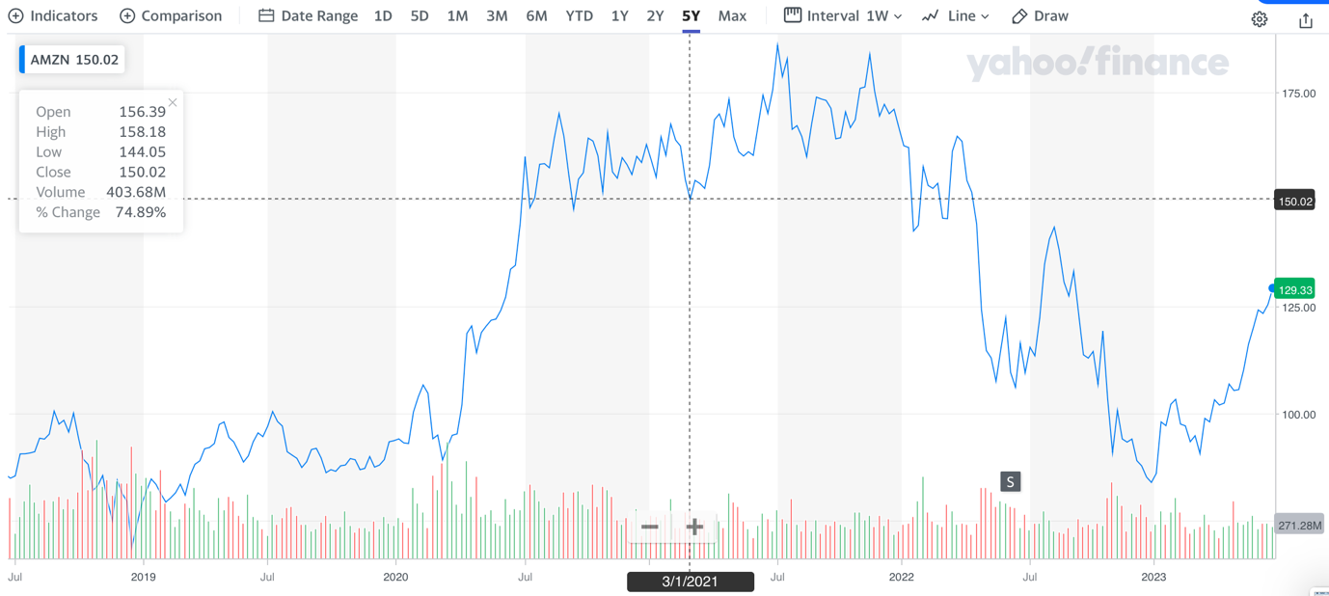
Graph shows, amazon stock over 5 year period and the rise AMZN in 2020, due to increased online sales during the covid lockdown, stock price rose, to decline in 2022 due to a stock split of shares, market cap also surpassed $1Trillion. Increased levels of volume of trading for AMZN, showing strong investor involvement.

Regional segments 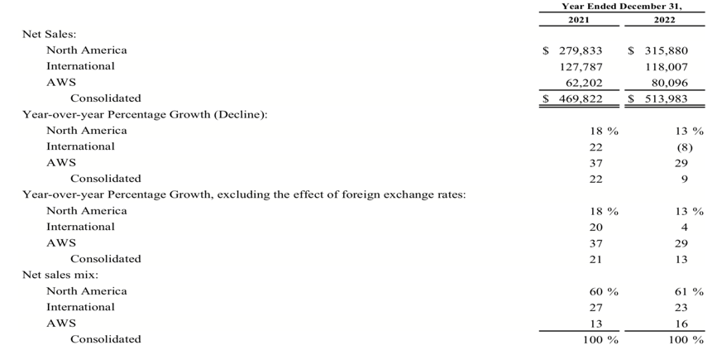
AMZN saw yoy growth of its business in all sectors in 2021 and saw growth in 2022, in north America AMZN grew by 13%, showing increased unit sales, and 22% international in 2021, with new warehouse openings in Europe. However in 2022, international sales dropped by 8%, showing a slowdown growth in amazon international sector.
AMZN saw, its sales in AWS increase by 29%, which has been a primary focus on amazon, in entering new market segment.

Free cash flow statement –
AMZN saw its free cash flow fall in 2021, to a minus (-9,069) negative free cash flow, however, this was due to increased investments in amazon and increase in operating expense and purchases for plant, property and equipment, which also saw, revenue increase, however free cash flow decline further negative to -11,569(millions) drastically reducing AMZN free cash flow, increased cashflow use in investing activities and lease payments.

Financial ratios--

Liquidity ratio analysis
Current ratio, for amazon for 2021, was 1.13 but decreased to below 1 in 2022, indicating amazon increased its current liabilities and decrease in assets, indicating a poor financial health compared to its competitor Alibaba, at 1.6 and 1.7 in 2022 and 2021 respectively, AMZN face issues in its ability to cover for obligation if they are due at once.
Quick ratio- amazon has a quick ratio of less than 1 indicating poor liquidity if need to cover current liabilities. AMZN had 0.66p liquid assets to cover for liabilities. Poor quick ratio, compared to industry competitors.
Cash ratio – cash ratio for AMZN is 0.3 less than 1 indicating there is too much current liabilities in amazon than there is cash, suggesting company not able to cover short obligation with cash.
Defensive interval days, amazon has a strong DIR of 251 and 341 in 2022 and 2021 strong ability to operate with current assets before selling long term assets.

Profitability ratio analysis

Gross margin- for amazon was at 43% and 42% indicating amazon recorded a high profit margin indicating business operation are able to generate a positive profit.

EBITDA company operating profit was at 10% in 2022, strong positive ability to generate profit from earnings.

Profitability ratios indicate AMZN has a positive return on profitability, for the firm showing firm is able to generate business profit for the past 2 years.

Solvency ratio

Debt to equity indicates company has $2 in debt for every $1 in equity indicating firm is highly in debt compared to its equity, showing share holders equity.

Debt to assets – the D/A for AMZN is high as 68% of debt financed assets in 2022, indicating a strong reliance on amazon on debt to finance company rather than equity.

Debt coverage – amazon had a 6% debt coverage ratio in 2022 indicating company a lot of its cash its used in the service of debt.

Asset utilization

Total asset turnover- total asset turnover for AMZN indicates that for every dollar of asset amazon generated 1.10 in sales revenue, indicating the company has slow sales on inventory.

Fixed asset turnover for amazon was 1.6 compared to industry it was high than Alibaba at 0.5 indicating among the industry AMZN has a higher turnover of fixed assets.

Inventory turnover – the amount of days it takes for AMZN to turnover inventory, was 8,3 days, compared to industry competitors it was a good number.

Amazon has a efficient asset utilization and is able to make use of its fast and more effiecent that its industry competitors such as Alibaba.

Investor ratios-

Price to equity – the p/e ratio for 2022 was negative, due to stock split in 2022, which saw reduction of earnings, in 2021 the earnings was $51 indicating growth and good earning potential for AMZN stock.

Earnings per share – EPS for 2022 was negative at $0.27 a share, and $3.24 in 2021, this indicates a decline in EPS this could be due to slowdown of economy and potential recession warnings which saw amazon value drop in 2022 and the stock split.

Price to book value – AMZN book price to ratio was 8.7 in 2022 a drop from 12.3 in 2021. The stock is trading 8x its book value indicating the stock may be overpriced compared to its book value.

Return on equity – ROE in 2022 was negative due to increase in shares as stock split and in 2021 ROE was at 24% indicating AMZN has a positive ROE for shareholders in 2021.

ROA- AMZN return on assets was low and negative showing poor return on assets. In 2021 there was a positive return on assets as the company was more efficient.

Investment grade- AA
Shares outstanding- 10,189
Total value of equity of share holders – 146,043

